“I am veru profiesional ples hirar me”

[Go Grid, or go home]

Not to toot my own horn, but

[Jacob]



[Master Thesis]

[Study programme]

[30/60 credits]

[Institute]

Abstract

The linear-quadratic (LQ) model is a well-established tool that explain the dose-response of in vitro irradiated cells. However, the model fails to describe effects occurring when spatially modulating the field during spatially fractionated radiation therapy (SFRT/GRID), creating high and low dose regions. Cell flasks containing A549 human lung carcinoma cells were irradiated by Magnus Børsting, former M.Sc student, with and without a GRID block (striped or dotted). The flasks were then scanned and segmented by Delmon Arous, PhD student. A traditional LQ model was fitted for OPEN field irradiations, then used to predict SFRT survival. Resulting in $α=0.06± 0.04$ and $β=0.010±0.008$. Survival for high dose areas was overestimated by the LQ model with a percentage difference of $40\%$. In low dose areas, the relative difference was about $5\%$.  
A 2D approach was proposed, where the segmented cell flasks were divided into equally sized quadrats and the number of surviving colonies within each quadrat was found before feeding the data to a Poisson regression model. Cell dosimetry was established for the spatially modulated field, where GafchromicTM EBT3 films were calibrated and irradiated with 5 Gy nominally to obtain dose maps. The mean dose calculated for all OPEN field dose maps were $4.98±0.05 Gy$.  
Dose and dose squared was used as explanatory variables in the Poisson regression, to obtain comparative results to the 1D LQ model. The 2D evaluated OPEN field regression with 0.5 mm2 quadrats, resulted in $α=0.06±0.01$ and $β=0.013±0.002$**.** The model was subsequently extended to include survival data from all GRID irradiated cell flasks, and the ratio of high dose and low dose area along with distance from the quadrat centers to the nearest peak were added as regressors. The regressors were added to explain the effects occurring when spatially modulating the irradiation field. More analysis needs to be performed, but the preliminary result is all regressors having a sub 0.05 p-value for 0.5 mm2 quadrats.

# Abbreviations and explanations

AICc – Corrected Akaike Information Criterion

ANOVA – ANalysis of VAriances

Apoptosis – A mechanism allowing damaged cells to initiate self-destruction (*Apoptosis | Cytology | Britannica*, 2013).

ATM – A protein activated by DNA damage. Its purpose is to phosphorylate (activate) numerous proteins related to cellular response after exposure to ionizing radiation (Samuel et al., 2002).

ATP – Adenosine triphosphate a molecule, which provides cells with energy for the cell and phosphate groups for protein activation. Through the process of hydrolysis, ATP is converted to ADP (adenosine diphosphate) (*Adenosine Triphosphate | Definition, Structure, Function, & Facts | Britannica*, 2020).

BM – Biomolecule. There are four types of biomolecules: carbohydrates, lipids, nucleic acids and proteins (*Biomolecule | Definition, Structure, Functions, Examples, & Facts | Britannica*, 2020). These are molecules important for normal cell functioning, and damage to them can have harmful consequences.

CDK – Cyclin dependent kinase

CT – Computed Tomography is an image modality using an X-ray source that creates an X-ray beam, which rotates around the patient, which lays between the source and a detector array. Attenuation values in different tissues are found and used to create an image (Villarraga-Gómez, 2016).

Cytokines – A category for signaling molecules that mediate immune responses by enabling cell to cell communication (Mandal Ananya, 2019). The cytokines relevant to this thesis are different variants of IL (interleukin) cytokine, TNF- $α$ and TGF- $β$. They are all important in regulating cell division (Najafi et al., 2014).

DNA – Deoxyribose nucleic acid

DNA transcription – A process of creating a messenger ribonucleic acid (mRNA), which is used to create specific proteins. A transcription factor binds to the DNA, telling the enzyme RNA-polymerase to read a gene sequence of interest. As each base (Adenine, Cytosine, Thymine and Guanine) in the sequence is read, a complementary nucleotide is attached to form the mRNA strand (*Transcription | Definition, Steps, & Biology | Britannica*, 2019). In the DNA Adenine binds to Thymine, but during transcription, Thymine is replaced with Uracil (Mason et al., 2020, p.48).

EBT – External Beam Therapy

GD – Gradient Descent

GLCM – Grey-level co-occurrence matrix

GLM – Generalized Linear Models

GN – Gaussian-Newton

HR – Homologous recombination

IAEA – International Atomic Energy Agency

IQR – Interquartile Range

KDE – Kernel Density Estimation

LET – Linear energy transfer

LINAC – Linear accelerator is a device that accelerates charged particles using an alternating electric field. They are used in radiation treatment to accelerate electrons into a high atomic-number target, creating high energy (MV) bremsstrahlung (Philip Mayes et al., 2007).

LM – Levenberg-Marquardt algorithm

MN – Micronuclei are chromosome fragments not included in either daughter cells following cell division. They are a result of DNA damage, and might lead to immune responses (Harding et al., 2017).

MLC – Multileaf collimators are individual metal (often Tungsten) blocks used to shape a radiation beam coming from an external radiation therapy machine (Galvin et al., 1993).

MLE – Maximum likelihood estimator

NHEJ – Nonhomologous End-Joining

OD – Optical density

P53 – A protein that is bound to another protein called mdm2. When DNA damage occur, it is released from mdm2, and it will bind to a gene for transcription of the p21 protein. This protein will in turn inactivate a protein complex responsible for promoting cell division (Alberts et al., 2014, p.1014).

PCA – Principle Component Analysis

Phosphorylation – Is the process of transferring a phosphate group (PO3) to a molecule. Proteins are activated by phosphorylation, and the addition of a phosphate group might change the proteins in different ways: Extra charge from PO3 can attract amino acid chains that connect to the existing protein, or the structure of the binding cite can change (Alberts et al., 2014, p.153-154). Both processes regulate the activity level of the protein.

PMF – Probability Mass Function

PreRC – Prereplicative complex

Proteins – Chains of amino acids with different shapes, sizes and functions. One main function is catalyzing certain chemical reactions. These proteins are called enzymes and have binding cites where specific molecules fit. The enzymes can both break and form chemical bonds (Mason et al., 2020, p.38).

RNA-primer – Ribonucleic acid primers are short nucleotide sequences generated by RNA-polymerase. They exist as a starting point for DNA-polymerase, because they are only able to continue an existing strand (Mason et al., 2020, p.292). The RNA-polymerase will attach Uracil instead of Thymine (see 1.7.1), and they must be removed and replaced by a different DNA-polymerase (Cooper, 2000b).

ROS – Reactive Oxygen Species is a collective term for highly reactive molecules based on oxygen. It has been shown an increase in ROS after exposure to radiation, and it has been hypothesized that they mediate DNA damage (Narayanan et al., 1997).

SCE – Sister Chromatid Exchange is the process of sister chromatids exchanging genetic material. Increased SCE reflect the activity of homologous recombination (see 1.7.3), which again reflect the degree of DNA double strand breaks occurrences (see 1.7.3).

SDD – Source to Detector Distance

SVD – Singular Value Decomposition

Contents

Abbreviations and explanations 5

1 Introduction 13

1. Theory 13

1.1 Ionizing Radiation 13

1.1.1 Photon interaction in matter 14

1.1.2 Charged Particle interaction in matter 20

1.2 Creating the radiation beam 24

1.2.1 X-ray tube 24

1.2.2 X-ray filtering 26

1.3 Dosimetry 26

1.3.1 Quantities 27

1.4 Cavity Theory 31

1.4.1 Bragg-Gray cavity 32

1.4.2 Bragg-Gray-Laurence 33

1.4.3 Burlin 34

1.5 Dosimetry methods 35

1.5.1 Parallel- Plate Ionization Chamber 35

1.5.2 Thimble Ionization Chamber 37

1.5.3 Radiochromic film 38

1.6 Statistics 39

1.6.1 Non-linear curve fit 39

1.6.2 Poisson Regression 42

1.6.3 Confidence interval 44

1.7 Radiobiology 44

1.7.1 DNA basics 44

1.7.2 Cell Cycle and Checkpoint 47

1.7.3 DNA damage and repair 50

1.7.4 Cell Survival Curves 53

1.7.5 LQ-model 54

1.7.6 Radiation Induced Bystander Effect 56

1.7.7 Spatially Fractionated Radiation Therapy 58

2 Materials and Methods 60

2.1 Dosimetry 60

2.1.1 X-ray dosimetry 60

2.1.2 Gafchromic film 65

2.2 Cell Experiments 76

2.3 Segmentation 77

2.4 Cell Survival Analysis 79

2.4.1 Data acquisition and image registration 79

2.4.2 1D Analysis 81

2.4.3 2D Analysis 82

3 DUMP 88

4 Results 89

4.1 X-ray dosimetry 89

4.2 Gafchromic film 92

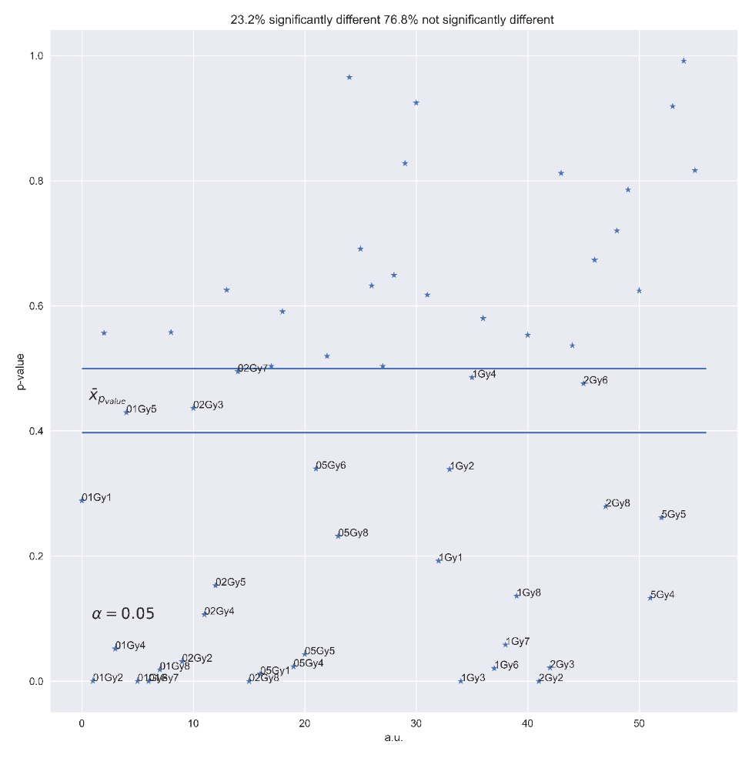 92

4.3 Cell survival 98

5 Discussion 99

5.1 X-ray Dosimetry 99

5.2 Gafchromic film dosimetry 99

5.3 1D survival analysis 99

5.4 2D Survival analysis 99

6 References 101

7 Appendix 119

7.1 Appendix A 119

7.1.1 Compton Scattering 119

7.1.2 Mean free path 123

7.1.3 Nearest Peak Code 125

7.1.4 Reference conditions of FC65-G ionization chamber 126

7.1.5 Initial guess LM 127

# Introduction

Using dose as an explanatory variable in the LQ model is well documented, but we wanted to see if we could expand the model using other variables, and maybe explain how survival is affected by having a spatially fractionated radiation field.

(ikke ferdig, some explanation of cancer treatment and how spatially fractionated radiotherapy has the potential of improving tissue sparing but keep tumour control)

We know how well it reduces large bulky tumours. But the mechanisms behind it is not well defined. The LQ model does not include spatial fractionation and how it affects survival. Is there another parameter that might explain effects such as the bystander effect?

This thesis examines the 2D survival of A549 lung cancer cells irradiated with a spatially modulated X-ray radiation field. The thesis is therefore separated into two parts: First we need to establish the dosimetry of the cells. Then we need to establish a model that explains how the spatial modification affects survival.

We will use segmentation data from Arous et al. of irradiated cells from experiments performed by (Magnus Børsting, 2020). Because the cells have been irradiated using a spatially fractionated radiation field, the dose is not uniform, and dosimetry experiments have been made.

# Theory

## Ionizing Radiation

Radiation is transfer of energy. The main categories are ionizing and non-ionizing radiation. I.e., it either has enough energy to liberate an electron from the atom, or it doesn’t. Non-ionizing radiation consists of low-energy electromagnetic (EM) waves such as UV-light and microwaves. Further right in the EM spectrum the frequency of the radiation increases. Because energy is $E=hf$, with $h$ being the Planck constant and f being the frequency, the energy also increases, and the radiation becomes ionizing X-ray and $γ$ particles. To clarify: The EM waves do not become particles, but it is know from the discovery of the photo-electric effect that you might interpret EM waves as “showers” of photons (Einstein & Infeld, 1938). Together with neutrons, they make up a group called uncharged particles. They are highly penetrating because they need to interact directly with a target.

Charged particles are different, they consist of particles with either positive or negative charge. Some examples are protons (+), electrons (-), and $α$-particles (+2). Their interaction probability is greater compared to uncharged particles. A photon must be close to either a nucleus or an electron for an interaction to occur. A charged particle may interact at a distance. Their Coulomb field interacts with the Coulomb fields of other electrons, causing a “Continuous Slowing Down” (Attix, 1986, p. 160).

The path of a charged particle through a medium is highly dependent on the particle at hand. What is the charge, its velocity, and its weight?   
In medical physics, the primary interested is ionizing radiation and using its properties to identify or treat medical lesions. This is further examined in the radiobiology section (1.7).

### Photon interaction in matter

Photons are energy-carrying particles, without mass, traveling at the speed of light. They interact with the surrounding medium in several ways. The main interactions are Rayleigh Scattering, Photoelectric effect, Compton Scattering, pair/triplet production, and photonuclear interactions (Attix, 1986, p.124-125). Which interaction you’ll have is highly dependent on the atomic number $Z$ of the photon absorber and the energy of the incoming photon. The probability of interaction is defined as interaction cross-section, with the unit $cm^{2}$. In Figure 1‑1 we see which interaction type dominates for specific energies and atomic number Z. Pair production is the annihilation of photons in the presence of a nucleus’s Coulomb field, producing a positron ($e^{+}$) electron ($e^{-}$) pair. The interaction demands, at minimum, the rest energy of two electrons ($2m_{0}c^{2}=1.02 MeV$) (Attix, 1986, p.146-148). We will use photons with energies in the kV region, where the photoelectric effect and Compton scattering dominate, and these interaction types will naturally be our focus.

Rayleigh scattering is a relevant interaction type for lower energy photons. The photons are deflected from their path, but no energy transfers occur; hence, Rayleigh scattering does not contribute to the absorbed dose in the medium. Nevertheless, it is still an important interaction type because it gives a complete picture of the photon’s path.   
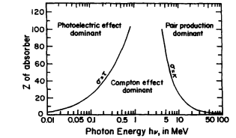

Figure 1‑1. Photon interaction probability (defined as interaction cross-section $σ$ [$cm^{2}$] as a function of atomic number Z and photon energy $hν$ [MeV] The curves represent the area where two interactions have the same probability (Attix, 1986, p.125).

#### Photoelectric effect

The photoelectric effect is when an incident photon’s energy is absorbed by an electron bound to an atom. The kinetics is illustrated in Figure 1‑2. If the energy is equal to or larger than the binding energy of the electron $E_{b}$ it will ionize the electron. The energy transferred from the photon to the electron depends on its initial energy and the electron’s binding energy (Attix, 1986, p. 139).

|  |  |
| --- | --- |
| $$T=hν- E_{b}.$$ | 1‑1 |

The photon might liberate an inner shell electron with higher binding energy (K- or L-shell electron). A looser bound electron will deexcite, filling the vacancy. The energy difference is either emitted as characteristic X-rays or by ionization of a valence electron (outer shell electron). The latter is called the auger effect, and the ionized electrons are known as auger electrons (Attix, 1986, p.143).   
The cross-section per atom for the photo-electric effect is proportional to atomic number and incident energy of the photon

$$τ α \frac{Z^{n}}{{\left(hν\right)}^{m}} \left[\frac{cm^{2}}{atom}\right] , 4<n<5 , 1<m<3 ,$$

The expression confirms Figure 1‑1, as photoelectric effect increases with atomic number, and decreases with energy.

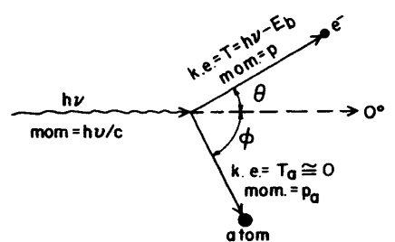

Figure 1‑2. Illustration of the photoelectric effect. A bound electron absorbs all the energy of incoming a photon. If the energy is high enough, it will ionize the electrons (Attix, 1986, p.138). The kinetic energy of the electron is dependent on the initial energy of the photon $hν$ and the binding energy of the electron $E_{b}$. Recoil energy is given to the atom, but it is approximately $0$.

#### Compton Scattering

The scattering process differs from the photo-electric effect in that the electron orbiting the nucleus is assumed free, which results in an inelastic collision. It is illustrated in Figure 1‑3. The errors from this assumption have proved negligible, as the errors don’t become substantial until we have a high atomic number Z and low initial energy $hν$. When these conditions are reached, the photoelectric become the dominating interaction type (Attix, 1986,p. 125).

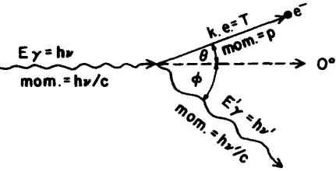

Figure 1‑3. Illustration of Compton scattering, where the electron is assumed free.

The second difference compared to the photo-electric effect is that the photon only transfers part of its energy. The energy of the scattered photon follows this expression, which is derived in Appendix A

|  |  |
| --- | --- |
| $$hν^{'}=\frac{hν}{1+\frac{hν}{\left(m_{e}c^{2}\right)\left(1-cosϕ\right)}}$$ | 1‑2 |

We observe a strong correlation with the energy of the incident photon, and the scattering angle. And a maximum energy transfer to the electron for ${180}^{∘}$.   
The Compton cross section per electron was derived by Klein and Nishina. They improved on the existing theory of Thomson scattering. Thomson’s cross section was independent of incident photon energy, and assumed $hν=hν^{'}$ (Attix, 1986, p.130). This is correct for low energies. However, in Figure 1‑4 we see the energy of the scattered photon starts decreasing for increasing scattering angle around $0.01 MeV$, and reaches its minimum at ${180}^{∘}$.

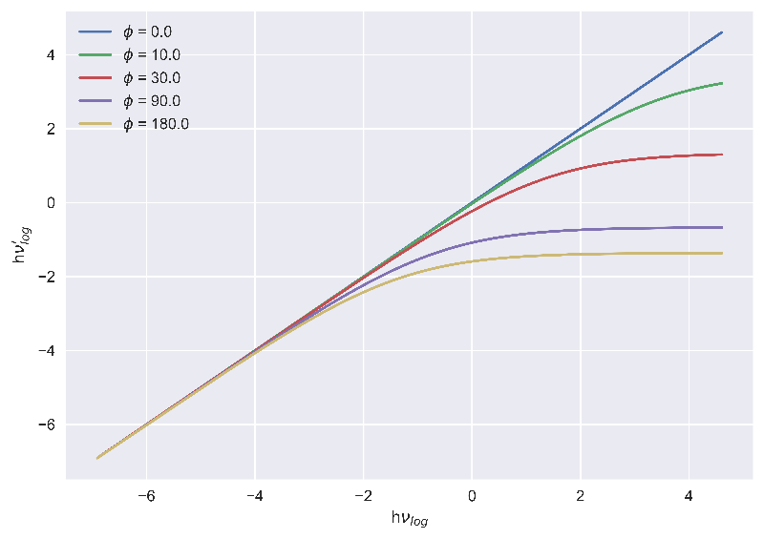

Figure 1‑4. Compton scatter energies in $\log{eV}$. $hν$ is energy of incident photon, $hν'$ is energy of scattered photon.

The Klein-Nishina cross section is represented by the symbol $σ$.

Each interaction has its cross section. The photo-electric effect has $τ$, Compton scatter has $σ$ pair production has $κ$ and Rayleigh scattering has $σ_{R}$. It is practical to sum each cross section to create a combined interaction variable. It is defined as the attenuation coefficient

|  |  |
| --- | --- |
| $$μ= σ + τ+ κ+σ_{R} \left[cm^{2}/atom\right] .$$ | 1‑3 |

However, it is more insightful to normalize it with density $ρ$. This way, we get $μ/ρ\left[\frac{cm^{2}}{kg}\right]$, which represents how a photon is attenuated in a medium. This is called the **mass attenuation coefficient**.

For a polyenergetic photons, you must average the coefficient to include the full energy spectrum of the photons, but for simplicity we’ll assume monoenergetic photons.   
Now that we have the probability of interaction, we can include the fraction of kinetic energy transferred from the incident photon to a secondary electron within a volume of interest. This is called the **mass energy-transfer coefficient**

|  |  |
| --- | --- |
| $$\frac{μ_{tr}}{ρ}=\frac{σ}{ρ}⋅\frac{T}{hν}+\frac{τ}{ρ}⋅\frac{hν-E_{X}}{hν}+\frac{κ}{ρ}⋅\frac{hν-2m_{0} c^{2}}{hν} ,$$ | 1‑4 |

Where $T$ is the energy of the liberated electron after Compton scatter, $E_{X}$ is the energy of either K- or L-shell (highest binding energy) characteristic X-rays generated after the Auger effect. These X-rays carry energy away from the volume of interest and we therefore subtract their energy. $2m_{0}c^{2}$ 
 is the rest energy of the electron-positron pair created by pair production. We subtract because it’s the energy needed to create the electron-positron pair, leaving us with the kinetic energy (Attix, 1986, p.155).  
  
The last expression we want is the **mass energy-absorption coefficient $μ_{en}/ρ$** . It represents the energy absorbed by the volume. It relates to the mass energy-transfer coefficient by

|  |  |
| --- | --- |
| $$\frac{μ_{en}}{ρ}=\frac{μ_{tr}}{ρ} (1-g),$$ | 1‑5 |

Where g is the fraction of energy lost to radiative loss (Attix, 1986, p.155-156).

#### Photon range

(Might remove)

Mean free path is the expected distance a photon will travel before interacting with the medium (*Mean Free Path | Physics | Britannica*, 2007). In Appendix A we derived an expression for mean free path for a photon traversing a slab of material with infinitesimal area $da$ and thickness $dx$

|  |  |
| --- | --- |
| $$<x> =\frac{1}{μ} .$$ | 1‑6 |

The pathlength of the photon decreases with increasing attenuation. This is an important result, because it allows us to predict the path of the photon. It is especially useful when performing Monte Carlo simulations, which we’ll come back to in (ref here).

### Charged Particle interaction in matter

A charged particle has either positive or negative net electrical charge, such as electrons ($e^{-}$), protons ($e^{+}$) and ions (an atom with a surplus of electrons or protons). Because of their charge, the particles will interact with other charged particles through their Coulomb fields. Two equal charges will repell and two opposite charges will attract. A charged particle traversing a medium is surrounded by Coulomb fields of positive (nuclei, positive ions) and negative (electrons, negative ions) charges, enabling the charged particles to interact at a distance. This distance is known as the impact parameter and is defined as the distance from the charged particle to the closest nucleus. We have three main categories of interactions:  
Soft collisions, hard collisions, and Coulomb interactions with the nucleus.

#### Soft collisions

Soft collisions are small Coulomb interactions between the Coulomb fields of an atom and a charged particle. The impact parameter is much larger than the atomic radius (distance from valence electrons to nuclei), and small amounts of energy are transferred to the orbiting electrons of an atom, mainly causing excitations. Even though the energy transfers are very small, the interaction is highly probable, therefore contributing to half of the energy loss of the charge particle (Attix, 1986, p.161).

#### Hard collision

Hard collisions happen when the impact parameter has the same order of magnitude as the atomic radius. The result is a significant kinetic energy transfer to an assumed free and stationary electron. These electrons are called $δ$-rays, which undergo the same charge particle interactions. The hard collisions might also result in liberation of an inner shell electron as described in 1.1.1.1, resulting in emission of characteristic X-rays (Attix, 1986, p.162).

#### Radiative transfer

Radiative transfer, also known as bremsstrahlung, is a process where a charged particle interacts with the nucleus’s Coulomb field. The impact parameter must be much lower than the atomic radius for this to happen. The interaction mainly occurs with electrons and will therefore be the focus point (Attix, 1986, p.163). The radiative transfer refers to an inelastic collision between the nucleus and the electron (See Figure 1‑5). The electron with its negative charge is attracted to the nucleus’s positive charge, causing a deacceleration and deflection of the electron from its incident path. The decrease in kinetic energy $ΔE_{e}$ is converted to a photon, thus conserving energy.   
The probability of radiative transfer Is much lower compared to elastic scattering (2-3%) and is proportional to $q^{2}z^{2}T/M_{e}^{2}$ (Grieken & Markowicz, 1993, p.3), where q is the charge, Z is the atomic number of the atom, T is the kinetic energy of the electron and $M_{e}$ is the rest mass of the electron. With a larger Z, the atom has a higher proton count, resulting in the nucleus having a larger Coulomb field attracting the electron. The kinetic energy of the electron is important because the electron needs to penetrate the electron cloud surrounding the nucleus.  
Radiative transfer is used when creating X-rays inside an X-ray tube, but we will come back to this in the section covering the X-ray tube (1.2.1).

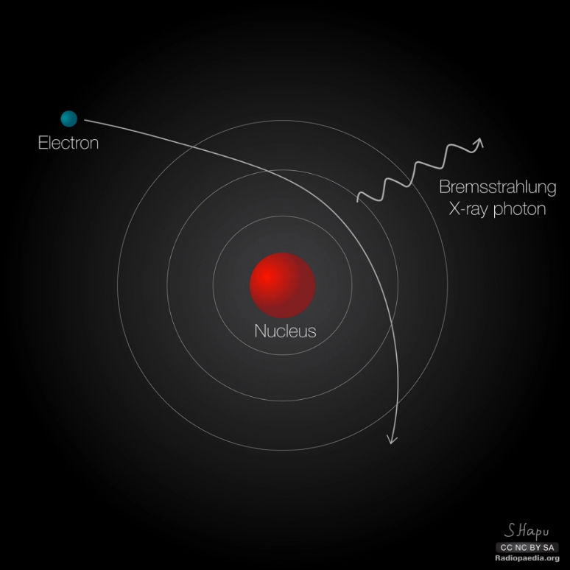

Figure 1‑5. Illustration of radiative transfer, where an electron inelastically collides with an atom’s nucleus deflecting it from its path. The result is an emitted photon with energy equaling the energy loss of the electron (Hapugoda, 2017).

#### Stopping Power

Stopping power is how much energy we expect the charged particle to lose per unit length. It can be found by integrating differential energy loss per length $dT\backslash dx$ over possible energy transfers.   
As discussed, the charged particle might lose its energy by colliding or by radiative transfer, we therefore separate these contributions (Attix, 1986, .165)

$$S=S_{c}+S_{r}$$

Energy lost to radiative transfer does not contribute to dose, because of the larger range of the bremsstrahlung. Radiative stopping power is still important to accurately describe the range of the charged particle.   
Collision stopping power is split into two parts: for soft $S_{soft}$ and hard collisions $S_{hard}$. Energy loss is dependent on the material it penetrates, we therefore introduce **mass stopping power** by dividing the stopping power by the material density $S/ρ$.   
The total collision mass stopping power is

|  |  |
| --- | --- |
| $$\frac{4πN_{A}Z}{A}\frac{r_{e}^{2}m_{e}c^{2}}{β^{2}}z^{2}\left[\ln{\frac{2m_{e}v^{2}}{I}}-\ln\left(1-β^{2}\right)-β^{2}-\frac{C}{Z}\right] \left[MeV\frac{cm^{2}}{g}\right] .$$ | 1‑7 |

Where $N_{A}Z/A$ is electrons per gram, $r_{e}$ is classical electron radius, $β=v/c$, *I* is mean excitation potential in the medium, z is electron charge, and $C/Z$ is shell correction. The collision stopping power assumes the electron’s velocity to be much greater than that of the orbiting electrons in atoms. As the electrons slow down the assumption becomes untrue, and the shell correction accounts for this. Stopping power is inversely dependent on the square of the velocity and electrons with high kinetic energy will lose more energy further into the medium.

Mass collision stopping power is closely related to absorbed dose (energy absorbed per mass). When CPE is achieved absorbed dose is expressed as

$$D=ϕ\frac{S_{c}}{ρ} \left[MeV/g\right],$$ $ϕ$ is electron fluence in a radiation field (1.3.1) (Seuntjens et al., 2005).

Stopping power is useful because we can estimate the range of the charged particle, but we also need to know how much of that energy is absorbed by the medium. Linear Energy Transfer (LET) represents this quantity with the unit $keV/μm$. It is also known as restricted stopping power (Attix, 1986, p.179). When high energy electrons experience hard collisions, they liberate secondary electrons. A cutoff energy $Δ$ is introduced, because some electrons might have high enough energy to escape the volume of interest. If none of the secondary electrons can escape, we have CPE (1.3.1) and

$$LET=S_{c}.$$

LET is especially important in radiobiology because it measures how damaging a radiation type might be. A higher density of energy depositions results in higher dose absorbed and more damage. A typical percentage depth dose curve from photon beams of various energies is shown in **Error! Reference source not found.**. As photons attenuate through the medium, they dissipate their energy by interactions mentioned in 1.1.1. For high-energy photons we see a buildup of dose. Because of the high energies of the photons, the generated electrons will also have high energies. As seen in equation 1‑7 the stopping power is lower for charged particles with high kinetic energy. So, the secondary electrons will lose their energy further into the medium, causing the buildup of dose we see in Figure 1‑1. For kV photons the buildup is small but not negligible.

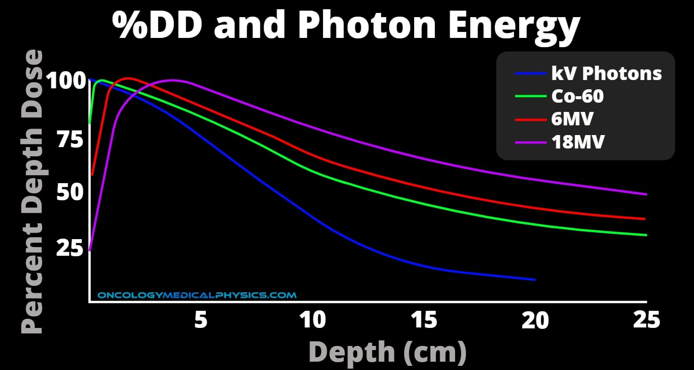

Figure 1‑6. Percent Depth Dose curve for photon beams of different energies. As the photons attenuate through the medium they lose energy to electrons, which in turn lose energy through various interactions. A buildup region is seen for high energy photons before the maximum relative dose is reached. The same effect is not seen for photons of kV energy (Photon Dose Distributions | Oncology Medical Physics, n.d.).

#### CSDA

If we assume that the electrons are continuously slowing down (i.e., neglecting fluctuations in energy loss) as they interact, we can integrate total mass stopping power to get an approximate range called the continuously slowing down approximation (CSDA) range

$$R_{CSDA}=\int_{0}^{T_{max}}{\frac{dT_{c+r}}{ρdx}} \left[\frac{g}{cm^{2}}\right] .$$

This lets us describe the path of secondary charged particles following an ionization event. It is different to **projected range**, as it describes the total range of the particle including all twists and turns. Projectedrange is a measure of how deep into the medium the particle penetrates (Attix, 1986, p.181).

## Creating the radiation beam

When treating or diagnosing patients using radiation, you need a stable and reliable beam. Various techniques are used for this purpose, but for our case we will focus on the X-ray tube.

### X-ray tube

The X-ray tube’s purpose is to convert electron energy into X-rays. As mentioned in 1.1.2 we have two interaction types generating X-rays from electrons interacting with matter. The first is characteristic X-rays generated after ionization of an inner-shell electron and the second is generation of bremsstrahlung from deacceleration of electrons traversing close to the atomic nucleus. In Figure 1‑7 we see an illustration of the tube. The first component of the X-ray tube is the cathode, which is a spiraled wire called the filament. The filament is often placed inside a glass chamber called the envelope (Nadrljanski, 2021b). The filament is heated through resistance heating of a wire running through the cathode (Goel, 2021a). When the cathode reaches the right temperature, it will emit electrons through thermionic emission. A process where the heating energy surpasses the binding energy of electrons, and they are emitted from the metallic structure (*Thermionic Emission | Physics | Britannica*, 2021). The electrons are released into an evacuated tube with a high voltage. The potential difference accelerates the electrons toward a positively charged anode/target. Most anodes in x-ray tube targets are made of tungsten, because of their high atomic number and high melting point (Nadrljanski, 2021a).

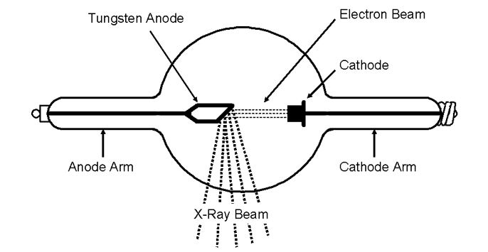

Figure 1‑7. Coolidge hot cathode X-ray tube with heated cathode, that releases electrons into vacuum sealed tube with potential difference $dV$ causing acceleration of the electrons. The electrons are focused using a magnetic lens before hitting a target of high density material image ref. (Aksnes, 2020).

The electrons generate bremsstrahlung at different impact parameters (see 1.1.2), we therefore get a spectrum of possible X-ray energies, which is decided by Kramer’s rule. The essence of this rule is that when electrons hit a thick target the probability of direct impact with the nucleus, i.e., the impact parameter (see 1.1.2) is 0, is small. It is more probable that the electron experiences many smaller energy transfers and gradually deaccelerates, creating X-rays with less energy (Attix, 1986, p.211-214). X-ray tubes usually produce photon energies between 20 and 100 kV (Potts, 2005). The intensity of the beam follows the inverse square law where intensity decreases with the square of the distance away from the source following the equation (Attix, 1986, p.44)

$$I=α/r^{2} ,$$

where $α$ is a proportionality constant.

### X-ray filtering

It is often desirable to remove the smaller X-ray energies from the X-ray beam. This is done by inserting a filter inside the X-ray beam. The filter attenuates lower energy X-rays and creates a more homogeneous energy spectrum (Goel, 2021). Figure 1‑8 illustrates the difference between an unfiltered and filtered X-ray beam created in an X-ray tube with tungsten as target. The first peak is the low energy photons such as background radiation, the second and third peak is X-rays emitted after ionization of K-shell electrons (Amiri et al., 2021).

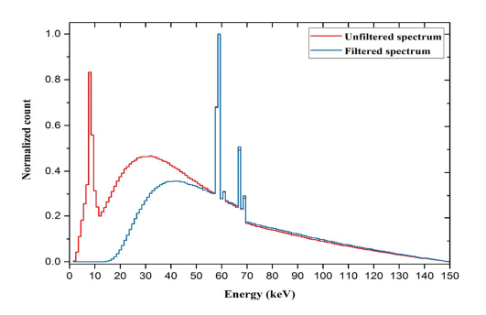

Figure 1‑8. Unfiltered vs filtered X-ray energy spectrum created from a Tungsten anode with 2.5 mm aluminum filtering (Amiri et al., 2021).

## Dosimetry

Taking any medicine requires knowledge about the correct dosage. Medicine is often administered through pills with carefully measured ingredients to give the right effect. Radiation does not have that advantage. Radiation dose is dependent on the energy, exposure time, distance from source, material of the absorber and quality (e.g., photons, protons or neutrons) of the radiation.   
The solution has been to use the effects of radiation on different substances such as discoloring (film dosimeter), temperature change (calorimeter) and light emission (thermoluminescence). To understand all the intricacies of dose measurement we need to define important quantities.

### Quantities

#### Ionizing radiation field

We wish to find number of ionizations in a point P inside a field of ionizing radiation. A ray cannot interact with a 0-dimensional point, we therefore define a finite area $a$ around the point. The incident angle of the ray might not be parallel to the area $a$, we therefore need to account for all possible angles. This results in a sphere around P as seen in **Error! Reference source not found.** with infinitesimal volume dV, mass dm and cross-sectional area da (Attix, 1986, p.5-6).   
The number of traversing rays per cross sectional area da is defined as **fluence $Φ$** .

$$Φ=\frac{dN}{da}$$

If the number of rays differs over time, the fluence needs to be integrated over time to get the fluence rate.   
The radiant energy of the rays is equally as important as the number of rays, for a polyenergetic beam with energies E, we have **energy fluence $Ψ$**  **.**

$$Ψ=\frac{d^{2}N\left(E\right)}{dadE}=\frac{dΦ\left(E\right)}{dE}$$

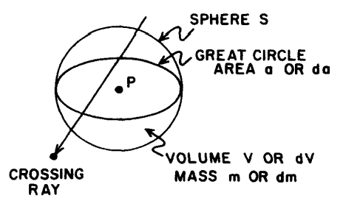

Figure 1‑9. Ionizing radiation field defined as a sphere encapsulation a point P with infinitesimal volume dV, mass dm, with a cross sectional area da (Attix, 1986, p.6).

#### KERMA

With the energy fluence we have the energies traversing the sphere, but to get a dose we need the rays to interact and release energy. This is where KERMA comes in. Kinetic Energy Release per Mass. It describes the process where uncharged particles (photons and neutrons) enters a defined volume and transfers some or all of their energy to electrons in the volume. The energy transfer is expressed by

|  |  |
| --- | --- |
| $$ϵ_{tr}=E_{γ,in}-E_{γ-rl,out}+∑Q ,$$ | 1‑8 |

Where $ϵ_{tr}$ is the expected energy transferred from uncharged radiation with energy $E_{γ,in}$ into the volume minus the energy of the uncharged radiation $E_{γ-rl,out}$ leaving the volume without interacting.   
RL stands for radiative losses and represents interactions where charged particles generate photon energy after the initial ionization. If these photons leave the volume, it does not matter because we are only interested in the energy transferred by the incident particles entering the volume.  
The final term is conversion of rest mass to energy or energy to rest mass e.g., pair production (see 1.1.1) where a photon annihilates creating an electron positron pair.   
With $ϵ_{tr}$ we can define KERMA

|  |  |
| --- | --- |
| $$K=\frac{dϵ_{tr}}{dm} \left[\frac{J}{kg}\right]$$ | 1‑9 |

For monoenergetic photons, KERMA is related to energy fluence using the expression

$$K=Ψ\frac{μ_{tr}}{ρ} ,$$

Where $μ_{tr}/ρ$ is the mass energy transfer coefficient (see 1.1.1), which represents the probability of the photons transferring energy to the volume (Attix, 1986, p. 21-22).

Until now, we’ve neglected how the electrons have spent their energy after they’ve received it from the incident photons. Accounting for radiative loss gives net energy transfer $ϵ_{tr}^{n}$ represented by this expression

$$ϵ_{tr}^{n}=E_{γ,in}-E_{γ,out}+ΣQ.$$

$ϵ_{tr}^{n}$ represents the energy of the electrons, not lost to radiative transfer. We can now separate KERMA into two parts: collision KERMA $K_{c}$ and radiative KERMA $K_{r}$, where $K_{c}$ for monoenergetic photons is expressed as

$$K_{c}=\frac{dϵ_{tr}^{n}}{dm} .$$

We can relate $K_{c}$ and energy fluence to another known quantity: mass energy-absorption coefficient $μ_{en}/ρ$ (see 1.1.1) (Attix, 1986, p.24-25)

$$K_{c}=Ψ\frac{μ_{en}}{ρ} .$$

#### Absorbed dose

When describing KERMA, we are interested in how energy is transferred from the photon to the medium. But photons aren’t the only contributors to dose; charged particles also transfer energy to the volume. We therefore define total energy transfer as

$$ϵ=E_{e,in}+E_{γ,in}-E_{e,out}-E_{γ,out}+ΣQ$$

Where we include the energy transferred by charged particles $E_{e}$ entering the volume.   
We can now define dose as (Attix, 1986, p.26-27)

$$D=\frac{dϵ}{dm} [J/kg].$$

The unit is the same as KERMA, but it is called Gray or Gy. The unit is especially important in radiobiology, because the amount of absorbed energy affect an organism’s chance of repairing the damage caused by the radiation (see 1.7.3).

#### Exposure

Exposure is defined as total charge Q of ions of one sign (+ or -) produced by X-rays or $γ$-rays per mass m of air when all secondary electrons are stopped in the air and charged particle equilibrium (see next paragraph) is achieved (Attix, 1986, p.29-30). The expression for exposure in an infinitesimal air volume is

|  |  |
| --- | --- |
| $$X=\frac{dQ}{dm} [C/kg].$$ | 1‑10 |

We can relate exposure to mass energy absorption coefficient ($μ_{en}/ρ$) and energy fluence $Ψ$ by introducing the variable $\overline{W}$. $\overline{W}$ is the mean energy required to create an ion pairs (Podgorsak, 2016, p. 744). The resulting expression for monoenergetic photons is

|  |  |
| --- | --- |
| $$X=Ψ {\left(\frac{μ_{en}}{ρ}\right)}_{air}{\left(\frac{e}{\overline{W}}\right)}_{air}=K_{c} {\left(\frac{e}{\overline{W}}\right)}_{air}.$$ | 1‑11 |

$e$ is the elementary charge.

#### Charged Particle Equilibrium (CPE)

If $E_{e,in}=E_{e,out}$ the energy distribution of charged particles entering the volume is equal to the energy distribution of charged particles leaving the volume (visualized in Figure 1‑10) (Attix, 1986, p.65). This situation is called **charged particle equilibrium** (CPE), and if satisfied,  
reduces absorbed dose to $K_{c}$ (Attix, 1986, p.69).

|  |  |
| --- | --- |
| $$D=K_{c}=Ψ\frac{{ μ}_{en}}{ρ} .$$ | 1‑12 |

CPE essentially demands constant photon fluence everywhere around and within the smaller volume v in Figure 1‑10. If the fluence dropped significantly when entering the large volume V, more secondary electrons would be generated at the entrance of v, compared to the exit and we don’t have CPE (Attix, 1986, p.67).

When CPE is achieved, we can easily find the dose ratio between two volumes. This is a practical metric because we often need to relate dose to mediums of different densities.   
CPE is not necessarily easy to achieve. If the volumes are near the source, we’ll have much higher fluence on the side closest to the source (Attix, 1986, p.72). This causes more ionizations closer to the surface of V, compared to the surface of v, and CPE fails.   
For larger photon energies, the range of the liberated charged particles will increase compared to the range of the photons. Therefore, charged particles ionized near the surface of V have larger ranges than the charged particles ionized near the surface of v. The generated charged particles will therefore enter volume v but doesn’t exit, and CPE fails.

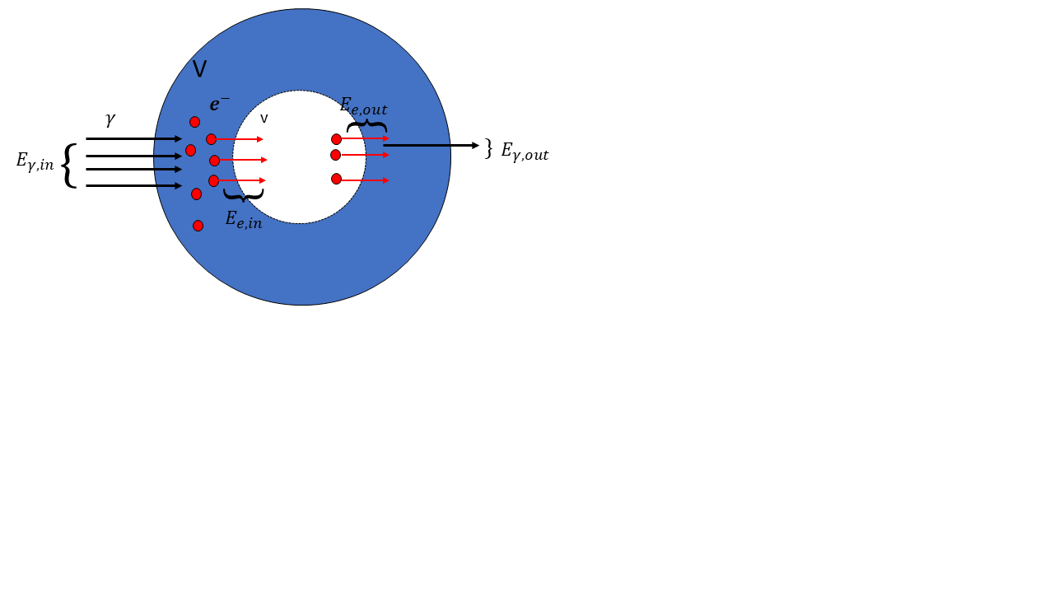

Figure 1‑10. Charged particle equilibrium visualized, where photon energy enters a volume $V$ transferring energy to charged particles (electrons in this case), that traverses a smaller volume $v$. The electrons exiting $v$ are of same type and energy distribution as the electrons entering, and we have CPE.

**Transient Charged Particle Equilibrium (TCPE)**

CPE demands no significant attenuation of photons within the smaller volume in Figure 1‑10. As mentioned, this would require an infinitesimal small volume. A more realistic approach is that the photons ionize electrons inside the smaller volume. As the photons traverse, they lose energy, causing a decrease in dose contribution. Instead of dose being equal to $K_{c}$ we assume proportionality, and the expression for dose becomes

$$D=K_{c}(1+f) ,$$

where f is the dose contribution from attenuation of photons through the volume.

## Cavity Theory

When measuring dose, we use a dosimeter. A very popular dosimeter is the ionization chamber, which we’ll discuss in detail (1.5). A more fundamental description of an ion chamber is a gas filled chamber connected to an electrometer. Radiation ionizes the gas, and the electrometer measures a charge proportional to absorbed dose.   
However, dose (a.k.a., energy absorbed in the medium) is not equal between mediums of different density. We therefore need to relate the dose absorbed by the gas to the medium we are interested in. The situation is visualized in Figure 1‑11.

### Bragg-Gray cavity

In Bragg-Gray cavity theory, dose to water is related to dose to air by

$$D_{W}=D_{Air}⋅{\left(\frac{S}{ρ}\right)}_{air}^{w} ,$$

where ${\left(\frac{S}{ρ}\right)}_{w}^{air}$ is the mass stopping power ratio between water and air. Dose to water is often used because radiation beams in the clinic are calibrated with the assumption that all tissue is “water-like” (Andreo, 2015). We see that the electron fluence is assumed constant, but for this to be true two conditions needs to be fulfilled (Attix, 1986, p. 232):

1. The fluence of charged particles should not be perturbed in the cavity
2. Only charged particles crossing the cavity contributes to the dose.

The second condition requires no significant attenuation of photons inside the cavity. Which in turn requires an infinitesimally dimensioned cavity. Gray calculated the size that satisfies these conditions and found that for unfiltered $γ$-radiation you would need a $3 cm^{3}$ air volume, while $100 kV$ X-rays require $0.1 cm^{3}$ for air filled cavity with graphite walls (Alm Carlsson, 2001).

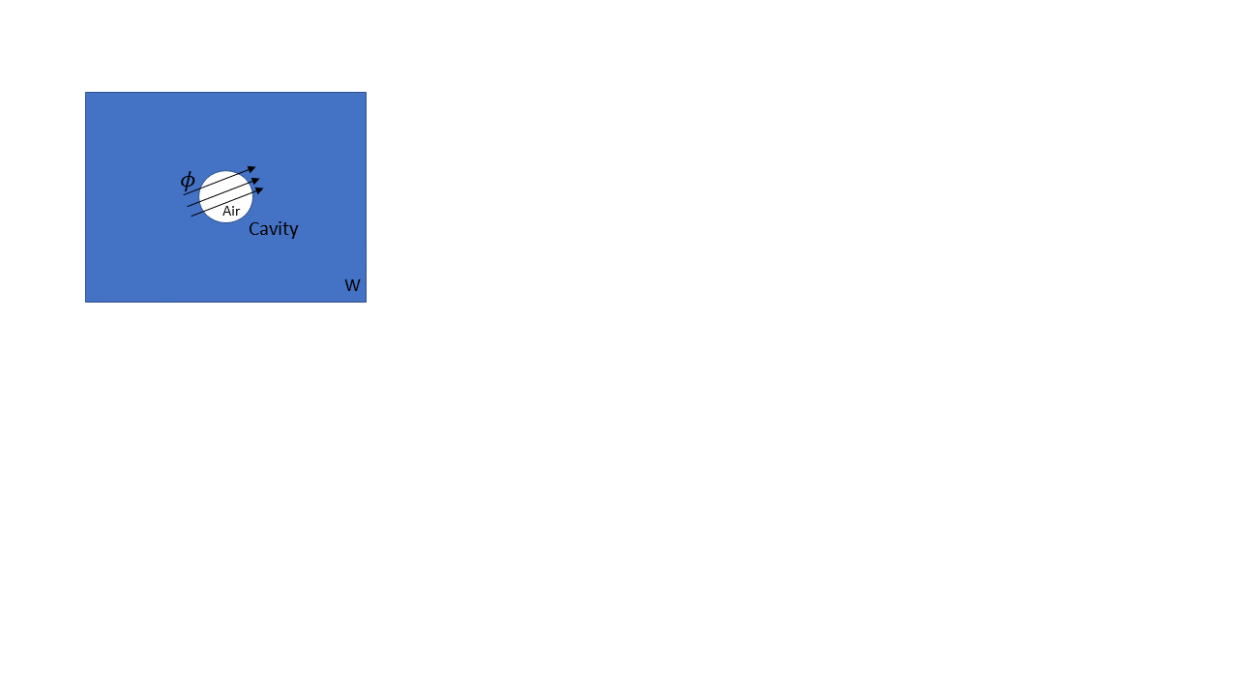

Figure 1‑11. A volume with material w (e.g., water), with an air-filled cavity inside. Energy $Ψ$ traverses the volume releasing energy contributing to dose inside the cavity.

### Bragg-Gray-Laurence

The ideal Bragg-Gray scenario is not possible, as it would require an infinitesimally dimensioned dosimeter not to alter the charged particle fluence. It also demands the stopping power ratio ${\left(\frac{S}{ρ}\right)}_{W}^{Air}$ to be independent on energy, which is not the case for increasingly different mediums (Alm Carlsson, 2002). The theory was improved by introducing CSDA of the charged particles. This allows the charged particles to slow down inside the cavity, and we need to integrate over the stopping power ratio

$$\frac{D_{w}}{D_{air}}= \int_{0}^{T_{max}}{\frac{ϕ\left(T\right){\left(\frac{S}{ρ}\right)}_{w}}{{ϕ\left(T\right)\left(\frac{S}{ρ}\right)}_{air}} dT . }$$

Bragg-Gray-Laurence in its simplest form requires CPE to accurately calculate the energy distribution of the electrons (Alm Carlsson, 2001). It might seem like a contradiction to incorporate CSDA, because CPE requires the energy of entering charged particles to be equal to the energy of the exiting charged particles. However, the cavity is still assumed to be small compared to the charged particle range and the energy loss inside the cavity is negligible. And because of the small size of the cavity, even small energy transfers will result in a significant dose.

The Bragg-Gray-Laurence cavity theory does not account for secondary electrons ($δ$-rays) generated inside the cavity. The **Spencer-Attix** cavity theory accounts for these electrons, and sets a cutoff energy $Δ$, where all $δ$-rays with energy higher than $Δ$ escapes the cavity. As a result, more low energy electrons are added to the fluence.

### Burlin

All previous cavity theories concern small cavities. Burlin cavity theory tries to make a general theory for small, intermediate and large cavities (Attix, 1986, p.248). Looking at Figure 1‑12, we see that the dose contribution from charged particles generated inside the cavity g outweighs the dose contribution from charged particles generated in w. The dose is therefore collision KERMA ratio $D_{air}=D_{w}{\left(\frac{μ_{en}}{ρ}\right)}_{w}^{air}$.   
For intermediate sized cavities we have a mix of charged particles that are generated inside and outside the cavity. We also have charged particles that are either stopped inside the cavity or they escape.

The expression for dose ratio using the same air-water example

|  |  |
| --- | --- |
| $$\frac{D_{air}}{D_{w}}=d{\left(\frac{S}{ρ}\right)}_{w}^{air}+\left(1-d\right){\left(\frac{μ_{en}}{ρ}\right)}_{w}^{air} ,$$ | 1‑13 |

where d is a factor that becomes 0 for large cavities and 1 for small cavities.

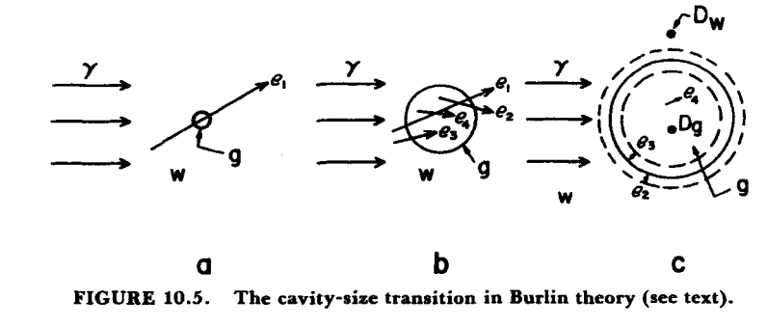

Figure 1‑12. From left to right we see increasing cavity sizes, where dose contribution differs. W is the medium surrounding the cavity, g is the medium of the cavity. e is charged particles released in either w or g and $γ$ is incoming photons. Burlin cavity is a general cavity theory which includes small, intermediate and large cavity sizes.

## Dosimetry methods

As mentioned in 1.3 different techniques are used for dose measuring. However, this thesis will focus on three different dosimeters: Ionization chamber, Gafchromic film and Alanine EPR (Electron Paramagnetic Resonance) dosimeter. These dosimeters fall into one of two categories: Absolute and relative dosimeters. The volume of an absolute dosimeter responds to radiation in such a way, that we are able to directly measure the received dose and does not require calibration in a known radiation field (Attix, 1986, p. 277). E.g., a free-air ionization chamber is an ionization chamber without walls, where the goal is to measure exposure (1.3.1) in a known mass of air. However, for photon energies surpassing 1.5 MeV the secondary electrons have such a large range, that the free-air ionization chamber cannot fulfill CPE without becoming unpractically large (Podgorsak, 2016, p. 737). The ionization chambers we’ll discuss here are relative dosimeters.

### Parallel- Plate Ionization Chamber

The purpose of an ionization chamber is measuring ionizations inside a gas-filled cavity. A fundamental type of ionization chamber is the parallel plate chamber illustrated in Figure 1‑13  
The chamber is connected to a polarizing (negative cathode) and measuring electrode (positive anode). The polarizing electrode is directly connected to the power supply and creates the voltage difference, which in turn generates an electric field. Adjacent to the measuring electrode you have the guarding ring/electrode with the purpose of preventing leaking current from being measured by the electrometer (Podgorsak, 2016, p. 702). Looking at Figure 1‑13 you see that the electrometer is connected to the power supply. Ideally the impedance (a circuit’s opposition to charge) inside the electrometer is high enough (typically ${10}^{14} Ω$) and no charge moves through it (*High Accuracy Electrometers for Low Current/High Resistance Applications | Tektronix*, n.d.). However, some leakage will occur, and the guard rings are there to prevent this from being measured. The second purpose is to help define the effective collection volume of the chamber (see 1.5.2), by ensuring straight electric field lines (Podgorsak, 2016, p.703).

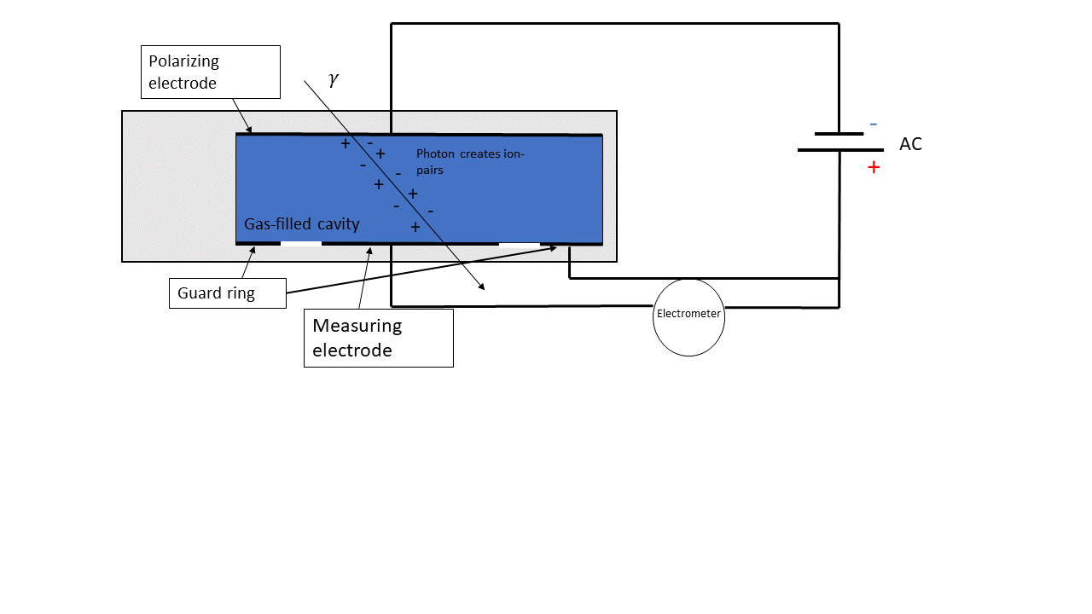When the electrons are ionized one of two things may happen: If the cavity is filled with electronegative gas with high electron affinity, the electrons will bind to the gas to create an ion. The ion will move toward the positively charged plate and the charge is “collected” by a measuring electrode connected to the electrometer. If the cavity does not have electronegative gas the ionized electrons moves directly to the measuring electrode (Podgorsak, 2016, p.705). The electrometer measures the accumulated charge, which is converted to dose.   
If the applied voltage is too low the negative ion will tend to recombine with the positive ion. The solution is increasing the voltage until the measured current is no longer dependent on voltage, this is called the saturation region (Attix, 1986, p.330-331). The measured output in this region is known as the saturation charge, or $Q_{sat}$.

Figure 1‑13. The schematics of a parallel plate ionization chambers. An electric field is established on the gas-filled cavity, so when the gas is ionized electrons will move toward the positively charged side, where they are collected by a measuring electrode connected to an electrometer.

### Thimble Ionization Chamber

In Figure 1‑14 we see a thimble (a.k.a. farmer type) ionization chamber. The chamber differs from the parallel-plate type by having a graphite thimble surrounding the gas-filled cavity. The graphite is chosen because it protects the sensitive volume and it is air equivalent, therefore minimizing the density difference between cavity and wall. This achieves charged particle equilibrium (Shortt et al., 2002). The protection cap is not shown in Figure 1‑14 but surrounds the wall and ensures that we are passed the buildup region when the secondary electrons reach the wall and the cavity (see 1.1.2.4). The chamber has a central electrode connected to the electrometer.   
In a thimble ionization chamber, we want to find the exposure (see 1.3.1) to measure absorbed dose in the sensitive volume. Rearranging equation 1‑11 we see that collision KERMA might be written as

$$K_{c}= X\left(\frac{\overline{W}}{e}\right) .$$

From equation 1‑10 we have the expression for exposure. Replacing the infinitesimal $dQ/dm$ with the saturated charge $Q_{sat}$ and total air mass $m_{air}$, we get collision KERMA for air

$$K_{air}=\frac{Q_{sat}}{m_{air}} \left(\overline{\frac{W}{e}}\right) .$$

CPE is achieved in a thimble ionization chamber, so absorbed dose can be found using equation 1‑12. But the challenge arises when finding $m_{air}$. $m_{air}$ is found using the effective volume, which is not necessarily the same as the geometrical volume of the chamber. The effective volume is defined by the electric field lines running from polarizing electrode to measuring electrode (Podgorsak, 2016, p.745). The field lines tend to bend outward away from the center, and this affects the fate of the ionized electron, thereby affecting the effective volume where electrons can be collected.   
To ensure most accurate dose measuring, a primary standards laboratory is given the job of calibrating the ionization chamber and finding its effective volume.

The calibration of a thimble ionization chamber is performed by measuring exposure $X$ using a free-air chamber, then replacing it with a thimble chamber and measure the air KERMA $K_{air}$. The measurements are performed under specific reference conditions such as temperature, air pressure and humidity, using a reference beam energy and quality (typically 60Co photons). From this we get a calibration factor $N_{k}$ that relates output in nC to dose Gy (Podgorsak, 2016, p.744). The thimble chamber is then inserted into a water phantom, still in the known radiation field, where the $K_{air}$ is measured again and converted to dose to undisturbed water (as if the ionization chamber wasn’t present) using a conversion factor and correction factors ) (P.Andreo et al., 1996, p.48).

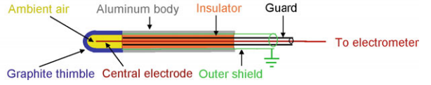

Figure 1‑14. Schematic of thimble ionization chamber, where the sensitive air-filled volume is encapsulated in a thimble (Podgorsak, 2016, p. 741).

### Radiochromic film

(ikke ferdig, why does film response vary with batch)

Radiochromic film is a self-developing film, which reacts when exposed to radiation (McLaughlin & Chalkley, 1965). The film is typically made ­up of a protective layer and an active layer (see Figure 1‑15**.**). The active layer consists of one or two layers of monomers called diacetylene. Monomers are molecules that interact with other monomer molecules to create polymer chains (*Monomer | Definition & Facts | Britannica*, 2022). When diacetylene is exposed to radiation it polymerizes to create polydiacetylene, changing both the chemical and optical characteristic of the active layer (McLaughlin et al., 1996).   
The color of the film darkens and optical density (OD) can be measured either by measuring light transmitted through the film, or light reflected by the film (Andreo et al., 2017, 562). Extracting absolute dose from the films requires an established relationship between the film response and absorbed dose, which demands calibrating the films and accounting for factors that might change the response, such as time waited after irradiation before scanning the films, temperature, and light exposure (Girard et al., 2012; Park et al., 2012). New calibrations are necessary for every new batch, because of batch-to-batch variation (Mizuno et al., 2012).

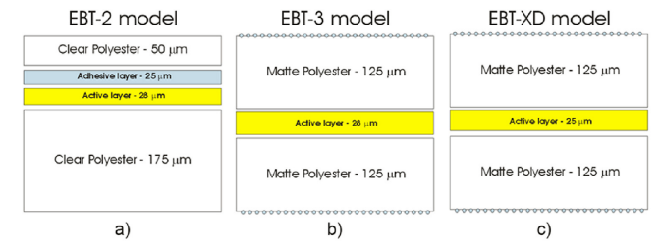

Figure 1‑15. Different radiochromic film structures used for external beam therapy (EBT) (Devic et al., 2016). The active layer is made from monomers that polymerize when exposed to radiation, causing a darkening of the film. The optical density (OD) is measured and related to dose.

## Statistics

### Non-linear curve fit

Regression is a tool used for predicting data. In traditional linear regression you have a dataset containing m response/dependent variables $y$ and n explanatory/independent values $x$. Linear regression tries to find the optimal coefficients/parameters $\hat{β}$, to fit the equation

|  |  |
| --- | --- |
| $${\hat{y}}_{i} =β_{0}+β_{1}x_{0}+β_{2}x_{1}+…+β_{n}x_{n} ,$$ | 1‑14 |

using the method of least squares. I.e., find the line that minimizes deviation between the true response variables $y_{i}$ and the predicted values ${\hat{y}}_{i}$ . $β^{T}=[β_{0}, β_{1}…, β_{n}]$ represents the true coefficients, that explain the model perfectly. The linear regression assumes standard normal distributed errors ($μ=0, σ=1$) and does not account for measurement error in $x$ itself, which might lead to the coefficients being biased towards zero (Griliches & Ringstad, 1970). However, accounting for this is beyond the scope of this thesis. The deviation is defined as the cost function, and both linear and nonlinear regression uses the sum of squared residuals (RSS)

|  |  |
| --- | --- |
| $$\sum_{i=0}^{n}{{\left(\frac{y_{i}-{\hat{y}}_{i}(x_{i})}{σ_{y,i}}\right)}^{2}} ,$$ where $σ_{y,i}$ is the individual weight of the ith residual, which is used when the assumption of approximately equal residual for every ${\hat{y}}_{i}$ is not satisfied (Kirkup, 2012, p.226-232). | 1‑15 |

For linear regression, one can find differentiate the RSS w.r.t. both coefficients $β_{0}$ and $β_{1}$ and find a closed form expression for both coefficients (Bingham & Fry, 2010, p.3-5).   
Not all response variables are linearly dependent on the explanatory variable, which might lead to the ${\hat{y}}_{i}$ expression in RSS not having a closed form solution when differentiated. The solution is to guess the values of the unknown coefficients, then iteratively tune them to find the minimum RSS (Kirkup, 2012, p.335-337).

#### Levenberg-Marquardt algorithm

*This section is based on (Gavin, 2020)*.  
Levenber-Marquardt algorithm (LM) combines two minimization methods known as the Gradient descent (GD) and the Gaussian-Newton (GN) method. **GD** uses the derivative of the RSS to update the parameters towards the steepest descent towards the minimum of RSS. For all n parameters $p^{T}=[p_{0},p_{1}, …, p_{n}]$ we have a weighted RSS of

|  |  |
| --- | --- |
| $${\left(y(x)-\hat{y}\left(x;p\right)\right)}^{T}W\left(y(x)- \hat{y}\left(x;p\right)\right) ,$$ | 1‑16 |

$W$ is a diagonal matrix with shape m x m for m datapoints, with all the weights on the diagonal.   
Using the second binomial formula we remove the parentheses and get

|  |  |
| --- | --- |
| $$y^{T}Wy-2y^{T}W\hat{y}+ {\hat{y}}^{T}W\hat{y}$$ | 1‑17 |

Differentiating the RSS w.r.t. all parameters we get

$$-2 {\left(y-\hat{y}\right)}^{T}WJ ,$$

where $J$ is the m x n jacobian matrix containing the partial derivatives of $∂\hat{y}/∂p$, 2 comes from the fact that RSS is squared, and the minus sign is from $-\hat{y}(x;p)$. The partial derivatives $∂y/∂p$ becomes 0 because $y$ does not vary with changing parameters.

Rearranging the expression using the fact that $W$ is symmetrical, the theorem ${\left(AB\right)}^{T}=B^{T}A^{T}$ and introducing a constant $α$ we get the value $h$ that updates the parameters in the direction of steepest descent

$$h_{GD}=αJ^{T}W\left(y-\hat{y}\right).$$

$α$ is chosen and decides how fast we are moving. Choosing an $α$ too large we risk passing the minimum but choosing one too small we might never reach the minimum.

**GN** is an expansion of the Newton’s method (Cavazzuti, 2013, p.85). Newton’s method assumes that the RSS function is quadratic near the minimum. This is reasonable because if the RSS function has a minimum, the value will sink to the minimum then increase when passing the minimum like a quadratic function. The quadratic function around the minimum is Taylor expanded and becomes

$$\hat{y}\left(p+h\right)≈ \hat{y}+Jh .$$

Inserting the approximation for $\hat{y}$ into the RSS in equation 1‑17, we get

$$y^{T}Wy-2y^{T}W\left(\hat{y}+Jh\right)+{\left(\hat{y}+Jh\right)}^{T}W\left(\hat{y}+Jh\right) .$$

Again, using the second binomial formula and the theorem ${\left(AB\right)}^{T}=B^{T}A^{T}$ we get

|  |  |
| --- | --- |
| $$y^{T}Wy+{\hat{y}}^{T}W\hat{y}-2y^{T}W\hat{y}-2{\left(y-\hat{y}\right)}^{T}WJh+h^{T}J^{T}WJh .$$ | 1‑18 |

Newton’s method differs compared to GD, because it also accounts for the curvature of the RSS function. We therefore differentiate equation 1‑18 w.r.t. $h$ to find the one that minimizes RSS. As mentioned, $J$ is the jacobian and differentiating $J$ w.r.t. $h$ we get a matrix called the hessian matrix. It can be written as the sum (Chen, 2011)

$$\sum_{i=0}^{m}{\left(\frac{∂{RSS}_{i}}{∂p_{j}}\frac{∂{RSS}_{i}}{∂h_{k}} +{\hat{y}}_{i}\frac{{∂^{2}RSS}_{i}}{∂p_{j}∂h_{k}} \right)1/σ_{y,i} } .$$

In the GN method the second derivative term is assumed to be 0. Going back to matrix notation we are left with

|  |  |
| --- | --- |
| $$J^{T}WJ .$$ | 1‑19 |

This results in the derivative becoming

|  |  |
| --- | --- |
| $$-2{\left(y-\hat{y}\right)}^{T}WJ+2h^{T}J^{T}WJ .$$ | 1‑20 |

Setting equation 1‑20 equal to 0 and rearranging using the same theorem from before we get

$$J^{T}WJ h_{GN}=J^{T}W(y-\hat{y})$$

The **LM** method introduces a dampening link $λ$, which is scaled according to the diagonal elements of the hessian matrix

$${(J}^{T}WJ+λ diag(J^{T}WJ) ) h_{LM}=J^{T}W\left(y-\hat{y}\right) .$$

The dampening factor punishes updated parameters that does not contribute to reduced RSS by increasing $λ$, and encourage updated parameters that reduce RSS by decreasing $λ$. The result is a method that acts as GD far from the minimum but becomes GN when approaching the minimum.

### Poisson Regression

Poisson regression is a way of predicting discrete count data. It is like linear regression (see 1.6.1) in that it tries to fit a model to data, but the method is different.   
In Poisson regression you assume that your $m x 1$ response variables in $y^{T}=[y_{0}, y_{1}, …, y_{m}]$ are Poisson distributed. I.e., it follows the probability mass function (PMF) (Cameron & Trivedi, 2013a, p.3)

$$P\left(y_{i}\right)=\frac{e^{-λ}λ^{y_{i}}}{y_{i}!} ,$$

where it finds the probability of getting $y_{i}$ counts when mean and variance is both equal $λ$. Poisson regression treats each count as an independent Poisson random variable, where it estimates $λ_{i}$ for every $y_{i}$ in using the linear model with a set of $m x n$ regressors in $X$ and estimated $n x 1$ coefficients in $β$ (Cameron & Trivedi, 2013a, p.10)

|  |  |
| --- | --- |
|  | 1‑21 |

where $x_{i,j}$ is the $j^{th}$ of a total of $n$ regressors for the $i^{th}$ datapoint. However, a problem arises if the combination of regressors and coefficients sums to a negative number. The mean counts cannot be negative, we therefore use the natural log of $λ_{i}$

|  |  |
| --- | --- |
| $$\log{λ_{i}=\sum_{j=0}^{n}{x_{j,i}β_{j,i}}→λ_{i}= \exp{\sum_{j=0}^{n}{x_{j,i}β_{j,i}}}}=e^{x_{i}^{T}β}.$$ | 1‑22 |

The estimation of coefficients is done using the maximum likelihood estimator (MLE). The likelihood function describes the joint probability of observing all the data $y$ given a set of parameters $β$ represented by

$$L\left(\hat{β}\right)= \prod_{j=0}^{n}{P\left(y_{i} | β\right) }= \prod_{j=0}^{n}{\frac{\exp\left(-λ_{i}\right){λ_{i}}^{y_{i}}}{y_{i}!} },$$

now inserting the expression for $\log{λ_{i}}$ from equation 1‑21 we get

$$\prod_{j=0}^{n}{\frac{\exp\left(-e^{x_{i}^{T}β}\right){e^{x_{i}^{T}β}}^{y_{i}} }{y_{i}!} }$$

It is important to note that the datapoints are assumed independent, which allows us to use the fact that $P\left(A∩B\right)=P\left(A\right)⋅P(B)$. Using the log-likelihood allows us to compute the sum instead (Cameron & Trivedi, 2013b, p.23)

$$\log{L\left(β\right)= \sum_{j=0}^{n}{-e^{x_{i}^{T}\hat{β}}+{y_{i}x}_{i}^{T}β-\log{y_{i}!} .}}$$

Differentiating w.r.t. $β$ and setting the expression equal to zero we get

$$\sum_{j=0}^{n}{\left(y_{i}-e^{x_{i}^{T}β}\right)x_{i} =0 . }$$

We want to minimize the difference between $y_{i}$ and $e^{x_{i}^{T}β}$ to maximize the log-likelihood $\log{L (β)}$. The equation does not have a closed form solution and an iteration method is needed to find the best fitting set of parameters $\hat{β}$. Methods such as the ones described in 1.6.1 can be used.

### Confidence interval

A confidence interval for e.g., 95% confidence claims that the true population mean will be within the limits of the confidence interval 95% of the times a sample mean is measured (James et al., 2013, p.66). For a general mean value $\overline{X}$ with unknown population mean, the confidence interval is found using the formula

$$\overline{X }±t_{crit}σ_{\overline{X}}=t_{crit}\frac{σ}{\sqrt{n}} ,$$

if the t distribution has a mean of $μ$, then $t_{crit}$ is the number of standard deviations out from $μ$ in both directions that encapsulates the allowed variations of $μ$. $σ_{\overline{X}}$ is the standard deviation of the mean $\overline{X}$.

## Radiobiology

Cells are the building blocks of all living things. Animals are made from eukaryotic cells, which contain a nucleus. The purpose of a cell is converting consumed nutrients into energy needed to perform a task. Such tasks might be to provide structure (bone cells, muscle cells), sensory signaling (nerve cells) or transportation (blood cells). These cells are highly specialized and stem from an unspecialized cell (stem cell) that have finished their chain of cell divisions.   
The process of cell division (proliferation) is sensitive and damaged DNA (deoxyribose nucleic acid) might lead to cancer if not repaired.

### DNA basics

DNA or deoxyribose nucleic acid contains the complete genetic information needed to produce necessary proteins. The DNA is made up of two antiparallel strands (3 to 5 and 5 to 3, see further down for explanation) with a nitrogenous base pair connecting the strands (see Figure 1‑17).  
The strands consist of nucleotides, which again is broken into a sugar-phosphate backbone and the DNA nitrogenous base (*Nucleotide | Biochemistry | Britannica*, 2008). There are five bases: Adenine, Guanine, Cytosine, Thymine and Uracil. The first four are in our DNA, and Uracil replaces Thymine in the mRNA (see DNA transcription in *Abbreviations and explanations*). The bases are divided into two categories: Adenine and Guanine are known as pyrimidines, while Cytosine, Thymine and Uracil are purines.   
If three adjacent bases (not base pairs) code for an amino acid (see proteins in Abbreviations and explanations), it’s called a codon. Gene sequences, which includes codons are called exons, but if they do not include codons, they are called introns.   
The bases form hydrogen bonds to create a base pair, but only with dedicated “partners”. Because of the chemical structure adenine only binds with thymine (or Uracil during DNA transcription), while guanine only binds with cytosine (Mason et al., 2020, p.48). The hydrogen bonds are the first of two bonds between nucleotides. The second bond is the phosphodiester bonds between each sugar-phosphate (see Figure 1‑17).

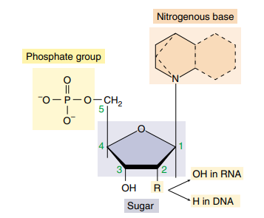Looking at Figure 1‑16 we have a closer look at an individual nucleotide. The carbon atoms in the deoxyribose molecules are marked with numbers 1-5 (Mason et al., 2020, p.47). When a new nucleotide is bound to the existing nucleotide, they can only be connected to the 3 carbon because they are able to chemically interact to create the phosphodiester bond (Mason et al., 2020, p.284).

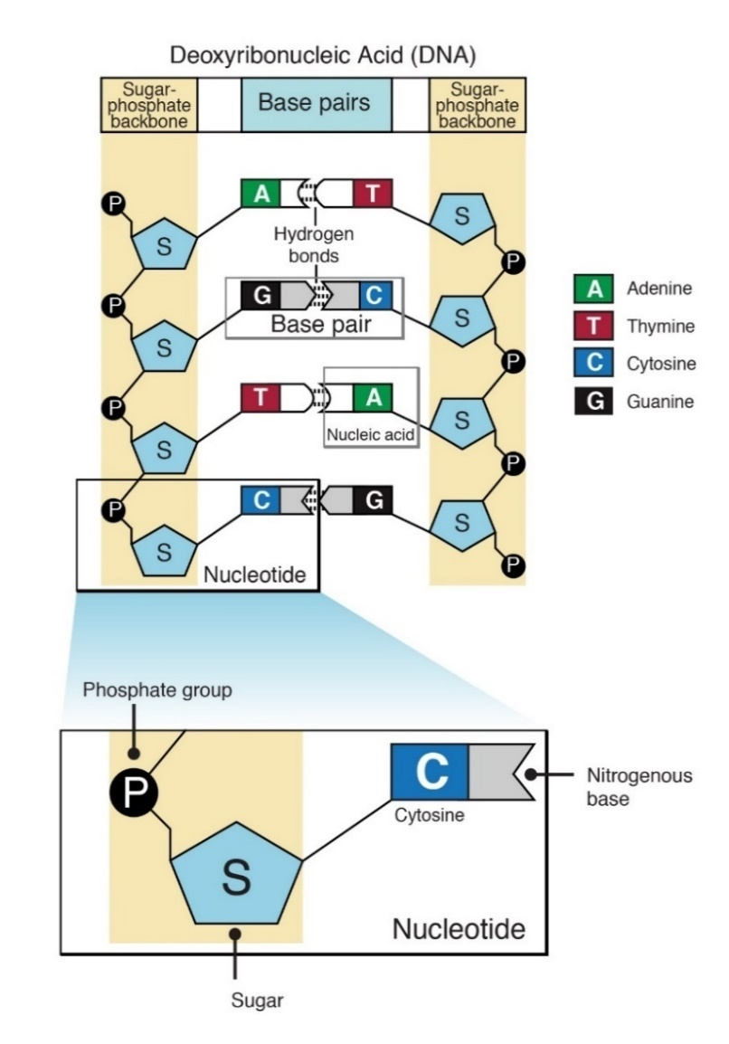

Figure 1‑16. Three molecules making up a nucleotide. The positions of each carbon in the sugar molecule are marked by a number (Mason et al., 2020, p.47).

Figure 1‑17. Schematic of DNA double strand (Nucleotide, n.d.)

The DNA strands are twirled around its own axis to form a DNA double strand helix, then they are coiled around proteins known as histones to form a nucleosome. The nucleosomes are folded to produce fibers called chromatin. When a cell is preparing for cell division, the chromatin is tightly coiled into a supercoil (Mason et al., 2020, p.210). However, during interface (see 1.7.2) the DNA needs to be accessible for DNA replication and DNA transcription (Abbreviations and explanations). Therefore, the chromatin is a dynamic structure that condense and decondense according to the needs of the cell (Alberts et al., 2014, p.193).   
When chromatin is folded it forms a chromosome. The chromosome has a centromere which allows for linkage between chromosomes to create chromosome pairs. When chromosomes are connected, we refer to the individual chromosomes as a sister chromatids (*Centromere | Biology | Britannica*, 2012).

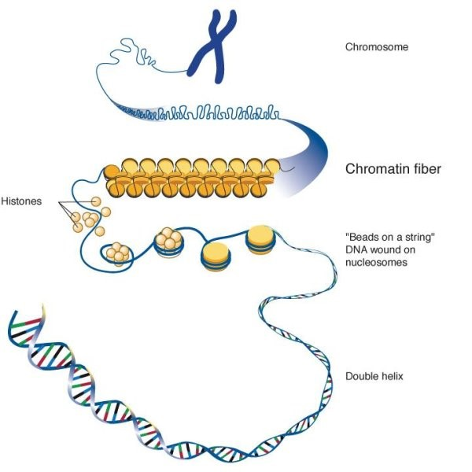

Figure 1‑18. Chromosome structure (The Structure and Function of Chromatin, 2017).

### Cell Cycle and Checkpoint

The cell cycle consists of four phases: G1, S, G2 and M (see Figure 1‑19). G1 and G2 are the gap phases where cell growth occurs. G2 is the last phase before cell division where all organelles, but the DNA, replicates. During S-phase DNA is replicated. This happens by a series of initiator proteins that open the DNA double helix, creating a replication fork (see Figure 1‑20) (Mason et al., 2020, p.293). An enzyme known as helicase separates the strands by disrupting the hydrogen bonds between the base pairs (Matson et al., 1994). Two DNA-polymerase enzymes are recruited to the DNA strands, with the purpose of generating two new complementary DNA strands. DNA-polymerase is only able to continue an existing complementary strand, therefore RNA-primers (Abbreviations and explanations) are created as a starting point for the DNA-polymerase (Mason et al., 2020, p.293). As mentioned in 1.7.1 new nucleotides can only attach to the 3 carbon. Since the two strands are antiparallel, the 5-3 strand is easy enough to replicate because the DNA-polymerase moves in the same direction as the helicase. This strand is known as the leading strand. But the complementary 3-5 strand must be replicated away from the replication fork. Therefore, the DNA-polymerase must jump back and forth, creating smaller bites of a DNA-strands called Okazaki fragments. Then the RNA primers are removed and the bites are glued together by an enzyme called ligase ­­(Mason et al., 2020, p.292). This strand is known as the lagging strand.

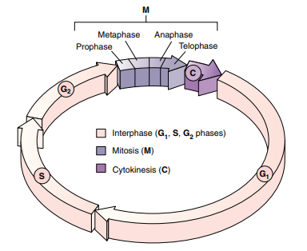

Figure 1‑19. Cell cycle schematic, G1, S and G2 phase is known as interphase, where the cell grows and replicates its organelles to prepare for cell division in Mitosis. In Mitosis the cell separates the chromosomes before the cytoplasm is separated, and we are left with two identical daughter cells (Mason et al., 2020, p.212).

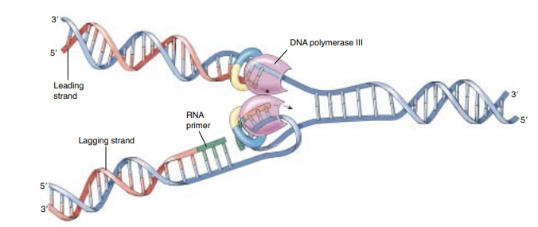

Figure 1‑20. DNA replication schematic, where DNA is opened, and two complementary strands are created. Nucleotides only binds on 3’-OH group, which affects how the DNA-polymerase connects new nucleotides, leading to a leading strand and a lagging strand (Mason et al., 2020)

M-phase is mitosis and the process of separating the replicated chromosomes before the cytoplasm (medium surrounding the organelles of the cell) is separated to create two identical daughter cells. The process is divided into **prophase:** where the chromosomes are condensed, and the mitotic spindle apparatus is assembled. **Metaphase:** where the centromeres of the chromosomes align at the center of the cell. **Anaphase:** centromeres separate and move towards each pole of the cell, splitting the chromosomes. **Telophase:** Then the spindle disassembles, and the daughter cells form individual nuclei (Mason et al., 2020, p.214-216). If the cell’s external environment isn’t favorable the cell might enter a resting phase known as G0, where it’s still able to perform its tasks, but does not prepare for cell division (Mason et al., 2020, p.212).

A cell’s progression through the cell cycle is highly regulated. The three checkpoints G1- G2- and M-checkpoint has the task of controlling that the adjoining phase has had enough time to complete its tasks (Alberts et al., 2014, p.967). If the cells were to enter cytokinesis before completely separating the chromosomes, or if the DNA weren’t replicated correctly before entering Mitosis, it would have disastrous consequences.

One very important enzyme in cell cycle progression (see protein in Abbreviations and explanations) is the cyclin dependent kinase (CDK). cdk’s are inactivated unless bound to another protein called cyclin. There are three main categories of cyclins: G1/S- S- and M- cyclins. Their levels rise and fall as the individual cyclins are needed (Mason et al., 2020, p.219). A cdk bound to a cyclin is called a cdk complex.   
  
For a cell to pass the G1-checkpoint there is a threshold of external and internal signaling levels that needs to be passed, for the cell to enter S-phase. A complex system of positive feedback loops drive the cell over a point called the restriction point (Pardee, 1974). E.g., when enough cdk’s are activated, they will phosphorylate (see Abbreviations and explanations) a protein called Rb (retinoblastoma). If the Rb protein receives two phosphors it will release itself from a protein called E2F, which in turn induce transcription of new cyclins (Alberts et al., 2014, p.1012-1013). E2F also targets a protein on the SCF protein complex, which is important in degradation of the p27 protein, a protein that binds to a cdk complex inhibiting phosphorylation (Yung et al., 2007).

The S-cyclin activated cdk’s phosphorylate proteins, such as activation of DNA helicases responsible for activation of the DNA replication process. The S-cdk is also responsible for the construction of a prereplicative complex (preRC), which ensures that the DNA is only replicated once per cycle (Alberts et al., 2014, p.974).

The G2-checkpoint makes sure that necessary proteins for mitosis are present and that the DNA, as well as all the organelles, has been correctly replicated in S-phase and G2-phase. Both G1- and G2-checkpoints can arrest the cell cycle if DNA-damage is spotted (Studzinski & Danilenko, 2005).

The M-checkpoint is the final checkpoint, and ensures correct separation of chromosomes before cytokinesis (Studzinski & Danilenko, 2005). Another set of positive feedback loops kicks in. A protein called Cdc25 activates M-cdk complexes, which was inactivated by another protein called wee1. These M-cdk complexes begins inhibiting the Wee1 protein, while also induce important events mitotic events (Alberts et al., 2014, p.978).

All checkpoints are controlled by genes that either promote or demote the cell cycle. Cell cycle promoting genes are called proto-oncogenes. If mutated, they become oncogenes and might lead to uncontrolled cell division and cancer (Weinstein, 2002). In the event of oncogene activation, tumor suppressors kick in. Tumor suppressors code for proteins responsible for inhibiting the cdk complexes from operating. Tumor suppressors are also responsible for cell cycle arrest when DNA-damages are detected (Alberts et al., 2014, p.1015), or if DNA-damage is unrepairable it might kill the cell through apoptosis (see Abbreviations and explanations) (Jeffers et al., 2003).

### DNA damage and repair

Ionizing radiation damage the DNA in two ways: Either directly depositing its energy in a biomolecule (see Abbreviations and explanations), or by ionizing molecules surrounding the biomolecules, creating highly reactive radicals that oxidize (loss of electrons) the biomolecules (*RADIATION BIOLOGY: A HANDBOOK FOR TEACHERS AND STUDENTS*, 2010).   
DNA is also damaged without being exposed to ionizing radiation. Especially during DNA replication and building of Okazaki fragments (see 1.7.2). About one mistake is made for every ${10}^{10}$ nucleotide (Alberts et al., 2014, p.242). The mistakes might also be spontaneous such as deamination (cytosine become uracil) and depurination (loss of either Adenine or Guanine) (Cooper, 2000a). Even UV-light might cause adjacent pyrimidines to glue together creating a pyrimidine dimer (Mason et al., 2020, p.364).  
  
The mentioned damages are discontinuities in the DNA strands and might be classified as either single strand breaks (SSB) or double strand breaks (DSB). A single strand break only occurs in one DNA strand. If two breaks happen, one on each strand and close in time and space, they are called double strand breaks (Hall & Giaccia, 2012, p.11).   
Damages might also be classified as sublethal, potentially lethal and lethal. Sublethal damages are not lethal, potentially lethal damages are lethal unless repaired and lethal damages are of course beyond repair.   
The cell has many DNA repair pathways, it can remove deaminated bases through base excision or remove whole nucleotides in a pyrimidine dimer with nucleotide excision repair (Hall & Giaccia, 2012, p.16). However, for more complicated damages like DSB’s, more intricate repair mechanisms are needed.   
  
Nonhomologous end-joining (NHEJ) is a repair mechanism activated in G1. The DNA is yet to be replicated so no sister chromatid is available. The solution is to simply reattach the strands as seen in Figure 1‑21. The result is loss of the damaged nucleotides, which might result in removing important exons (see 1.7.1) (Hall & Giaccia, 2012, p. 18).

Homologous recombination (HR) is another repair mechanism, but it is activated late S/G2 with available sister chromatid. The cell searches for a DNA segment on the unharmed sister chromatid, that is similar or identical to the damaged chromatid. This search is performed by one of the damaged strands by invading an unharmed strand and sampling base sequences. When homology is found DNA-polymerase is recruited to extend the damaged strand. The unharmed strand is released and the newly extended strand is used as a template to fix the other damaged strand (Alberts et al., 2014, p.278-279). Both repair mechanisms are illustrated in Figure 1‑21 . Compared to NHEJ, HR is less efficient, but no DNA is lost during HR (see Figure 1‑21) and DNA is accurately restored (Z. Mao et al., 2008). This underlines the importance of the G2 checkpoint.

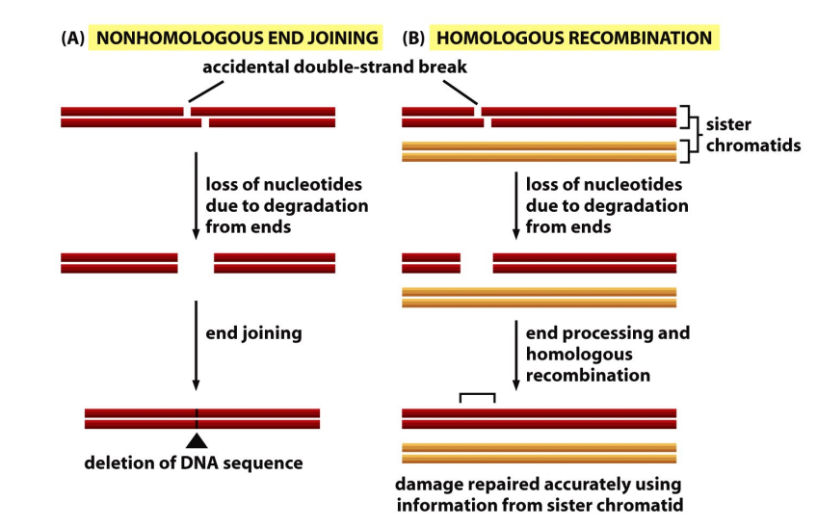

Figure 1‑21. (A) Nonhomologous end-joining is DNA repair happening in the G1-phase of the cell cycle, before DNA is replicated. The strands are connected, but the nucleotides that existed on the strand before damaged occurred, are gone. (B) Homologous Recombination during late G2/S phase where sister chromatid is available after DNA replication and completely restores the broken DNA (Alberts et al., 2014, p.275).

Failure of repairing DNA damage might result in severe consequences. An unbound base caused by a DSB easily forms new hydrogen bonds with unbound bases elsewhere on the strand where a DSB has occurred (Hall & Giaccia, 2012, p.25). If enough DSB’s are left unrepaired, or the cell isn’t arrested or the damage occur late in the cell cycle, they can cause severe abnormalities known as chromosomal aberrations (Grote & Revell, 1972). Lethal chromosomal aberrations result in chromosomes that are connected by more than the centromere. This leads to chromosomes not being fully separated during mitosis causing mitotic cell death (Hall & Giaccia, 2012, p.26). Worse is non-lethal chromosomal aberrations. Examples are symmetrical translocation and small deletions. Translocation is when a piece of chromosomes breaks and reattach to another chromosome, while deletion is removal of a piece of chromosome without reattaching. These aberrations are non-lethal because the chromosomes do not attach to each other when they are damaged, and they are able to separate successfully during mitosis (Hall & Giaccia, 2012, p.26-32). But the damages might lead to activation of oncogenes (Nambiar et al., 2008) or inactivation of a tumor suppressor gene (X. Mao et al., 2011), generating cancerous cells.

### Cell Survival Curves

A cell survival curve is a staple in radiobiology and explains the relationship between cell survival S and radiation dose D. If there is enough space and nutrients, a cancer cell will divide indefinitely. The cancer cell is therefore defined as dead if it has completely lost its ability to divide and form colonies, thereby the name clonogenic survival (Hall & Giaccia, 2012, p.35).   
Cancer cells response to irradiation is often studied by in vitro (in cell dish) cell survival experiments. The cells are seeded in monolayers at the bottom of a cell dish with a medium containing all necessary nutrients. The cells are kept in an incubator with ideal growth temperature, and after x number of days they are counted. The cells in a non-irradiated cell dish have a probability of growing into colonies, which is affected by the external environment as well as cell division errors (Hall & Giaccia, 2012, p.36). This efficiency is called the plating efficiency and is represented by the formula

|  |  |
| --- | --- |
| $$PE=\frac{\# colonies counted control flask}{\# cells seeded} .$$ | 1‑21 |

Plating efficiency is used as a normalization factor to accurately compare different experiments with different conditions. The survival fraction of an irradiated cell dish is found using the formula

|  |  |
| --- | --- |
| $$SF=\frac{\# colonies counted irradiated flask}{\# cells seeded⋅PE} .$$ | 1‑22 |

In Figure 1‑22 we see a typical cell survival curve, with the natural log of survival as a function of radiation dose. However, it is worth noting that each irradiated dish’s survival constitutes a point on the curve, and the curve is a result of interpolation. The interpolation is decided by a model known as the linear quadratic (LQ) model, which is discussed in 1.7.5.

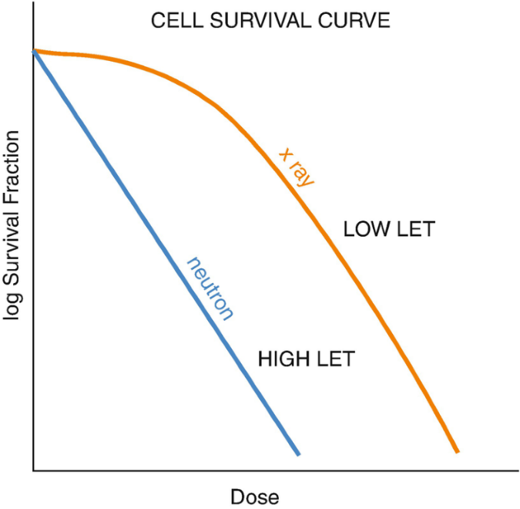

Figure 1‑22. Typical cell survival curve with low and high LET (see 1.1.2) which is typically expressed in the natural log of survival (Giridhar & Rath, 2020).

### LQ-model

This section is based on Chadwick & Leenhouts: A molecular theory of cell survival

The LQ-model tries to explain the shape of the cell survival curve as a function of increasing dose. From Figure 1‑22 we see that the survival curve becomes less linear as LET (see 1.1.2) decreases. The increased curvature of the low LET region is known as the “shoulder” of the survival curve. The formula explaining this shape is

|  |  |
| --- | --- |
| $$S= e^{-(αD+βD^{2})},$$ | 1‑23 |

where D is dose. $α$ and $β$ represents radiosensitivity of the cell (McMahon, 2018). The model assumes that there is a critical molecule crucial for a cell’s ability to divide, and that this molecule is the DNA. It also assumes that DSB is the critical damage type, but that the cell has repair mechanisms that might repair the damage. It accounts for two different DSB events (breakage of chemical bonds in the DNA molecule).

1. One event causing one DSB
2. Two SSB’s close enough in time and space to create one DSB

$α$ represents mode 1, and $β$ represents mode 2. In $α$ and $β$ we have the probability the chemical bonds, that received dose D, are broken. Represented by

$1-e^{-kDΔ}$

$1-e^{-kD(1-Δ)}$

where k is the probability per bond per unit dose that the bond is broken. $Δ$ is the proportion of dose that breaks the bonds with mode 1, and $(1-Δ)$ is the proportion of dose for mode 2. Chadwick & Leenhouts showed that the mean number of DSB’s from mode 1 was

$$A\left[1-e^{-kΔD}\right] ,$$

where A is the number of bonds on the DNA double helix, where mode 1 DSB’s occur.  
A first order Taylor approximation around 0 for $e^{-kΔD}$ gives

$$A⋅\left[1-\left(1-kΔD\right)\right]=AkΔD$$

For mode 2 they showed that mean number of DSB’s was

$$B{[1-e^{-k\left(1-Δ\right)D}]}^{2},$$

where B is number of SSB’s not repaired on both strands, that are also close enough in time and space to constitute a DSB. Doing the same Taylor expansion gives

$$B⋅\left[1-{\left(1-k\left(1-Δ\right)D\right)}^{2}\right]=Bk(1-Δ)D^{2} .$$

Combining the number of DSB’s from each mode and multiplying with the probability of the DSB’s being repaired f, we get

$$f⋅\left[AkΔD + Bk\left(1-Δ\right)D^{2}\right] .$$

From here they introduced a proportionality constant to relate number of DSB’s to cell death and assumed Poisson distribution (see 1.6.3) to achieve probability of cell survival per dose. Which results in the equation 1‑23. This shows why we have a linear and a quadratic link in the LQ-model, which does fit well with the curves we see in Figure 1‑22, where the high LET radiation has a denser energy deposition, creating more mode 1 DSBs. And for low LET there is a shoulder caused by accumulation of SSB’s for higher doses creating more mode 2 DSB’s.

The $α/β$ ratio is a typical measurement of sensitivity to fractionation, where you find the dose of equal contribution between $α$ and $β$ (see Figure 1‑23). The ratio indicates whether it is reasonable to split the dose into fractions to allow time for repair, thereby extending the shoulder of the survival curve and increasing survival (van Leeuwen et al., 2018). The ratio is found like this (Hall & Giaccia, 2012, p.39)

$αD=βD^{2}→D=\frac{α}{β} .$

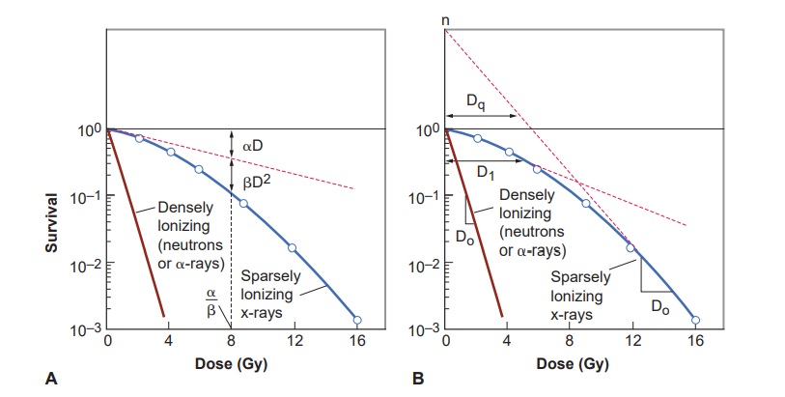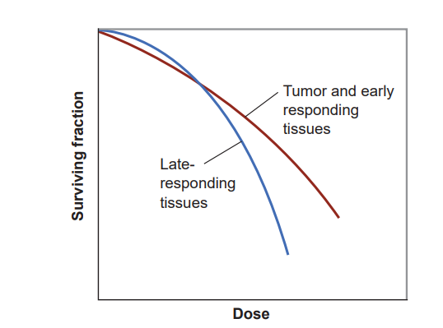

Figure 1‑23. Typical cell survival curves for low (blue) and high (red) LET, with $α/β$ ratio illustrated (Hall & Giaccia, 2012,p.39).

Figure 1‑24. Early (high $α/β$) vs late (low $α/β$) responding tissues. Early responding cells are typically cancer cells because they are always dividing, and (Hall & Giaccia, 2012, p. 395).

### Radiation Induced Bystander Effect

As mentioned in 1.7.3, cells are normally damaged either directly or indirectly. However, it has been showed that non-irradiated cells might exhibit the same biological endpoints (e.g. apoptosis, generation of micronuclei or DNA strand breaks) as irradiated cells. It was shown that 30% of analyzed cells expressed an increase in sister chromatid exchange, even though only 1% of cells were irradiated (SCE,Abbreviations and explanations) (Nagasawa & Little, 1992). This phenomenon is called the radiation induced bystander effect (RIBE). The theory is that irradiated cells signal to non-irradiated cells, either by intracellular communication trough protein channels (Gap junctions) between cells (Mesnil et al., 1996), or intercellular communication by excreting soluble factors into the surrounding medium (Luce et al., 2009). Although the existence of RIBE’s is indisputable, the characteristics of the biological parameters constituting an RIBE is not well defined (Blyth & Sykes, 2011).

It has been shown that a multitude of pathways are involved in RIBE’s, such as p53 (Koturbash et al., 2008), ATM (Ataxia telangiectasia mutated protein) (Ghosh et al., 2015), reactive oxygen species (ROS s) (D. Zhang et al., 2016) and various cytokines (Hu et al., 2014; Shareef et al., 2007).   
We will not discuss the various pathways in detail, but for shorter explanations see ***Abbreviations***.   
The bystander effect can either increase lethality or increase radio resistance. Mothersill & Seymour showed decreased clonogenic survival (see 1.7.4) when medium from irradiated cells were transferred to non-irradiated cells. However, Iyer & Lehnert showed increased clonogenic survival of cells that were irradiated after medium transfer.  
  
Which effect you’ll get is highly dependent on radiation quality (e.g., protons or photons), dose and which cell line is studied. A 2004 review on recent developments and implications of bystander effect concluded: For low-LET low dose radiation the protective effects were predominantly protective, but for high-LET it was less clear as both protective and detrimental was observed (Mitchel, 2004). Soleymanifard & Bahreyni found that QU-DB cancer cells had increased production of micronuclei (MN,see Abbreviations and explanations) , while number of MN for MRC5 fibroblasts remained constant.

Because of the bystander effect saturation for increasing dose, you neglect the effect for normal open field radiotherapy, but the effect has been established for SFRT (Spatially Fractionated Radiotherapy), where you have decreased toxicity in low-dose regions and increased survival in high-dose regions compared to open field (Asur et al., 2015).   
Better understanding of the biological mechanisms behind these results are important and has the potential of improving how SFRT (spatially fractionated radiotherapy) is used clinically.

### Spatially Fractionated Radiation Therapy

Spatially fractionated radiation therapy (SFRT) aims to achieve non-uniform dose distribution. It is a stark contrast to traditional radiotherapy where dose uniformity in the target is desirable. GRID therapy is a SFRT method where a photon beam is collimated into a specific pattern with low and high intensity areas, as is shown in Figure 1‑25. Traditionally a GRID block was used create high (peak) and low (valley) dose areas (Billena & Khan, 2019). GRID therapy arose from the need of treating deep seated or bulky tumors (Yan et al., 2019). The external beam therapy (EBT) machines of the early 20th century were typically X-ray tubes (1.2.1), and couldn’t create photon beams with energies surpassing kV (Gianfaldoni et al., 2017). Therefore, few photons penetrated deep enough into the skin to reach the tumor. A GRID block was necessary to increase the dose but keep skin toxicity at a tolerable level. When MV photons were introduced with the linear accelerator (LINAC see Abbreviations and explanations) and photon ranges increased, the need for GRID decreased (Yan et al., 2019).  
Today there are many ways to apply SFRT. Linear accelerators have preinstalled MLC’s (see Abbreviations and explanations) which can modulate the GRID pattern in a way the static GRID block cannot (Billena & Khan, 2019). Tomotherapy is a treatment method, that combines a CT machine (see Abbreviations and explanations) with a linear accelerator to give radiation treatment in ${360}^{∘}$ degrees (Sterzing et al., 2009). The CT image is used to adjust the position of the patient to ensure that accurate dose is given. Modulation of beam intensity and direction can create a GRID shaped dose distribution (X. Zhang et al., 2016).   
3D SFRT methods have been developed, where the linear accelerator is rotated and the beam is modulated to create a sphere-like dose distribution (Wu et al., 2010).

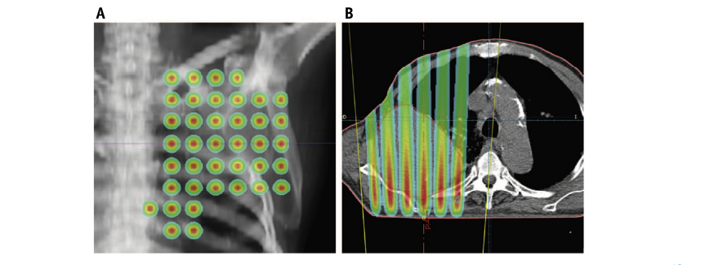

Figure 1‑25. (A) An example of a dose plan for GRID therapy from anteroposterior view of the lung area. The GRID pattern is clearly visible with dose gradients out from the center of the circles. (B) A transversal view of dose plan. Here we also see gradients in dose into the patient as the radiation attenuates into the body (Billena & Khan, 2019)

From the 1990’s to today, SFRT has primarily been used for palliative (treatment meant as pain relief rather than curing the patient) treatment of bulky (larger than 8 cm) tumors (Yan et al., 2019). However, (Asur et al., 2015) showed cells located in the valley region had overexpressed genes related to DNA-repair, cell cycle arrest and apoptosis. He also showed that cells located in peak areas had increased survival, leading it to believe that inter- and intracellular communication happen between cells (see 1.7.6). There is also evidence of immune system activation by recruitment of T-cells (a type of white blood cell) (Kanagavelu et al., 2014).  
These results indicate the potential of SFRT as a curative treatment.

# Materials and Methods

## Dosimetry

We want to establish a 2D survival analysis method for X-ray irradiated A549 cells through a GRID block. It was therefore necessary to accurately measure how much dose was given to the cells. The dosimetry methodology was proposed by Bjørg Vårlig Håland in her master thesis (Bjørg Vårli Håland, 2020). Gafchromic EBT3 film (Ashland, USA) was chosen as dosimeter for reasons we’ll get into (see 2.1.2). We needed to establish the films’ dose response and generate a calibration curve. Therefore, X-ray dosimetry on an air-filled thimble ionization chamber (ion chamber) (FC65-G, IBA, Germany) was performed to give the films a known dose. Calibrations were made for striped and dotted GRID configurations, respectively. First on the 31.8.21 then on the 13.10.21.

### X-ray dosimetry

An X-ray beam was generated using a PMC 1000 X-ray unit (PANTAK, USA) operating at 10 mA and 220 kV for sufficient electron fluence from the cathode with high enough energy to generate photons of kV range. We used filtering of 0.7 mm Cu and 1.52 mm of Al. This is a standard in the X-ray lab at medical physics department at the University of Oslo to achieve a more homogeneous energy distribution. The X-ray beam was isolated to a cabinet lined with lead, which we will refer to as the irradiation cabinet. The cabinet has a platform made from Perspex, where cells can be placed a distance away from the X-ray source. A source to detector distance (SDD) of 60 cm was used to ensure the right beam divergence and high enough intensity. The experimental setup can be seen in Figure 2‑2.  
When cell flasks were irradiated, they were inserted into a cell flask holder made from polymethyl methacrylate (PMMA) holding four cell flasks in position A, B, C and D. To simulate the same conditions, the ion chamber was placed inside a T25 cell flask (Nunc, Denmark) and measurements were performed in all positions as seen in Figure 2‑3. Positioning of the cell flask holder on the Perspex platform inside the irradiation cabinet (see Figure 2‑2) was decided by field homogeneity measurements performed by Bjørg Vårli Håland.   
The protective cap of the ion chamber slightly lifts the sensitive volume above the bottom of the cell flask (see Figure 2‑1) closer to the radiation source, but the cells are seeded in monolayers at the bottom. It was therefore necessary to account for this height difference when prescribing radiation.

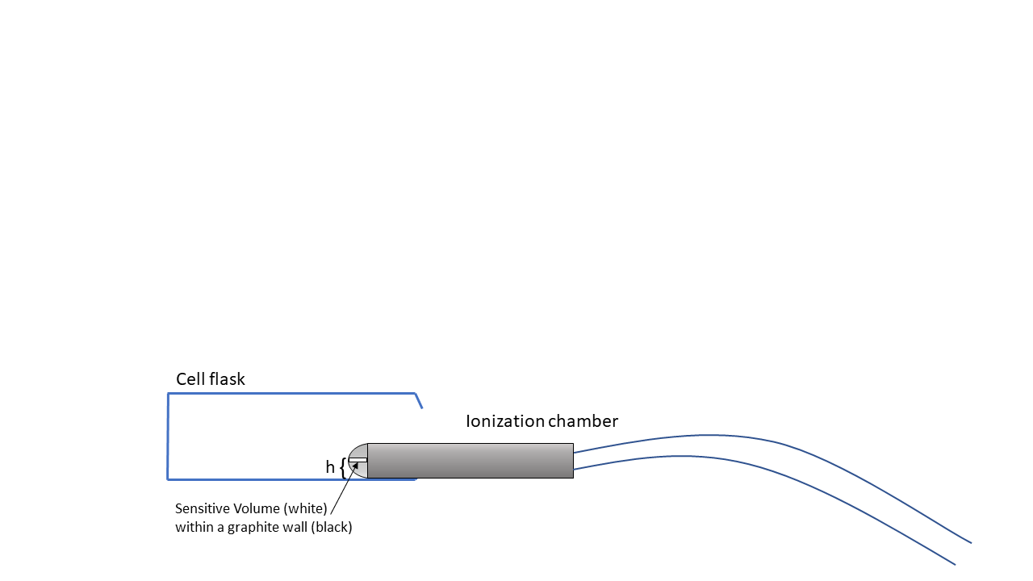

Figure 2‑1. Ion chamber inserted into a T25 cell flask, that has been cut open. The sensitive volume is surrounded by a graphite wall within the protective cap, and we observe the height difference between the bottom of the cell flask and the cell flask. During experiments efforts were made to position the ionization chamber as flat as possible inside the cell flask. Figure is only for illustration purposes.

Because intensity follows the inverse square law $I=α/r^{2}$ (see 1.2.1), the ratio between intensity at the sensitive volume of the ion chamber $I_{1}$ and the intensity at the bottom of the cell flask $I_{2}$ is

$$\frac{I_{1}}{I_{2}}=\frac{r_{2}^{2}}{r_{1}^{2}} .$$

Height measurements were made sing a caliper (FWP, Poland). We were unable to acquire a data sheet but based on the smallest measurement possible of 0.01 cm, we assumed an uncertainty of 0.001 cm. The thickness of the cell flask holder and the cell flask bottom were found to be $1.500±0.001$ cm and $0.200±0.001$ cm, respectfully. The diameter of the protective cap was $1.500±0.001$ cm, with a radius of $0.750±0.001$ cm. Uncertainty in $I_{1}/I_{2}$ was found with error propagation using equation 2‑2 assuming negligible uncertainty in SDD

$$\frac{I_{1}}{I_{2}}=\frac{{\left(60-1.5-0.2\right)}^{2}}{{\left(60-1.5-0.2-0.75\right)}^{2}}=1.02600±0.00002 .$$

Because of the low uncertainty we decided to neglect it, to not further complicate the uncertainty analysis. The intensity in the sensitive volume of the ion chamber is $2.6\%$ higher compared to the bottom of the cell flask, and we need to increase the dose accordingly when irradiating the EBT3 films.

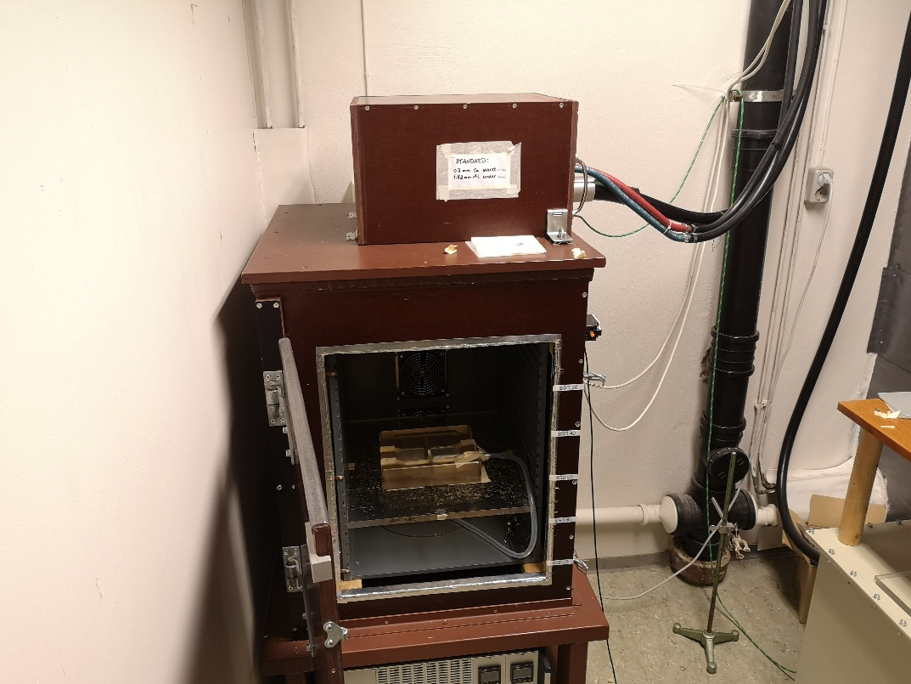

Figure 2‑2. An overlook of the experimental setup for X-ray dosimetry. The cell flask holder is placed inside an in-house made irradiation cabinet.

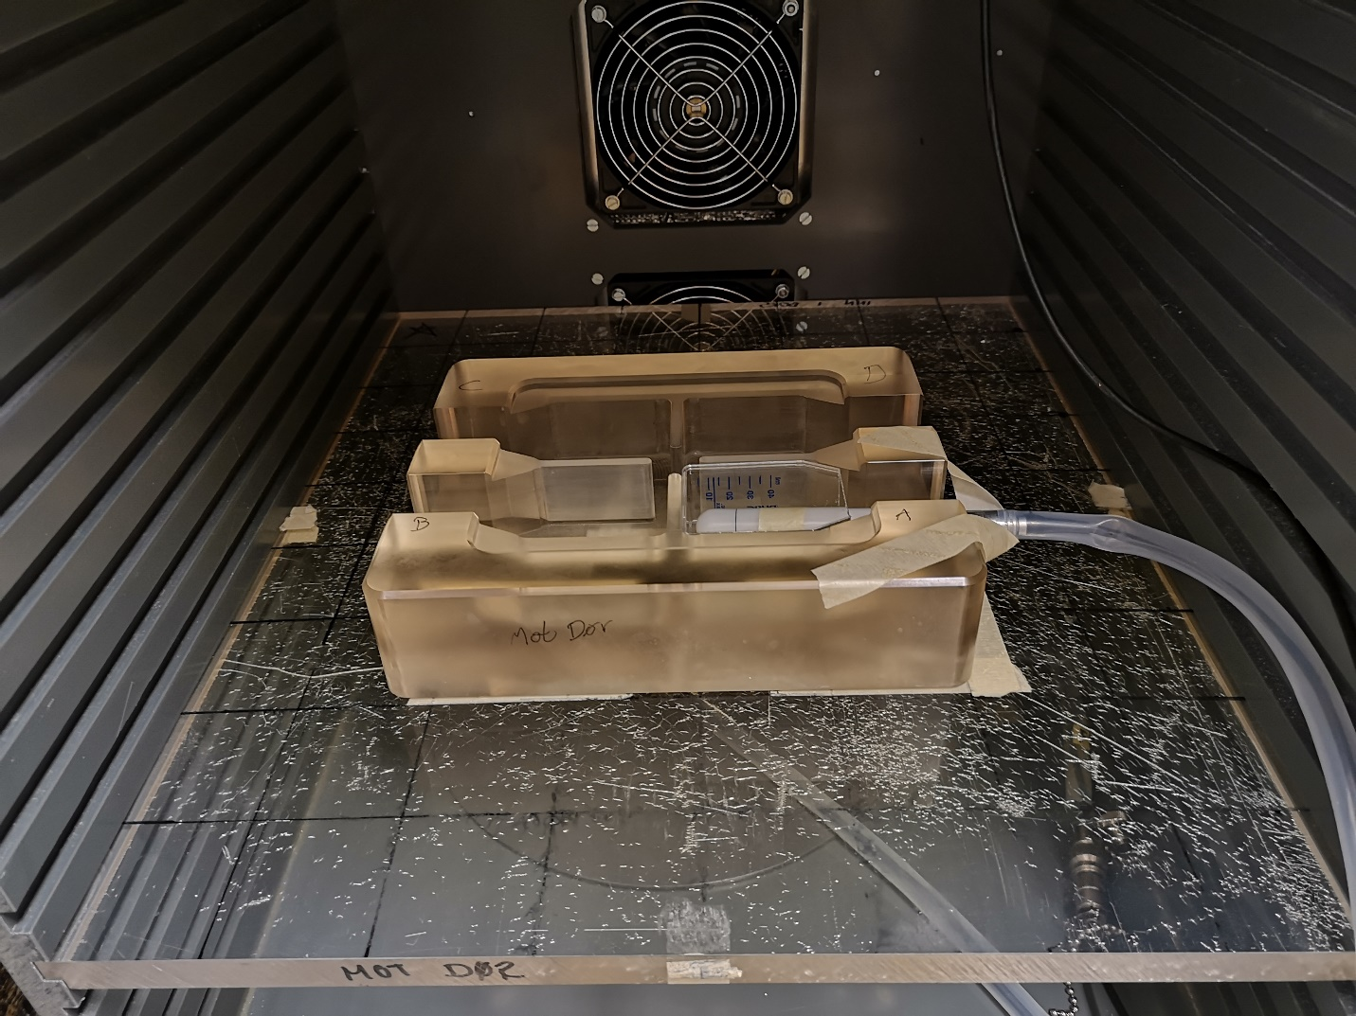

Figure 2‑3. A closer look at the experimental setup of X-ray dosimetry. The ionization chamber is inserted into the cell flask, which is placed into the cell flask holder. Ionizations is measured in all four positions.

A max 4000 electrometer (Standard Imaging, USA) was used to measure the ionization current from the ion chamber. Converting the output of the electrometer, from nC in air to $Gy$ [$J/kg$] in water, was done using the formalism established by the International IAEA explained in 1.5.2

|  |  |
| --- | --- |
| $$D_{w}=M_{u}N_{k}k_{u}p_{u}k_{TP}{\left(\frac{\overline{μ}}{ρ}\right)}_{w,air}=CM_{u}N_{k} .$$ | 2‑1 |

$D_{w}$ is dose to water, $N_{k} [mGy/nC]$ is the calibration factor relating ion chamber output to dose in water and is given by the calibration lab (Norwegian Radiation Protection Authority). $M_{u}$ is the output from the electrometer in nC, $k_{u}$ is correction factor accounting for change in ion chamber resulting in a shift in spectral distribution when moving from air to water. The correction factor is typically assumed to be 1, but it has been shown that $k_{u}$ is dependent on the angular distribution of photons (P.Andreo et al., 1996, p.54-55). However, for our experiments we assumed this to have a negligible effect. $p_{u}$ corrects for effects caused by the ion chamber displacing the water. ${\left(μ/ρ\right)}_{w,air}$ is mass energy absorption coefficient (see 1.3.1) ratio between water and air averaged over the photon energy spectrum during reference conditions, which can be found in Appendix A. $k_{TP}$ corrects for difference in air pressure and temperature conditions, compared to the reference conditions of the calibration lab. $k_{TP}$ was found using the formula

$$k_{TP}=\frac{273.15-T}{273.15+T_{0}}\frac{P_{0}}{P} ,$$

where $T$ and $P$ are temperature and air pressure during calibration with an assumed negligible uncertainty. $T_{0}$ and $P_{0}$ are reference temperature and air pressure. $T_{0}={20}^{∘}C$, $P_{0}=1013 Pa$. Updated Correction factors and mass energy absorption coefficient rates were found in (Waldeland et al., 2010) (see Table 1).

Table 1. Calibration factor $N_{k}$ with correction factors and mass energy absorption coefficient ratio. Two experiments were performed using dotted and striped GRID configurations with different temperature and air pressure conditions.

|  |  |  |  |  |  |
| --- | --- | --- | --- | --- | --- |
| $$N_{k} [mGy/nC]$$ | $$p_{u}$$ | $$k_{u}$$ | $k_{TP}$ (310821, stripes) | $k_{TP}$ (131021, dots) | $${\left(μ/ρ\right)}_{air}^{w}$$ |
| $43.77±0.39$ | $$1.02$$ | $$1$$ | $$1.006745405$$ | $$1.021463$$ | $$1.075$$ |

The ionization chamber was irradiated 5, 10, 15, 20 and 60 seconds 3 (31.08.21) or 4 (13.10.21) times in each position. We wanted the calibration films to receive doses that correlated with doses the cells would receive during GRID irradiation. Hence, dose points of 0 (control), 0.1, 0.2, 0.5, 1, 2, 5, 10 Gy were chosen. Because of potential delay in beam production from the X-ray machine, we needed to make sure that there was a linear relationship between irradiation time and the lowest doses (0.1, 0.2, 0.5 Gy). A linear regression model (see 1.6.1) was found for each position using a function called *linregress* from the *scipy.v.1.6* library (Virtanen et al., 2020) in Python (v.3.8) (Guido van Rossum & and the Python development team, 2020). Then the estimated parameters were averaged to get a model independent of positioning in the cell flask holder. This would greatly decrease the duration of the experiment because we could irradiate in all positions at once.

$$\hat{D}=\overline{β_{0}}+\overline{β_{1}}t ,$$

where ${\overline{β}}_{0}, {\overline{β}}_{1}$ are mean coefficients and D is dose. Rearranging the equation, we could find the time needed to achieve the desired dose (0.1, 0.2, 0.5 Gy).

and multiplying desired dose with 1.026

$$\hat{t}=\frac{D⋅1.026-{\overline{β}}_{0}}{{\overline{β}}_{1}}$$

Dose was multiplied with 1.026 to compensate for the height difference between the sensitive volume of the ionization chamber and the bottom of the cell flask mentioned in 2.1.1  
With a nonzero intercept, we could account for the delay in beam production. *Linregress* returns the standard error of the estimated coefficients. Because we found the average model the mean standard error of the model was found with $Δ\overline{β_{k}}= \sqrt{\sum_{i=0}^{n}{Δβ_{k,i}^{2}}}/n$, where k is either 0 or 1. The standard error of exposure time $Δ\hat{t}$ was found using the formula for error propagation of the multivariate function $f(x_{1}, x_{2}…x_{n})$ with independent variables

|  |  |
| --- | --- |
| $$df=\sqrt{ \sum_{1}^{n}{{\left(\frac{∂f}{∂x_{i}}Δx_{i}\right)}^{2} .}}$$ | 2‑2 |

The resulting error expression becomes

$$Δ\overline{\hat{t}}=\sqrt{{\left(-\frac{1}{{\overline{β}}_{1}}Δ{\overline{β}}_{0}\right)}^{2}+{\left(-\frac{D⋅1.026-{\overline{β}}_{0}}{{\overline{β}}_{1}^{2}} Δ{\overline{β}}_{1}\right)}^{2} .}$$

Because linear regression does not account for variability in the independent variable (see 1.6.1), $ΔD=0$. For doses above 0.5 Gy we assumed linearity. Therefore, we only made 60 second measurements to get dose rate (Gy/min) in all positions repeated 3 (31.08.21) or 4 (13.10.21) times. The measurements were averaged to obtain one dose rate. We assumed the uncertainties were connected to $N_{k}$ and $M_{u}$, respectively. With the error propagation we got

$$dD_{w}=C\sqrt{{\left(N_{k}⋅ΔM_{u}\right)}^{2}+{\left(M_{u}⋅ΔN_{k}\right)}^{2}} .$$

Finding time required for 1, 2, 5 and 10 Gy, we divided the dose with the dose rate. Again, using error propagation we get uncertainty

$$Δt=\sqrt{{\left(-\frac{D}{doserate^{2}}⋅Δdoserate\right)}^{2}}.$$

To get standard error of the mean we divided with the square root of number of measurements.

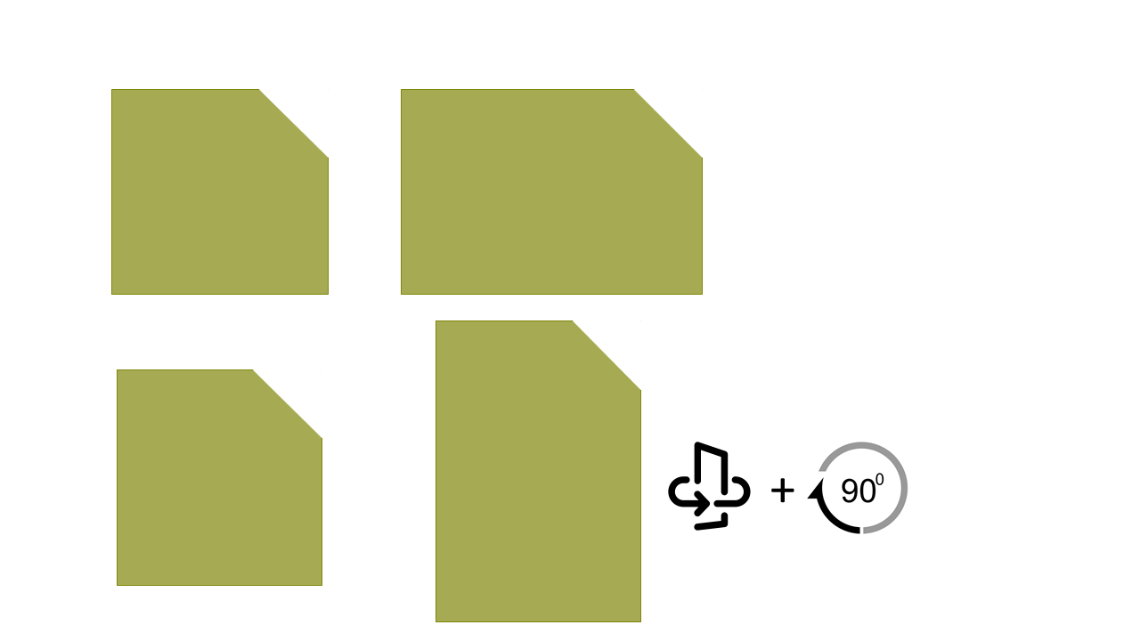

Figure 2‑4. Figure illustrating importance of having a rectangle with two clearly different sides. The left side has a small difference in height and width. When the film is flipped and rotated ${90}^{∘}$ it is hard to observe the rotation. But if the sides are clearly different, then it becomes clear that the film is oriented in the wrong direction.

### Gafchromic film

The protocol for Gafchromic film calibration follows the protocol established by (Devic et al., 2016)in: *“Reference radiochromic film dosimetry: Review of technical aspects”.*   
  
The Gafchromic EBT3 films (lot #: 02122001) were chosen because they give a high spatial resolution, 2D dose distribution, and they can be neatly fitted to a cell flask. The near tissue equivalent property of the films offers comparative dose measurements to cells suspended in medium. The polymerization process (see 1.5.3) changes the color of the film post irradiation, and because of its low sensitivity to light, it’s unnecessary to develop the film (Niroomand-Rad et al., 1998).   
EBT3 was chosen because of its symmetric chemical configuration (see Figure 1‑15), with a 125 $μm$ protective matt polymer layer on both side of a 26 $μm$ active layer. The implementation of a matte polyester protective layer instead of the smooth layer found in EBT2 removes the generation of the newton ring artefacts when scanning the films (GafChromic, n.d.). The films have a dose range of 0.1 – 10 Gy. Their optical density is known to change from exposure to UV light, temperature and humidity (Girard et al., 2012; Park et al., 2012), the films were therefore handled using gloves in a room with dark curtains, and stored in a room tempered drawer. Because of the external influences in film response, it was important to have a set of control films, that received zero dose.

#### Film irradiation

As mentioned in 1.5.3, we needed to establish a calibration curve before cell flask dose could be measured. Two calibrations were performed on two separate dates, one for striped and one for dotted GRID configurations respectively. The method was mostly the same on both occasions, but the size of the calibration films was different. The films were cut with a regular A4 paper cutter, that was sanitized before use. The calibration films for striped GRID were cut to a size of 4.3 x 4.1 $cm^{2}$. It has been shown that the scan response is sensitive to the direction of the film (Borca et al., 2013). A cut was therefore made on the top right corner of the longest side. The chosen size made it hard to detect which side was the longest. If the film was not handled properly and the film was flipped to its opposite side, one could not trust that the orientation was correct based on the cut. The scenario is illustrated in Figure 2‑4. For dotted GRID, we increased the difference between width and height.   
The T25 cell flasks were cut horizontally, and one film was placed inside each flask. The films were then irradiated in all positions simultaneously, twice per dose point. Thus, giving each dose point eight calibration films.   
A thin slab of 2 mm nylon6 (polymer) was placed on top of the films to act as a buildup material. The material filters low energy electrons, ensuring CPE within the sensitive layer. Because the ionization chamber has a protective cap, the nylon6 slab will increase the similarity between the experimental setups of film- (see Figure 2‑5) and ionization chamber (see Figure 2‑2 and Figure 2‑3). The films were irradiated with the exposure times found in 2.1.1.

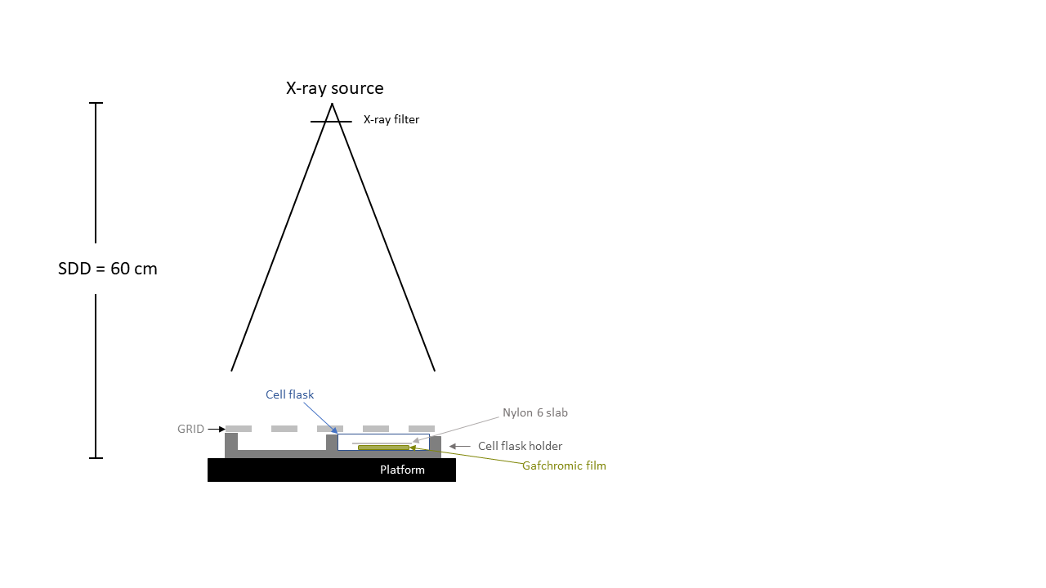

Figure 2‑5. The experimental setup for GRID irradiation of gafchromic films. For calibration, no GRID was used.

A new set of films were, to our best efforts, cut to match the shape of the bottom of the cell flasks. These will be called the measurement films. The films were given nominally 5 Gy. Then their response was mapped to the calibration curve. We irradiated films using the same experimental setup shown in Figure 2‑5**.** On the first dosimetry experiment (31.08.21) we irradiated using both GRID and OPEN field. The OPEN field films were used to evaluate the accuracy of our dosimetry. However, on the second dosimetry experiment, only GRID irradiations were made to save time. Four films were irradiated simultaneously in all four positions. This was repeated four times for OPEN field and GRID. Thus, resulting in 16 films per configuration.

Two in-house 0.5 cm tungsten metal collimators with striped or dotted grid patterns were constructed to be placed on top of the cell flasks laying in the cell flask holder (see Figure 2‑6). The stripes had 5 mm wide slits and the diameter of the dots was also 5 mm. The GRID’s create high and low dose areas, called peak and valley. The high atomic number of tungsten (see 1.2.1) makes tungsten a great photon absorber. It is well known that collimating an X-ray beam results in increased scattering (Philip Mayes et al., 2007, p.377). The high density of tungsten allows for a thinner design, thereby mediating the scattering within the slits of the GRID. Because of poor cutting accuracy, the measurement films did not fit perfectly into the cell flask, causing them to have small variations in how they lay inside the flask. This resulted in slightly skewed response patterns after irradiations.

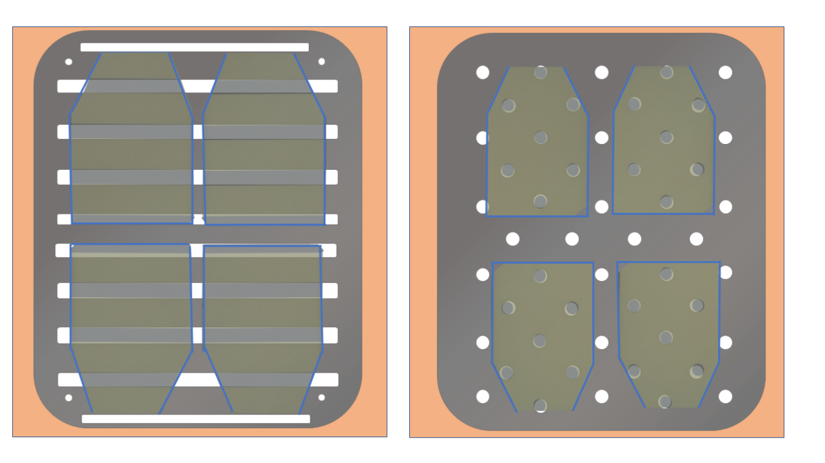

Figure 2‑6. Illustration of how the Gafchromic films were positioned underneath the different GRID configurations. The films were of equal size in both GRID configurations, but the size has been modified to fit the illustrations. The blue lines indicate the outline of the cell flasks, and the background represents the cell flask holder.

#### Scanning

To ensure a stable and saturated optical density of the films, we waited 48 hours after irradiation before scanning the films (Devic et al., 2005).

An Epson Perfection V850 Pro flatbed scanner was used to digitize the films’ radiation response. The films were placed in a central area of the scanner to minimize variations in scan readings (Lewis & Chan, 2015). Transmission mode was chosen, as recommended by (Aldelaijan & Devic, 2018). Using the Epson scan tool v.5.1 software we disabled automatic image corrections and adjustments to only extract raw data. Resolution of 300 dpi was chosen to achieve high enough spatial resolution while having a reasonable scanning time. A 16-bit color depth per channel (0 - $2^{16}$) RGB image was chosen for satisfactory intensity resolution. The scanner was allowed time to warm up for 30 minutes, then 10 dummy scans was performed to limit warm-up effects causing variations in response readings (Paelinck et al., 2006). Four scans were done per film to account for possible change in intensity readings caused by the scanner. Then the difference between the mean intensity values of the four scans were tested using analysis of variance (ANOVA). The method performs an F-test by calculating the ratio $F= \frac{variance between samples}{variance within samples} ,$ and finding the probability (p-value) of the scans being significantly different (Ross & Willson, 2017, p. 21). The test resulted in 23.2% of the films having significant difference between the four scans. The calibration films for striped GRID had a resolution of 507 x 484 pixels, resulting in a large sample size for ANOVA. This in turn reduced the standard deviation of the F-distribution, resulting in low p-values. We found the largest percentage difference between the fours scans to be approximately $0.1\%$. Which was small enough for us to neglect the scanners effect on film response and only use the first scan in our dosimetry.   
For a complete opaque film, light transmission should be zero. However, there will always be background noise. Therefore, a black film was scanned and its intensity was subtracted from all control and irradiated films.   
The images were saved as TIFF (Tag Image File Format) without compression to retain as much information as possible from the images.

#### Film calibration

Calculating netOD from the scanned images requires image processing using Python. First the raw data of the images were read and separated into a red, green, blue, and grey channel. Grey channel conversion follows rec 601 (*Recommendation ITU-R BT.601-7*, 2011) using the formula

$$I_{G}=0.299⋅I_{R}+0.587⋅I_{G}+0.114⋅I_{B} ,$$

where $I$ is pixel value. For 2D analysis of cell survival a mean dose map was generated using all 16 films (see explanation further down). It was therefore crucial that the GRID pattern aligned, so they could be stacked on top of each other. However, because of poor accuracy when cutting the measurement films, they were not equally positioned within the cell flask. We therefore had to spatially registe­r the films, which is the process of geometrically aligning two images. The calibration films were also registered. This ensured that the region of interest (ROI) was positioned equally in all calibration films. The only possible displacements during calibration were rotational and translational; hence a rigid body registration (preserving Euclidean distance) was performed. A python module called *pystackreg (version 0.2.5)* was used. The package is a port of the imageJ extension TurboReg/StackReg based on the paper:   
*“A Pyramid Approach to Subpixel Registration Based on Intensity”, by* Thevenaz et al.

Turboreg is a subpixel registration algorithm that aligns a source image $f_{S}$ to a reference image $f_{R}$, both with dimension M x N (rows, columns). Subpixel means that the algorithm has an error less than $± 1$ pixel. Turboreg uses the integrated square difference of the intensity values as a cost function denoted by $ϵ^{2}$

$$ϵ^{2}=∫∫f_{R}\left(x,y\right)-Q_{P}\left\{f_{S}\left(x,y\right)\right\} dxdy ={\left\|f_{R}\left(x,y\right)-Q_{p}\left\{f_{S}\left(x,y\right)\right\}\right\|}^{2} ,$$

where $Q_{p}$ is a transformation of the source image (e.g., translation, rotation scaling etc.) parametrized by $P$. The goal is finding a transformation that minimizes the intensity difference, by tuning the parameters in $P$.

$$\frac{∂{ϵ\left(P\right)}^{2}}{∂P}=0$$

The algorithm uses a modified LM (see 1.6.1 for general LM) to find the optimal parameters. When a minimum is reached, or number of maximal iterations surpasses, it returns a 3 x 3 transformation matrix. To optimize the registration various degrees of preprocessing was necessary. *Pystackreg* tended to align the background of the image, rather than the object within. Therefore, a small crop of 20 pixels in each direction of the image was made. We wanted all images to be aligned to the first image in the folder, but the high intensity discrepancy of the calibration films originating from irradiating with doses ranging from 0 Gy to 10 Gy, caused large errors in the registration. We therefore registered each image to the neighboring image.

This was not required when registering the measurement films, as they were all irradiated with 5 Gy. The background of the measurement films had to be dulled as well as cropping the image.   
We chose to use a package called *skimage.transform,* which includes a function called *warp*. *Warp* both applies the transformation matrix on an image and interpolates. Interpolation is necessary because when an image is transformed, each pixel is mapped into a new coordinate $P\left(x,y\right)→P'(x^{'},y^{'})$ (Ashburner & Friston, 2007). For instance, rotating an image is done by applying the rotational matrix $R$ on each coordinate of the image

$$\left[\begin{matrix}x' \\ y'\end{matrix}\right]= \left[\begin{matrix}\cos{θ} & -\sin{θ} \\ \sin{θ} & \cos{θ}\end{matrix}\right] \left[\begin{matrix}x \\ y\end{matrix}\right].$$

It results in non-integer coordinates with unknown intensity values. The easiest solution is to round the coordinates to nearest integer and use the intensity values of these coordinates (called nearest neighbor interpolation). However, a more accurate interpolation called bi-cubic interpolation was used. We will not go into detail, but the method looks at the 16 neighboring pixels and estimates the unknown pixel’s intensity value from these (Han, 2013).

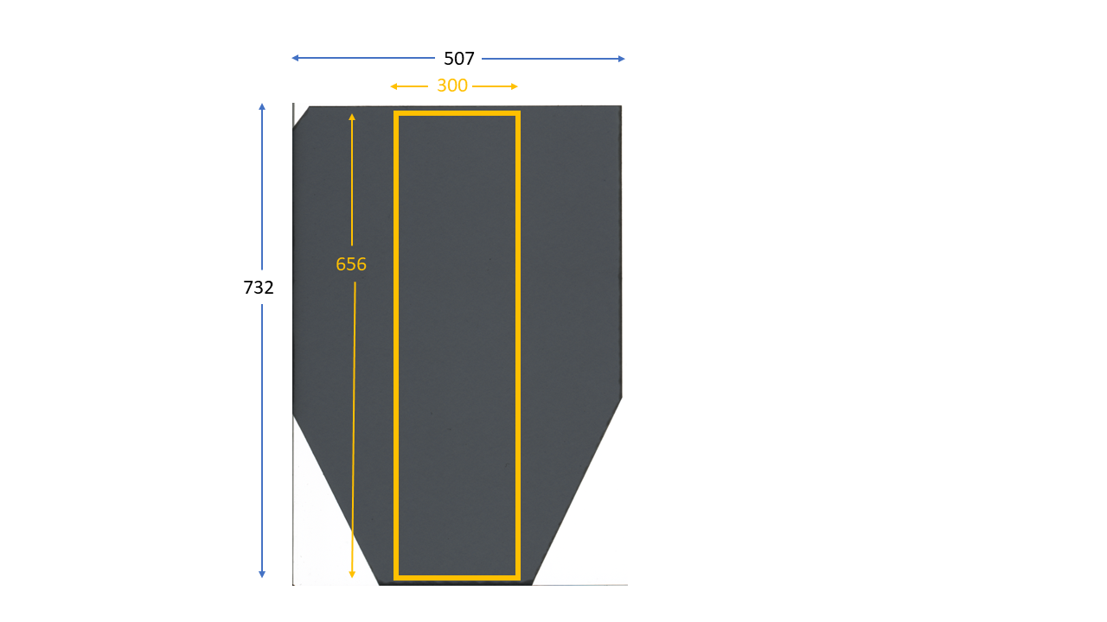In the cut area of the films a transparent white color appears. These areas are undesirable, we therefore chose a Region of Interest (ROI) in a central area of the calibration film that balances the need for sufficient datapoints and capturing the variance of the radiation field, while avoiding the edges of the film. A suitable ROI was found retrospectively, by creating dose maps from all OPEN field irradiated measurement films, then measuring mean relative error within a specified analysis area (see Figure 2‑7) using the expression $\frac{\left|observed-true\right|}{true}$, where true dose is 5 Gy. Based on these calculations an ROI of 2 x 2 mm2 was chosen.

Figure 2‑7. Area within the OPEN field dose map where relative error is found.

Measuring the darkening of the film we used the net optical density netOD. It describes the change in opacity compared to unirradiated films using the formula (Devic et al., 2004)

|  |  |
| --- | --- |
| $$netOD=ΔOD=\log_{10}\left(\frac{{\overline{PV}}_{ctrl}-{\overline{PV}}_{bckg}}{PV_{irr}-{\overline{PV}}_{bckg}}\right) ,$$ | 2‑3 |

where ${\overline{PV}}_{ctrl}$ and ${\overline{PV}}_{bckg}$ was found by finding the mean pixel value within the ROI of each control and background image, then finding a weighted average of these means (see Figure 2‑8). The weights are based on the standard deviations of each mean following the relationship (Devic et al., 2004) $w_{i}=\frac{{1/σ}_{PV}^{2}}{\sum_{i=1 }^{n}{1/σ_{PV}^{2}}}$. $PV_{irr}$ is the mean pixel value of the ROIs of all irradiated films, a weighted average was not found for $PV_{irr}$, because we wanted each dose point to have 8 accompanying films for increased accuracy when fitting the calibration curve. Using equation 2‑2 we estimate the error in $netOD$ as

|  |  |
| --- | --- |
| $$σ_{netOD}=\sqrt{{\frac{∂ΔOD}{∂PV_{ctrl}}}^{2}⋅{σ_{PV}^{2}}_{ctrl }+ {\frac{∂ΔOD}{∂PV_{bckg}}}^{2}{{⋅σ}_{PV}^{2}}_{bckg}+{\frac{∂ΔOD}{∂PV_{irr}}}^{2}⋅{σ_{PV}^{2}}_{irr}} \\ =\frac{1}{ln10}\sqrt{{\left(\frac{σ_{{\overline{PV}}_{ctrl}}}{{\overline{PV}}_{ctrl}-{\overline{PV}}_{bckg}}\right)}^{2}+{\left(\frac{σ_{PV_{irr}}}{PV_{irr}-{\overline{PV}}_{bckg}}\right)}^{2}+{\left[\frac{{\overline{PV}}_{ctrl}-{\overline{PV}}_{bckg}}{\left(PV_{irr}-{\overline{PV}}_{bckg}\right)\left({\overline{PV}}_{ctrl}-{\overline{PV}}_{bckg}\right)}\right]}^{2}σ_{{\overline{PV}}_{bckg}}^{2} }$$ | 2‑4 |

For measurement films, all pixels were converted to netOD, hence no mean pixel value was found and $σ_{PV_{irr}}=0$. We found ${σ_{\overline{PV}}}_{ctrl}$ and $σ_{{\overline{PV}}_{bckg}}$ using

$$σ_{{\overline{PV}}_{ctrl}}=\frac{\sum_{i=0}{\sqrt{\frac{σ_{i,PV_{ctrl}}^{2}}{p}}}}{n} , σ_{{\overline{PV}}_{bckg}}=\frac{\sum_{i=0}{\sqrt{\frac{σ_{i,PV_{bckg}}^{2}}{p}}}}{m} ,$$

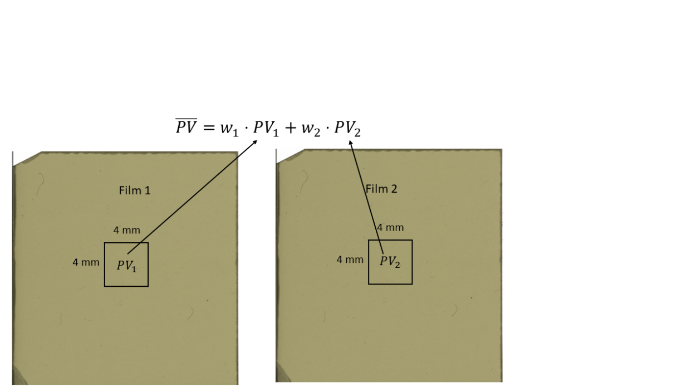where $n$ and m was the number of control and background films, and p is number of pixels within an ROI. ${σ_{PV}}_{ctrl}$ and $σ_{PV_{bckg}}$ represents the standard deviation of the pixel values within each image’s ROI.

Figure 2‑8. Illustration explaining the notation behind calculating weighted average pixel values $\overline{PV}$**.** Both $PV_{1}$ and $PV_{2}$ are mean pixel values within the 4 x 4 mm2.

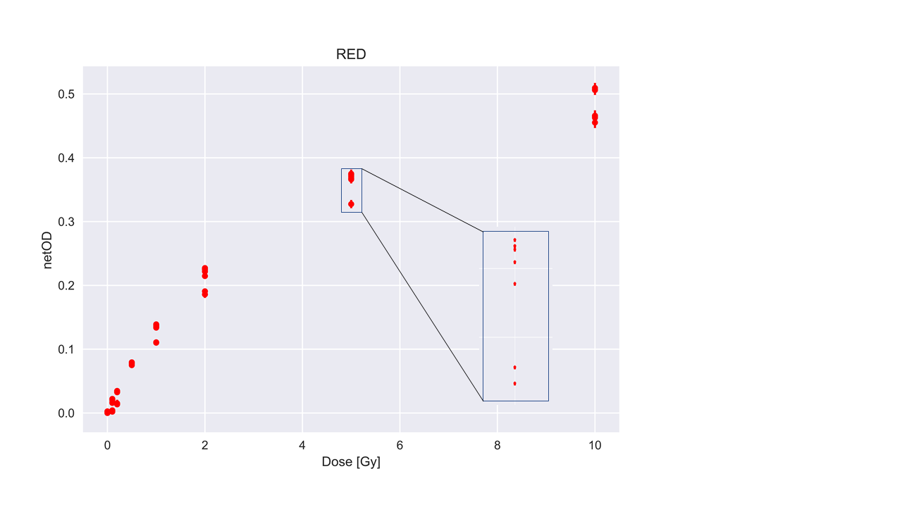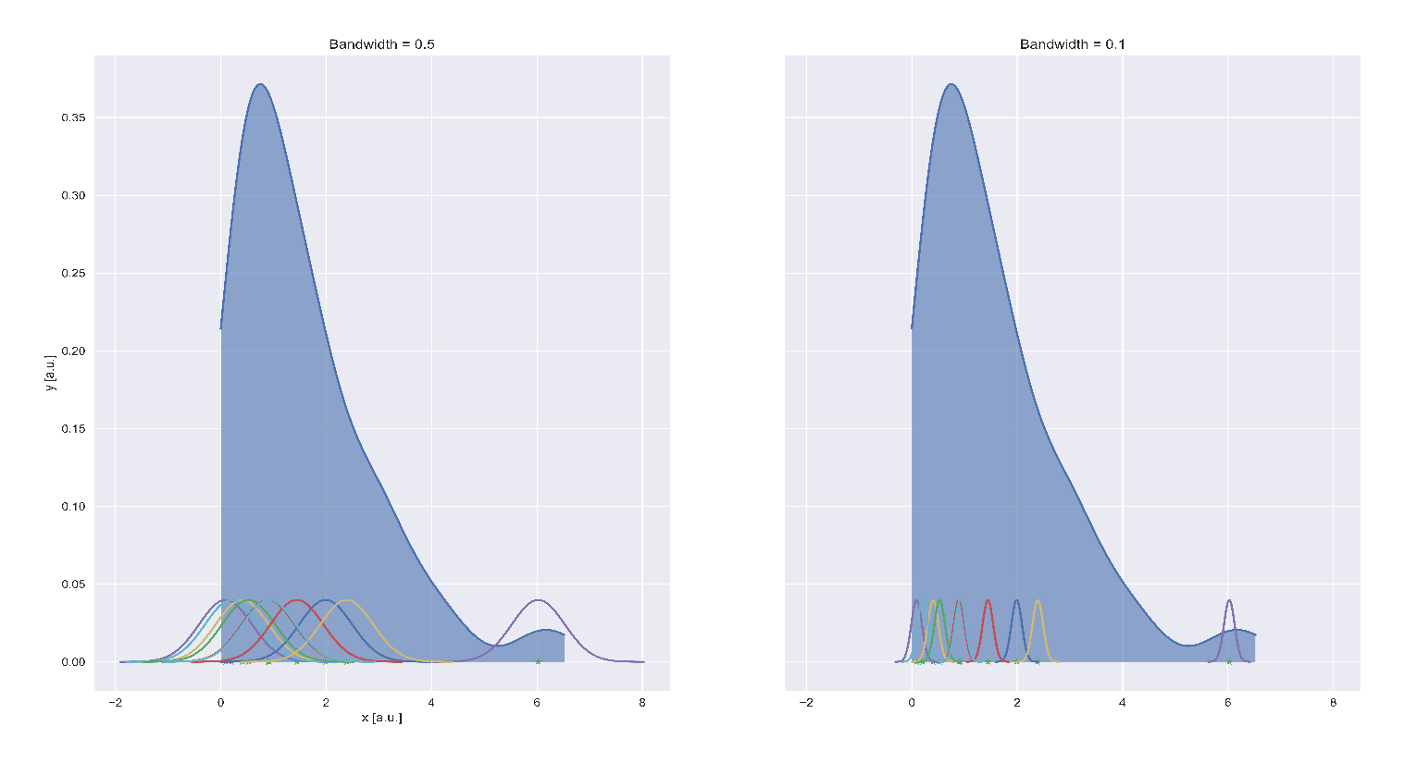When plotting netOD against dose it became apparent that we had a split response from the films, which can be seen in Figure 2‑10 The calibration films for dotted GRID did not have a clear split response, which complicated the fitting process (explained further down). But for striped GRID we separated the datapoints into low and high response using Kernel Density Estimation (KDE). KDE estimates the probability density function (PDF) of the data (Silverman, 1998, p.1). The method sorts the data in increasing order, before centering a kernel over all the datapoints. The kernel is a known PDF with a specified smoothing parameter called bandwidth. For our netOD data we used a Gaussian kernel, where the bandwidth acts as the standard deviation in the Gaussian PDF. The kernels are summed together, and the sum increases if many kernels are within each other’s bandwidths, as seen in Figure 2‑9. We used a python package called *sklearn.neighbors* (Pedregosa et al., 2011) with the module *KernelDensity*

Figure 2‑9. KDE schematic. Kernels are drawn over each datapoint and summed together. When more datapoints are clustered together, the kernel sum increases to form the shape seen in the image.

Figure 2‑10. Illustration of the split response in netOD. This was apparent in all color channels.

This function is slightly different, in that it finds the log likelihood of the kernels, which resulted in a negative curve. We know that we have two groups: high and low response, we can therefore identify the global minimum of the log likelihood curve to obtain the index separating the netOD values into high or low response.

Following separation of high and low response, we could fit the data to a model explaining the relationship between dose given and netOD measured $D(netOD)$. Bjørg Vårli Håland evaluated models using corrected Akaike Information criteria (AICc). We will come back to the concept of AIC in 2.4.2.5 , but we will not perform the same analysis. However, an evaluation of the model was done using the relative error in OPEN field dosimetry. If the response of these films were far from 5 Gy, we knew something was wrong. Based on the results of Bjørg Vårli Håland, we chose the model

|  |  |
| --- | --- |
| $$D=a⋅netOD+b⋅netOD^{n} ,$$ | 2‑5 |

where $a, b,$ and $n$ are unknown parameters. The python package *scipy.optimize* with the module $least_squares$ estimates the parameters using the LM method. It also returns necessary goodness of fit values to evaluate the model. Extracting the uncertainty of the estimated parameters is not trivial, as it is not returned by the function. However, it does return the Jacobian (see 1.6.1), which can be used to find the variances of each parameter. Using the relationship (Niclas Börlin, 2007, slide 12)

$$Σ=σ^{2}H^{-1} ,$$

where $Σ$ is the covariance matrix, a p x p matrix explaining how the parameters in $p$ vary following the expression

$$Cov \left(p_{x},p_{y}\right)=\frac{1}{n-1}\sum_{i=1}^{n}{(p_{x_{i} }-{\overline{p}}_{x_{i}} )(p_{y_{i}}-{\overline{p}}_{y_{i}})}$$

The diagonal elements of this matrix are $Cov (p_{x},p_{x})$, which reduces to $Var \left(p_{x}\right)$. $H^{-1}$ is the inverted hessian matrix. From 1.6.1 we saw that the hessian matrix could be approximated to $J^{T}J$, without the weights $W$. $σ^{2}$ is the standard error of the residuals. Combining these elements, we found the variances of each estimated parameter.

The LM method demands an initial guess of parameters. We evaluated the robustness of the algorithm by initializing random guesses for a,b and n, where the guesses came from a standard normal distribution, the output parameters were recorded to observe if the algorithm converged to the same parameters every time. The only criterion was that $n>0$.

All color channels were fitted, but only one channels was chosen for dosimetry. Which one was decided based the channels sensitivity to dose (Stevens et al., 1996) and the mean squared error (MSE) of the fit. The red color channel proved to have highest sensitivity and lowest MSE

With an established response between dose and netOD, we could perform netOD calculations on the measurement films. The pixel values of the films were first converted to netOD before they were classified as either high or low response using the KDE method. Then these pixel values were converted to dose using equation 2‑5. No ROIs were used because we wanted each pixel in the image to correspond to a dose measurement. This made it possible to determine peak and valley doses in the GRID irradiated films. Uncertainty in dose measurements were calculated using error propagation of the fitted function in equation 2‑5.

$$σ_{D_{fit}}=\sqrt{{\frac{∂D}{∂a}}^{2}⋅{σ_{a}^{2}}_{ }+ {\frac{∂D}{∂b}}^{2}{⋅σ}_{b}^{2}+{\frac{∂D}{∂netOD}}^{2}⋅σ_{netOD}^{2}+{\frac{∂D}{∂n}}^{2}⋅σ_{n}^{2}} \\ =\sqrt{netOD^{2}σ_{a}^{2}+{\left(netOD^{n}\right)}^{2}σ_{b}^{2}+{\left(a+bn⋅netOD^{n-1}\right)}^{2}σ_{netOD}^{2}+{\left(b\ln{netOD}⋅netOD^{n}\right)}^{2}σ_{n}^{2}}$$

One mean dose map was generated for OPEN field and both GRID configurations based on the 16 irradiated films. However, estimating the uncertainty of the dose map is not trivial. First the standard error from the fit of all pixels in either high or low response films was found using the expression

$${\overline{σ}}_{low}= \frac{\sqrt{\sum_{i=0}{σ_{D_{fit,low}}^{2}}}}{low} , {\overline{σ}}_{high} \frac{\sqrt{\sum_{i=0}{σ_{D_{fit,high}}^{2}}}}{high} ,$$

where *low* and *high* is the number of low and high response images. These were combined to form $σ_{\overline{D}}=\sqrt{{\overline{σ}}_{low}^{2}+{\overline{σ}}_{high}^{2}}$ the standard error in the mean dose map.

Dose profiles were made by calculating the mean dose in each pixel row within a limited area. The upper and lower limit was chosen to remove variations in the mean caused by areas where the GRID slits were not of equal length. In Figure 1‑10 we see a narrowing of the cell flask at the bottom, causing a decrease in mean dose for the rows located here.   
As mentioned, the lack of high and low response in the calibration films for dotted GRID complicated the fitting of equation 2‑5. When plotting the netOD response of both sets of calibration films, we saw that some films exhibited only low or high response (see Figure 2‑12). With the assumption that the existing high or low responses, are close enough to the recorded high and low response films from the previous calibration, we use the fitting parameters from the first calibration. Converting pixels to mm in a 300 dpi or a 1200 dpi image was done by finding the pixels per mm conversion factor. Assuming a one-to-one relationship between dots and pixels we have 25.4 mm per inch, resulting in

|  |  |
| --- | --- |
| $$\frac{300\frac{dots}{inch}}{25.4\frac{mm}{inch}}≈11.8 pixels/mm , \frac{1200\frac{dots}{inch}}{25.4\frac{mm}{inch}}≈47 pixel/mm$$ | 2‑6 |

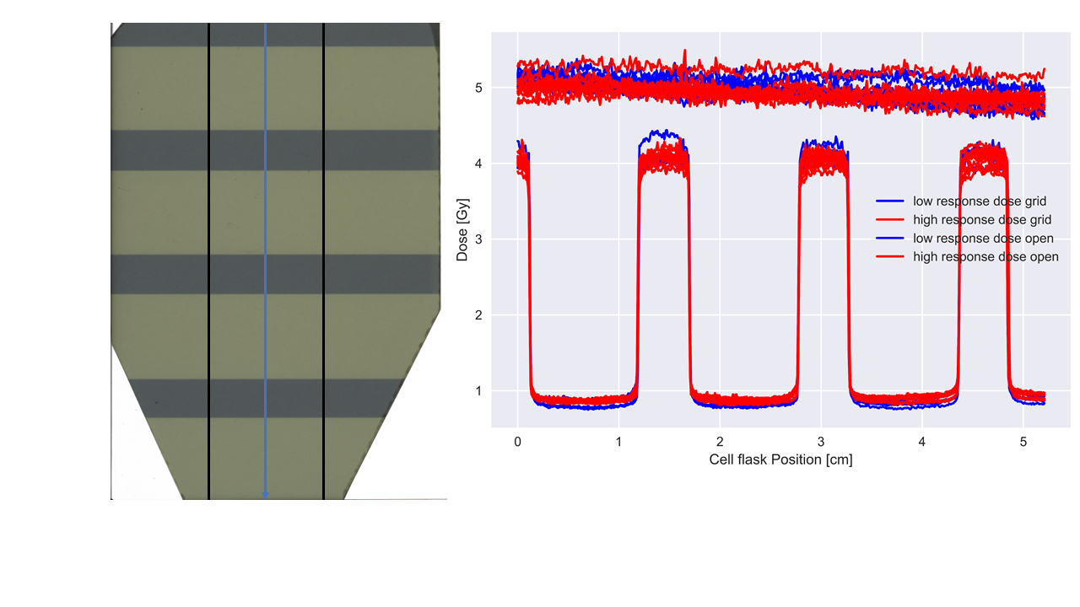

Figure 2‑11. Dose profile for striped GRID measured by calculating mean dose for each pixel row in the image. The image was cropped before making a dose profile to remove variations in mean dose caused by areas where the GRID pattern was not of equal length (see bottom of image to the left).

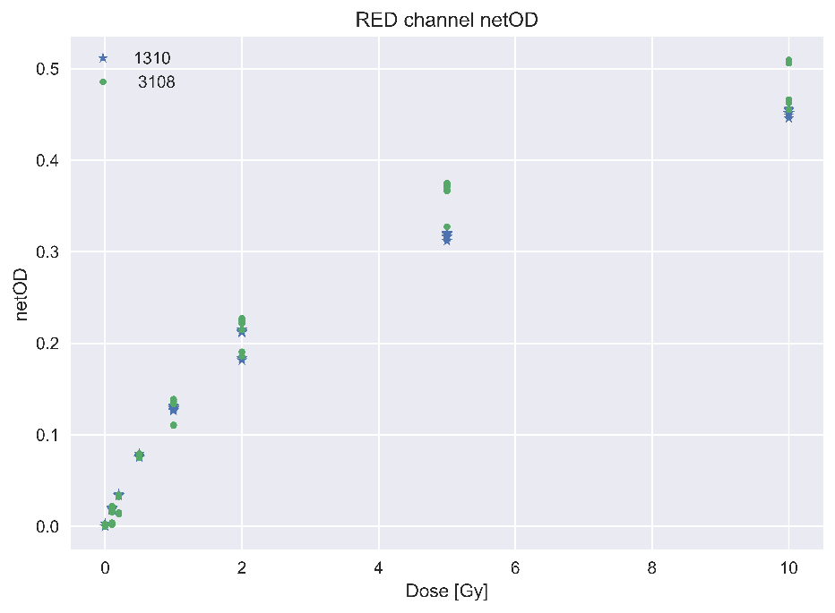

Figure 2‑12. netOD of red channel for both sets of calibration films 3108 and 1310. We see a clear separation for the first set, but for the second there are some films with high and some with low response.

## Cell Experiments

Cell experiments were performed by Magnus Børsting in his master thesis:   
*“GRID irradiation and bystander effect in lung cancer cells”*(Magnus Børsting, 2020, 45-56)*.*  
  
A549 cells were chosen for in vitro GRID irradiation. The cell line is a alveolar basal epithelial cancer cell originating from the study of 200 human tumors, where the goal was to establish cell lines (Giard et al., 1973). An alveolar cell originates from the alveoli of the lungs, which are small cavities that exchange oxygen for carbon dioxide. Epithelial cells are cells that covers the surface areas of the body (*Epithelium | Anatomy | Britannica*, 2009). Basal means that the cell is found in the lower parts of the epithelium (Morgenroth & Ebsen, 2008, p.70).   
30 000 cells were seeded with 6 ml growth medium in a T25 cell flask (Nunclon, Denmark) with 25 cm2 cell culture area. The cells were incubated in an incubator (Thermo, USA) holding ${37}^{∘}$ C with a CO2 percentage of 5%. The number of 30 000 was found by Magnus Børsting after performing a pilot experiment where different cell densities were used. All experiments used 30 000 cells to remove variability in survival that occurs for different cell densities. The number was chosen because it best balances the need of having enough cells to measure the effect of high doses, but small enough that it is possible to identify individual colonies.

The irradiations of the cells were done using the same experimental setup as shown in Figure 2‑5, and the same X-ray beam settings were chosen, with the same filtration. The differences were that no Gafchromic film or nylon6 slab was used. The cells are as mentioned seeded at the bottom of the cell flask, with medium covering the cells acting as the buildup material. The irradiation cabinet seen in Figure 2‑2 has a heater, ensuring the ideal temperature of ${37}^{∘}$ C.   
Nominal doses of 2, 5 and 10 Gy were chosen. Four flasks were used per dose point, including control flasks. The irradiation was done for OPEN field, GRID stripes and GRID dots.

A colony is a cluster of more than 50 cells (Franken et al., 2006). Number of colonies formed after irradiation was our metric of survival. It was chosen to wait six days before fixating the cells, seeing that a typical doubling times for A549 cells is 22 h (*A549 Cell Subculture Protocol – A549 Cell Line*, n.d.). Fixation of cells is the process of fixing the cells in their position and terminating all ongoing biological mechanisms, essentially killing them and disabling their natural degradation mechanisms so they can be viewed in a microscope (Panzacchi et al., 2019).  
3 ml of Ethanol was used to fixate. Ethanol was chosen because it is fast and has optimal preservation of cell structure (Rahman et al., 2022).  
The number of surviving colonies was counted using a segmentation algorithm, it was therefore necessary to stain the cells to make it easier for the algorithm to separate individual colonies. 3 ml of methylene blue dye was added. Because of a specific chemical reaction that only occurs in living cells, only dead cells are colored by the dye (O’Connor-Cox et al., 1997).

After fixation and staining the cell flasks with cells were scanned by Bjørg Vårli Håland the same way as the EBT3 films (see 2.1.2.2), except for a dpi of 1200 with the resolution of 2220 x 2976 x 3. The cell flasks have a height making it impossible to close the scanner completely. The scans of the cell flasks will therefore have a slight angle, causing a sharp dark shadow on the image.

## Segmentation

Segmentation of cells was performed by Delmon Arous in the article:   
*“Principal component-based image segmentation: a new approach to outline in vitro cell colonies”.* (Arous et al., 2022).   
  
This section uses the same notation found in (Strang, 2006, p.425-427).  
The scanned cell flask images were segmented using a combination of PCA, GLCM, k-means and topological multi-threshold watershed. The segmentation was performed with MATLAB. PCA is principal component analysis and aims to reduce the dimensionality of the image while retaining most of its variation (Jolliffe, 2002, p. IX). For easier understanding one scanned image of a cell flasks is used as an example. The dimension of the image is M x N x 3. By collapsing the first two dimensions and transposing the matrix, you get the matrix $X ϵ R^{3 x MN}$. Each column represents the RGB values ${\left[r_{i}, g_{i}, b_{i}\right]}^{T}$. The data is centered around the origin by subtracting the mean $μ ϵ R^{3 x 1}$ of each row of $X$ from the $r_{i}$, $g_{i}$ and $b_{i}$ values, to generate $\hat{X}=X-μ$. The covariance matrix $C ϵ R^{3 x 3}$ is generated from $\hat{X}$ and explains how the color channel intensity values r, g and b vary among themselves.

Through Singular Value Decomposition (SVD), which will not be elaborated further, the eigenvectors of $C$ is found and represented by the matrix $P=[u_{1}, u_{2}, u_{3}] {ϵ R}^{3 x 3}$.The eigenvectors are ordered in descending order, from highest to lowest variance. The important thing to note is that the eigenvectors are per definition uncorrelated, so they represent different parts of the image. It is therefore possible to isolate the eigenvector that represents the variance of the clusters of cell colonies in the image. Using the eigenvectors, you can transform the data in $\hat{X}$ into the PCA space using the transformation

$$\hat{Y}=P\hat{X}=\left[\begin{matrix}u_{1}^{T}{ \hat{X}}_{i} \\ u_{2}^{T}{ \hat{X}}_{i} \\ u_{3}^{T} {\hat{X}}_{i}\end{matrix}\right] ,$$

where $\hat{Y}$ are the new pixel values in the transformed data. $\hat{Y}$ is divided into three parts $I_{PCA1},I_{PCA2}$ and $I_{PCA3}$**,** which is named the PCA images with dimension 1 x MN. Deciding which image that contains cell colony variance was decided using the Grey-level co-occurrence matrix (GLCM) (Haralick et al., 1973), assuming that the suitable $I_{PCA}$ is composed of pixel values that are insensitive to and suppress the presence of various high-contrast artefacts, such as contaminants or residue in the suspension medium, shadow artefacts or background noise from the scan acquisition and the cell container boundary.

With a suitable $I_{CPA}$ it was necessary to distinguish background from foreground. I.e., cell colonies from black background. Using k-means on clusters of 9 pixels (one central pixel, with eight surrounding pixels), the pixels were assigned to either foreground or background (Lloyd, 1982). The resulting matrix is a binary mask (only two intensity values) with foreground objects named Binary Large Objects or BLOBs.

Topological multi-threshold watershed segmentation is applied to separate the BLOBs (see Figure 2‑13 into individual colonies (Khan et al., 2016). The watershed works by identifying parts of an image with local intensity minima known as catchment basins. These areas are filled with colors to identify different objects within the image (Preim & Botha, 2014, p.130). If watershed was used on the original scanned images, which does contain noise, dust etc. it would see all these artefacts as cell colonies. But because the BLOB’s coordinates were extracted using PCA, they are independent from the mentioned artefacts. Each BLOB was searched for local minima in intensity, but watershed has a tendency to over-segment an image caused by naturally occurring variations in intensity (Preim & Botha, 2014, p.130), therefore minima with depth less than a threshold value h was suppressed.   
After segmentation, the program returned information about individual colonies’ centroid coordinates, area, circularity, mean and standard deviation of intensity, as well as delineated cell flask images (see Figure 2‑13)

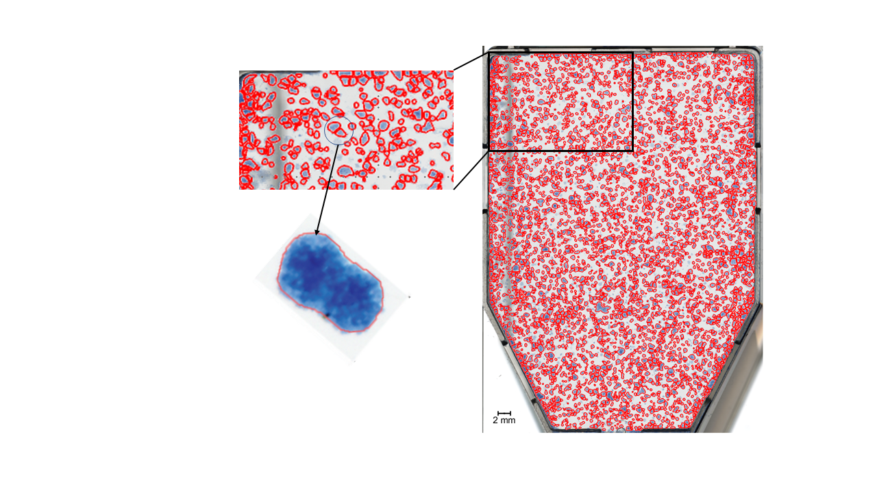

Figure 2‑13. An example of a BLOB that is difficult to classify. The red circles are delineations of colonies stained with blue dye.

## Cell Survival Analysis

With an established dosimetry for the cells, we could analyze the survival data from Delmon Arous’ segmentation program. Magnus Børsting performed four different single fractionation experiments. The irradiation configurations used in these experiments are summarized in Table 2. A traditional 1D analysis was performed on OPEN field and striped GRID irradiations, to have a basis of comparison for the novel 2D approach.

### Data acquisition and image registration

**The scanned cell flask images will from here on out, be referred to as cell flasks, and the scanned dosimetry films will be referred to as dosimetry films or simply films**.

For our 2D survival analysis we used Poisson regression, which models counting data. This limited how much data we could use. As mentioned in 1.7.4, one might normalize survival data using the plating efficiency to compare experiments performed under different conditions, but as Poisson regression demands counts, this is not possible. We still wanted to use as much data as possible. We therefore used Analysis of Variances (ANOVA, explained in 2.1.2.2) to evaluate the differences in mean number of colonies found in the four control cell flasks per experiments. There was no significant difference between experiments performed on the 18.11.2019 and the 20.11.2019. We therefore chose to combine these results for increased statistical significance in our calculations. Using the centroid coordinates of the cell colonies we created a colony map (binary), where intensity value 1 indicated a cell colony. The coordinates were in decimals, it was therefore necessary to round to nearest neighboring whole number pixel to place the colony in the colony map. In our 2D analysis we divided the cell flasks into quadrats of different sizes. The smallest size of our quadrats will be 0.5 mm2, which for a 1200 dpi image assuming 25.4 pixels per mm and a one-to-one relationship between dots and pixels, corresponds to a 24 x 24 matrix. We therefore chose to neglect the round off error.   
The films needed to be registered to the cell flasks. As mentioned, the different irradiation configurations (GRID or OPEN field, Stripes or Dots) needed various degrees of image processing, but the common modification was to match the resolution of the images. We either had to downscale the resolution of the cell flasks (1200 to 300 dpi), or upscale the resolution of the films (300 to 1200 dpi). The latter was chosen to retain as much accuracy as possible when pinpointing the positions of the cell colonies. Downscaling an image may result in valuable information being lost, and the centroid position of the colonies would be spread out onto four pixels with 0.25 intensity. For evaluation of interpolation performance, we used the mean dosimetry map for OPEN field irradiation and performed a welch t-test on the relative errors of the dose profiles for the unchanged and the upscaled image.

Table 2. Segmentation data generated by Delmon Arous, PhD student, from experiments performed by Magnus Børsting, former Msc student.

|  |  |  |  |  |
| --- | --- | --- | --- | --- |
|  | **Experiments** |  |  |  |
| **Configurations** | 18.11.2019 | 20.11.2019 | 03.01.2020 | 17.12.2020 |
| OPEN | ✓ | ✓ |  | ✓ |
| GRID Stripes | ✓ | ✓ |  | ✓ |
| GRID Dots |  | ✓ | ✓ | ✓ |

The films and the cell flasks are different images, we therefore needed to create binary maps to enhance the similarity of the images. E.g., for striped GRID we see dark striped patches in the peak area matched by a decrease in survival in the same area of the cell flasks (see Figure 2‑7). Changing the intensity to match these patterns helped to improve the registration. This approach was also used for OPEN field and dotted GRID. We still used a rigid body registration because the main displacements were still translational and rotational. However, assuming no influence on the scanning by the cell flask other than not properly closing the cover (see 2.2), the cell flask bottom has small feet that slightly raises the cells above the glass plate of the scanner. Because the films were scanned directly on the glass plate, there is a slight height difference of about $0.250±0.001$ cm, accounting for the feet and the thickness of the cell flask bottom. This led to a small error in registration, but not large enough for us to use scaled rotation (translation, rotation, scaling). This scaling is not increasing number of pixels using interpolation, but the process of increasing or decreasing the size of the image without changing the number of pixels.

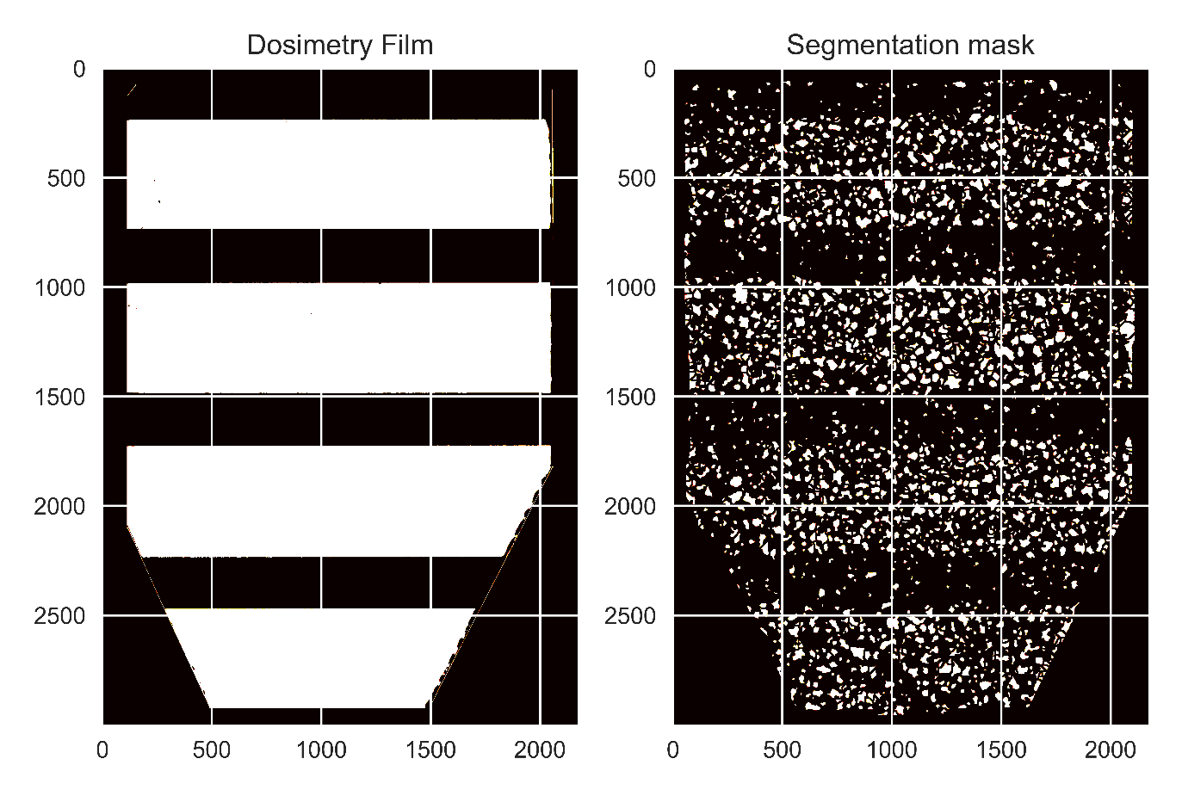

Figure 2‑14. How the patterns of the segmentation mask and the dosimetry films were matches for better registration. One of the 16 dosimetry films for striped GRID can be seen on the left, and the segmentation mask of surviving colonies can be seen on the right.

### 1D Analysis

A 1D analysis of survival to have a basis of comparison when performing our novel 2D analysis. For OPEN field data we used the traditional LQ model. Log transforming equation 1‑23 we get the quadratic expression

$$\log{S=}-αD-βD^{2} ,$$

that we could fit using ordinary least square (OLS) fitting from the *statsmodels* package (Seabold & Perktold, 2010) in Python. It finds the optimal parameters, with uncertainty, using the closed form solution of least squares (see 1.6.1). The OLS function takes the response variables $y$ and the explanatory values $X$. It demands $X$ tohave the shape m x n, with m datapoints and n regressors. With dose and dose squared as regressors you get the matrix

$$X= \left[\begin{matrix}1 & d_{0,1} & d_{0,2}^{2} \\ 1 & d_{1,1} & d_{1,2}^{2} \\ 1 & d_{2,1} & d_{2,2}^{2} \\ ⋮ & ⋮ & ⋮ \\ 1 & d_{n,1} & d_{n,2}^{2} \end{matrix}\right] ,$$

where the first column was added so statsmodels fits an intercept as well as $α$ and $β$, as we were not interested in forcing our regression through zero. We only used data from 2 and 5 Gy, because the segmentation algorithm did not work for 10 Gy OPEN field. We therefore had to extrapolate the curve to cover 10 Gy. Because all flasks were seeded with 30 000 cells, we normalized the data using mean survival of the control flasks across all experiment included in the analysis. The 95% confidence interval of estimated survival was found using *statsmodels’* own method.

Striped GRID data was analyzed by iterating over the rows of the colony map and summing up number of surviving colonies within each row. As seen in (Figure 2‑13), not all rows have an equal area to grow cells. Using a binary template image of the cell flask (0 is background 1 is cell flask), provided by Delmon Arous, we found a weighting factor for each row-sum based on the ratio of zeros and one $w=1+\frac{zeros}{ones}$. We divided the rows into survival bands of specified widths and summed up the colonies within the bands. Survival profiles were made by finding the mean survival within the bands for all cell flasks (see Figure 2‑14). The observed survival was compared to the survival predicted by the LQ model. Because of the heterogeneous dose distribution of GRID irradiated cell flasks, predicting survival was done by dividing the mean dose map into bands, and finding the mean dose within the bands and inserting them into the LQ model.

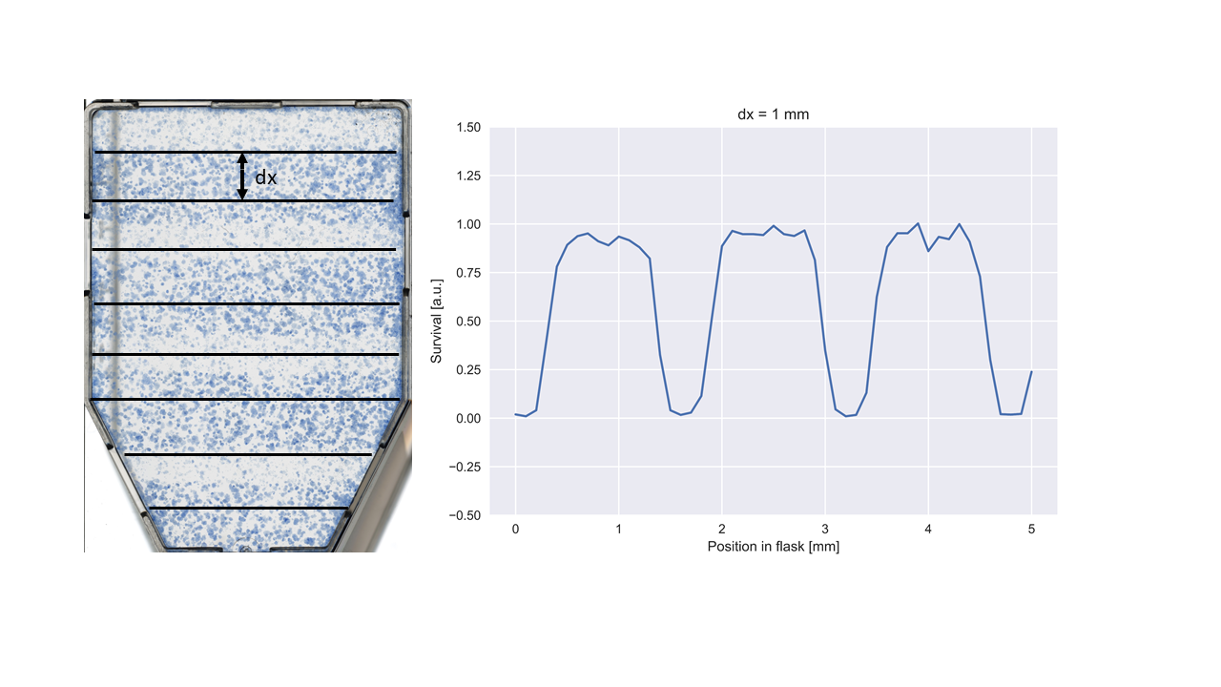

Figure 2‑15.

### 2D Analysis

This method of analysis was best suited for striped GRID as the survival naturally separated into high and low survival bands following the shape of the GRID. But we wanted the analysis to be independent from GRID configuration, and therefore introduced a 2D analysis method using Poisson regression (see 1.6.3).

#### Pooling

We started by dividing the registered cell flaks and dosimetry films into equally sized quadrats. Because of the geometrical displacement mentioned in 2.1.2.3, after registration, the GRID patterns would match nicely but the edges of the image would not. This limited the area where we had accurate dose measurements, thereby limiting the amount of survival data we could include.   
The number of colonies within each quadrat was summed using a *python* function called *LPPOOL2D* from the *pytorch* library (*LPPool2d — PyTorch 1.11.0 Documentation*, n.d.). The function lets a n x n kernel move in strides across the image, computing the power-average within the kernel

$$f\left(X\right)=\sqrt[p]{\sum_{x ∈X}{x^{p}}} .$$

Setting $p$ to 1, it simply finds the sum of the pixels within each kernel. The process of sum pooling is visualized in Figure 2‑15.Choosing a kernel with the same size as the quadrats, and a stride equal to the dimension of the quadrats, will let the kernel jump from quadrat to quadrat extracting the desired quantity from the pixel values within the quadrat.The dose of each quadrat was found in a very similar process called average pooling using the *AvgPool2D* (*AvgPool2d — PyTorch 1.11.0 Documentation*, n.d.). Choosing the right size of the quadrats is important, because you want to cover enough pixels to get a significant number of colonies within the quadrat. A 1 x 1 pixel sized quadrat would greatly inflate the number of quadrats not containing any colonies, making the data deviate from the Poisson distribution. But the quadrats must be small enough, so that the number of quadrats is large enough to have sufficient data for Poisson regression. Also, choosing quadrats too large leads to smoothing of doses because the quadrats might cover the area between a peak and a valley.   
We examined the survival data within the quadrats using sizes of 0.5 x 0.5, 1 x 1, 2 x 2, 3 x 3 and 4 x 4 mm2. Evaluations of each size were made using a set of measurements: zero inflation, reduction in dose variance and relative difference between variance and mean for peak and valley survival.   
The zero inflation was found by sum pooling the control cell flasks and finding the number of quadrats with zero colonies. Reduction in dose variance was found by finding the variance of the average pooled dose maps. The last two measurements were found by separating the mean dose map for GRID into peak and valley doses, where peak and valley doses were defined as greater than 75% of maximum, and smaller than 115% of minimum dose, respectively. Because the Poisson regression assumes Poisson distributed data with equal variance and mean, we calculated the relative difference between these quantities for peak and valley quadrats.

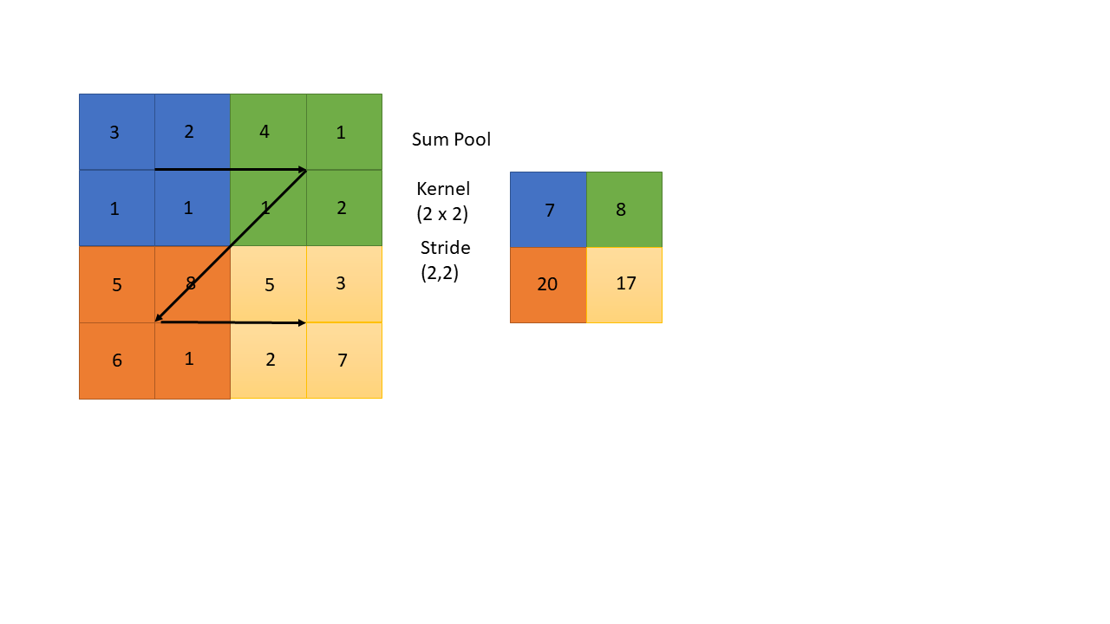

Figure 2‑16. Sum pooling, with a 2 x 2 kernel moving in 2 x 2 strides across the image, summing up the pixel values within the kernel. The arrows indicate the movement of the kernel.

#### Poisson Regression

For the Poisson regression itself, we chose the Generalized Linear Models (GLM) from the *statsmodels* module (Seabold & Perktold, 2010). GLM takes the response data $y$ and the explanatory data $X$**.** We chose to split the data into training and test (80/20 split). The training data was stacked together, to generate a model suitable for all irradiation scenarios: control, OPEN field, GRID stripes and GRID dots survival data. The test data was kept separate for model evaluation, which we will explain further in 2.4.2.5. GLM needs $X$ to have the shape m x n, with m datapoints and n regressors. E.g., using dose and dose squared as regressors you get the matrix

$$\left[\begin{matrix}1 & d_{0,1} & d_{0,2}^{2} \\ 1 & d_{1,1} & d_{1,2}^{2} \\ 1 & d_{2,1} & d_{2,2}^{2} \\ ⋮ & ⋮ & ⋮ \\ 1 & d_{n,1} & d_{n,2}^{2} \end{matrix}\right] ,$$

where the first column represents the intercept of the linear model in equation 1‑21. GLM also takes a family class. The family class provides the link function and the mean-variance relationship. We will of course use the Poisson family for our Poisson regression. After fitting the data, the GLM returns the estimated coefficients for our regressors, and numerous statistical quantities.

We wanted to expand the model and include regressors that could possibly explain difference in survival of GRID compared to OPEN field irradiated cells. We first incorporated the peak area ratios. The hope was that the ratios could describe degree of cell killing caused by changing GRID configurations. Secondly, we tried to incorporate the distance from a quadrat to nearest peak. This distance might explain the bystander effects occurring between the cells.

#### Peak area ratios

For both striped and dotted GRID we measured the area positioned underneath the grid opening, called peak area. Using a caliper and one irradiated EBT3 film, we were able to measure the area of the stripes to get peak area. However, poor cutting accuracy causes this area to be slightly different for all films and does not perfectly represent the peak area of the irradiated cells. The length measurements of the chosen film can be seen in Figure 2‑16. For peak 3 we assumed the same area as peak 1 and 2 of $4.3⋅0.5=2.15 cm^{2}$. Which results in the total area for peak 1, 2 and 3 of $3⋅2.15=6.45±0.01 cm^{2}$. Peak 0 had a trapezoidal shape, with the area of $\frac{3.19+3.64}{2}⋅0.5=1.7075±0.0004 cm^{2}$, which results in a total peak area of approximately $8.16 ±0.01 cm^{2}$. The total peak area was divided by the area of the bottom of the cell flask (25 cm2) to obtain peak area ratio. Uncertainties were found using the error propagation in equation 2‑2, with the assumption of no uncertainty in the width of the grid slits and the uncertainty of the caliper being 0.001 cm.   
For dotted GRID the peak area was found by multiplying the number of holes within the irradiated films, of which there was 7, with the area of the holes. The holes have a diameter of 5 mm, resulting in a peak area of $7⋅π{\left(\frac{0.5}{2}\right)}^{2}=1.37 cm^{2}$ No uncertainties were estimated because no caliper measurements were needed. Peak area ratios were found similarly as for striped GRID. For OPEN field all area would be within a “peak”, and peak area ratio was therefore 1. The control films were not irradiated; hence they are neither peak nor valley and the peak area ratio was set to 0.   
In Table 3 we see the peak area ratios for all irradiation configurations.

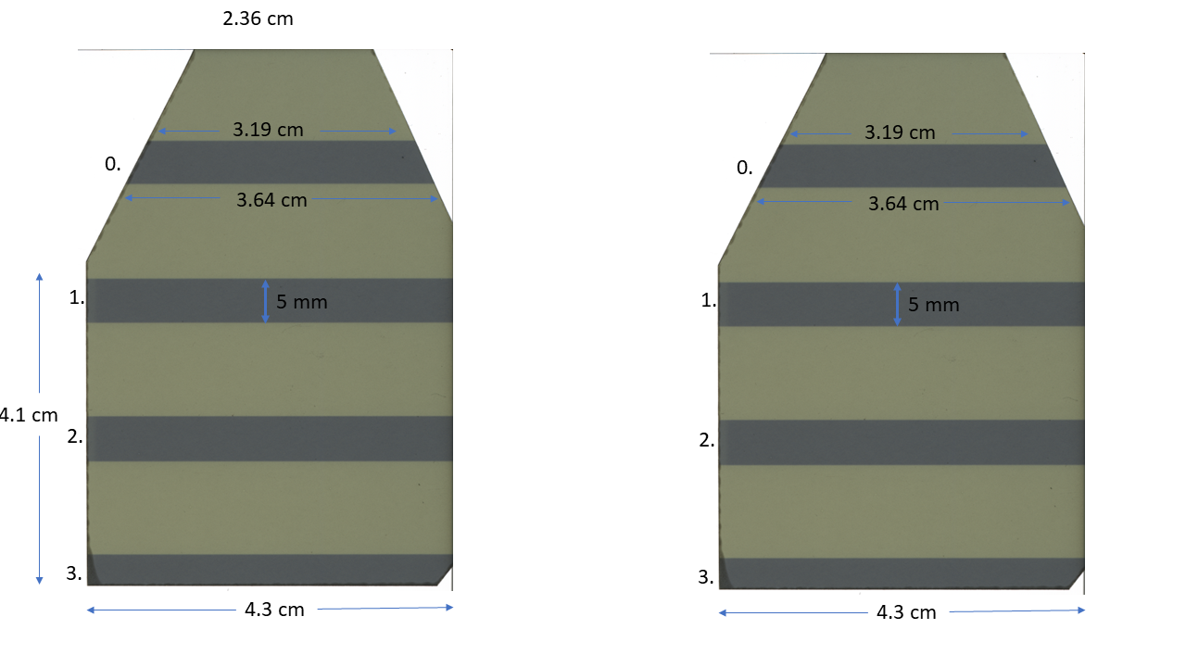

Figure 2‑17. Caliper measurements on irradiated EBT3 film. Every peak is marked with a number.

Table 3. Peak area ratio and valley area ratios for dotted and striped GRID. The area measurements for striped GRID were found using an irradiated EBT3 film.

|  |  |  |  |  |
| --- | --- | --- | --- | --- |
|  | Dots | Stripes | Open | Control |
| Peak area ratio | $$0.05498$$ | $$0.32640±0.0005$$ | $$1$$ | $$0$$ |

#### Nearest Peak estimation

An algorithm was made to loop over each quadrat and find the distance to the nearest peak. The code can be found in Appendix A. Note that $\text{kernel_size}$ is the length of the sides of the quadrats converted to pixels.

We defined peak dose as 85% of maximum dose to cover variance in peak doses. Contour lines were generated at the peak doses. To exclude sporadically occurring high intensity pixels, which did not constitute peak doses, we only included lines surpassing 500 pixels. The two loops are looping over rows and columns in the pooled image, jumping from quadrat center to quadrat center. For all centers, the algorithm finds the smallest Euclidean distance between the center and each peak contour lines. It then saves the smallest distance, i.e., it finds the distance to all the peaks and stores the smallest one in a matrix. If the quadrat is positioned within a peak, then the distance should be set to 0. An if-test handles this scenario.   
When looping over the quadrat centers in the pooled image, index *i* is not 0,1,2 etc., but will follow $\sum_{k=0}{\frac{\text{kernel_size}}{2}+\text{kernel_size}⋅k},$ where k represents the iteration we are currently on. In the case of a 3 x 3 mm2 quadrat, converted to 141 x 141 pixels using the 47 pixels per mm conversion from equation 2‑6, *i* becomes 70,211,352 etc. One cannot index the distance matrix using these values.  
It was therefore necessary to find a general expression to downscale the indexes, so they become 0,1,2 etc. For the case of odd quadrat pixel size, we used the formula

$$i-\frac{\text{kernel_size}}{2}⋅\text{odd_i} ,$$

where odd_i is 1,3,5 etc. The formula is equivalent for i and j. The resulting distance measurement are illustrated in Figure 2‑17.

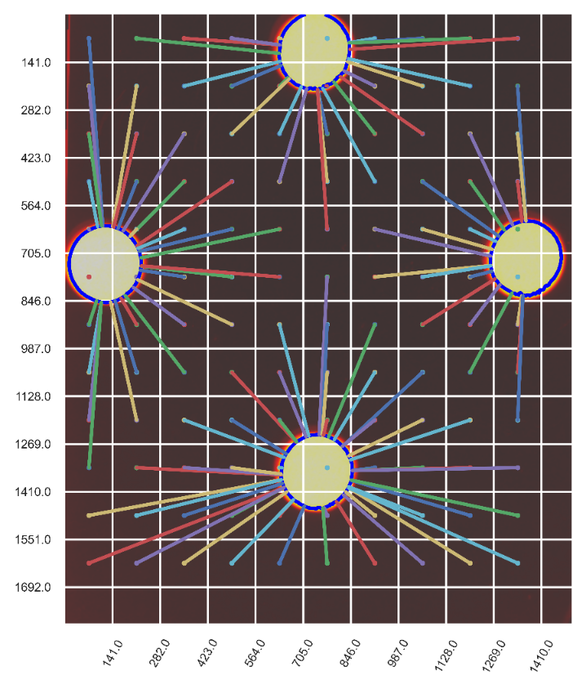

Figure 2‑18. Illustration of nearest peak distance for all quadrats of size 3 x 3 mm2 with dotted GRID configuration. The distances of quadrats with center located inside a peak, are not found.

#### Model Evaluation

Introducing more regressors might lead to a better result but making a more complex model might lead to overfitting. The opposite problem occurs if not enough complexity is introduced.   
Overfitting and underfitting is illustrated using polynomial fitting in Figure 2‑18.   
Akaike information criteria (AIC) is a model selection metric that represents the tradeoff between overfitting and underfitting, and is found using the expression (Burnham & Anderson, 1998, p.47)

$$AIC=2k-2\ln{\hat{L}} ,$$

where $\hat{L}$ is the likelihood (see maximum likelihood function 1.6.3) when the algorithm reaches convergence (or maximum iterations have been reached). $-2\ln{\hat{L}}$ tends to shrink when introducing more regressors. *k* is the number of estimated parameters making AIC increase when adding more regressors to your model. A small AIC is desired, but evaluating a model using AIC alone is not fruitful, as AIC increase with sample size (Burnham & Anderson, 1998, p.55). However, if two models are curated from the same dataset, we can use AIC to find the model that strikes the best balance between complexity and generality.   
AIC values were extracted from the GLM model. The model was also evaluated based on how well it predicted survival $\hat{y}$. For all irradiation configurations, including control, we found the mean squared error.

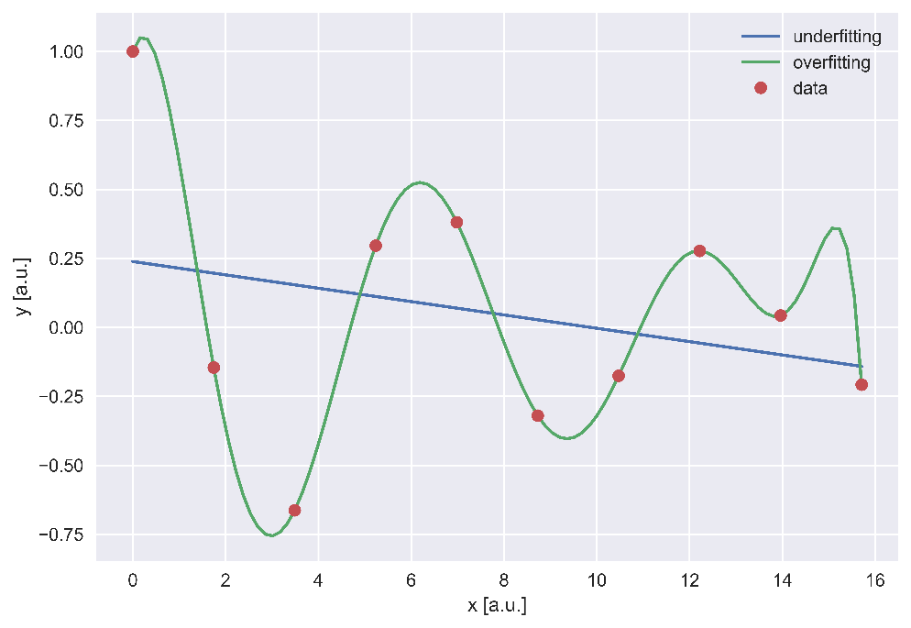

Figure 2‑19. Overfitting vs underfitting of data. The Straight blue line fits the data using a one-degree polynomial, while the green line fits the data using a tenth degree polynomial.

Todo:

Get results!

Husk å se på tidligere artikler

# DUMP

Getting ${σ_{\overline{PV}}}_{ctrl}$ and $σ_{{\overline{PV}}_{bckg}}$ we need to combine the standard deviations of the individual films using pooled standard deviation. With the assumption of independent images, equal variance, and sample size we can use the formula

$$\sqrt{\frac{\sum_{i=0}^{n}{σ_{i}^{2}}}{k},}$$

where k is the number of samples.

We can also find confidence intervals from the covariance matrix. A confidence interval for e.g., 95% confidence claims that the true population mean will be within the limits of the confidence interval 95% of the times a sample mean is measured. For a general mean value $\overline{X}$, the confidence interval is found using the formula

$$\overline{X }±t_{crit}σ_{\overline{X}}=t_{crit}\frac{σ}{\sqrt{n}} ,$$

if the t distribution has a mean of $μ$, then $t_{crit}$ is the number of standard deviations out from $μ$ in both directions that encapsulates the allowed variations of $μ$. $σ_{\overline{X}}$ is the standard deviation of the mean $\overline{X}$.

**we ended up not using this to generate confidence interval**

In the general case of fitting a function $G(x)$ with LM, $σ_{\overline{X}}$ was found with the delta method. Differentiating $G(x)$ w.r.t. all the parameters $p$ and multiplying with $Σ$ on both sides gives the variance of $G(x)$ for all $x$ (Thomas S. Robinson, 2020)

$$Var\left(G\left(x\right)\right)= G^{'}\left(x\right)Σ G^{'}\left(x\right) ,$$ squaring this expression and dividing by the square root of number of observed values n.

# Results

## X-ray dosimetry

Maybe only include $R^{2}$

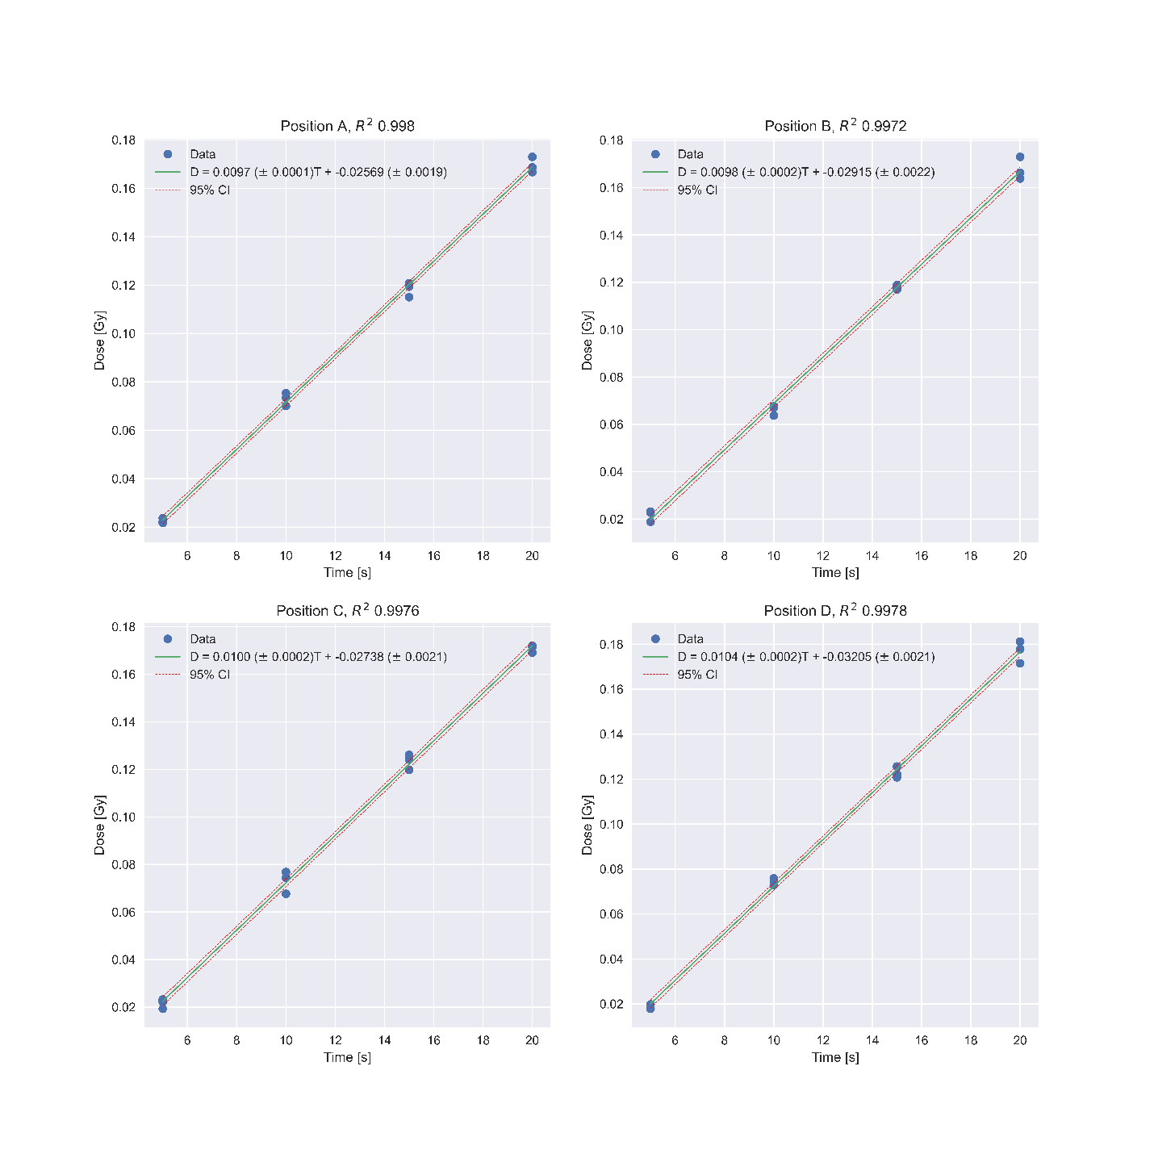

Resulting in a mean fit of

$$\hat{D}=0.0010±0.0002⋅T-0.029±0.003$$

With all four positions we got a mean doserate of

$$\dot{D}= 0.5918±0.0005 Gy/min$$

31.08.21

Table 4.

|  |  |  |  |  |  |  |  |
| --- | --- | --- | --- | --- | --- | --- | --- |
| Dose [Gy] Exposure Time | 0.1 | 0.2 | 0.5 | 1 | 2 | 5 | 10 |
| 31.08.21 | $$13.1s±0.3$$ | $$23.4s±0.4$$ | $$54s±8$$ | $$1 m 43 s \\ ± 2 s$$ | $$3 m 27 s \\ ±5 s$$ | $$8 m 39 s \\ ± 13 s$$ | $$17 m 19 s \\ ± 26 s$$ |
| 13.10.21 | $$13.0s \\ ± 0.3$$ | $$23.1s±0.5$$ | $$53.3s±0.9$$ | $$1 m 40 s \\ ± 1 s$$ | $$3 m 21 s \\ ±3 s$$ | $$8 m 22 s \\ ± 9 s$$ | $$16 m 45 s \\ ± 19 s$$ |

13.10.21

Mean fit

$$\hat{D}=0.00102±0.0002⋅T-0.0305±0.0024$$

For all four positions you get a mean dose rate of

$$\dot{D}= 0.5969±0.0004 Gy/min$$

## Gafchromic film

Because of very large sample size the F-distribution becomes narrow.

Maybe this plot should be in appendix, and we only have the result here.

Figure 4‑1. P-values from ANOVA test, comparing mean gray channel pixel values of the four scans. The majority of the scans were not significantly different.

ROI eval.

Table 5. Relative error calculations for different calibration ROIs based on OPEN field dose maps with analysis area of 565 x 300 pixels.

|  |  |  |  |
| --- | --- | --- | --- |
| ROI (mm2) | 2 x 2 | 3 x 3 | 4 x 4 |
| Relative error | 0.00088 | 0.00130 | 0.00188 |

Color channel eval

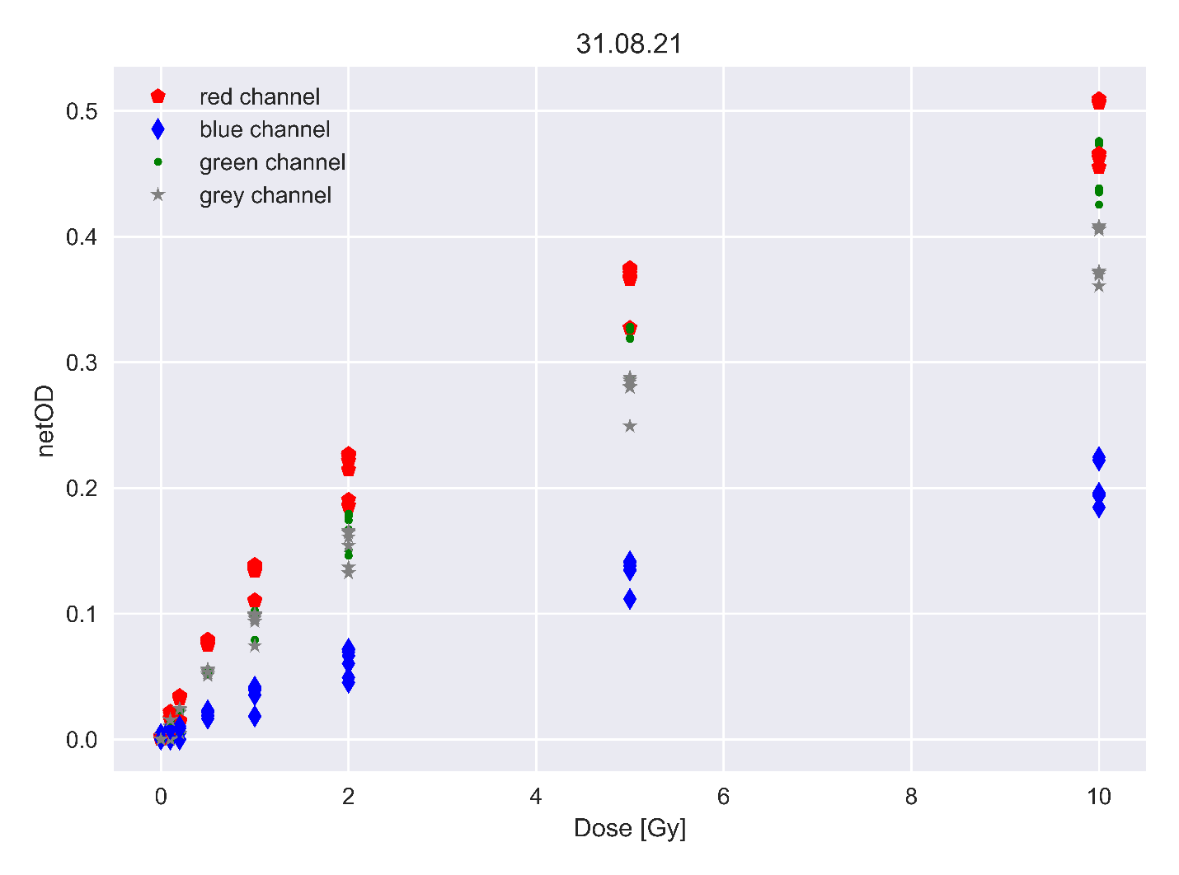

MSE for different color channels

|  |  |  |
| --- | --- | --- |
|  | MSE |  |
| Color Channel | Low response | High response |
| BLUE | 0.03319 | 0.00994 |
| GREEN | 0.01367 | 0.00266 |
| RED | 0.01004 | 0.00236 |
| GREY | 0.01617 | 0.00313 |

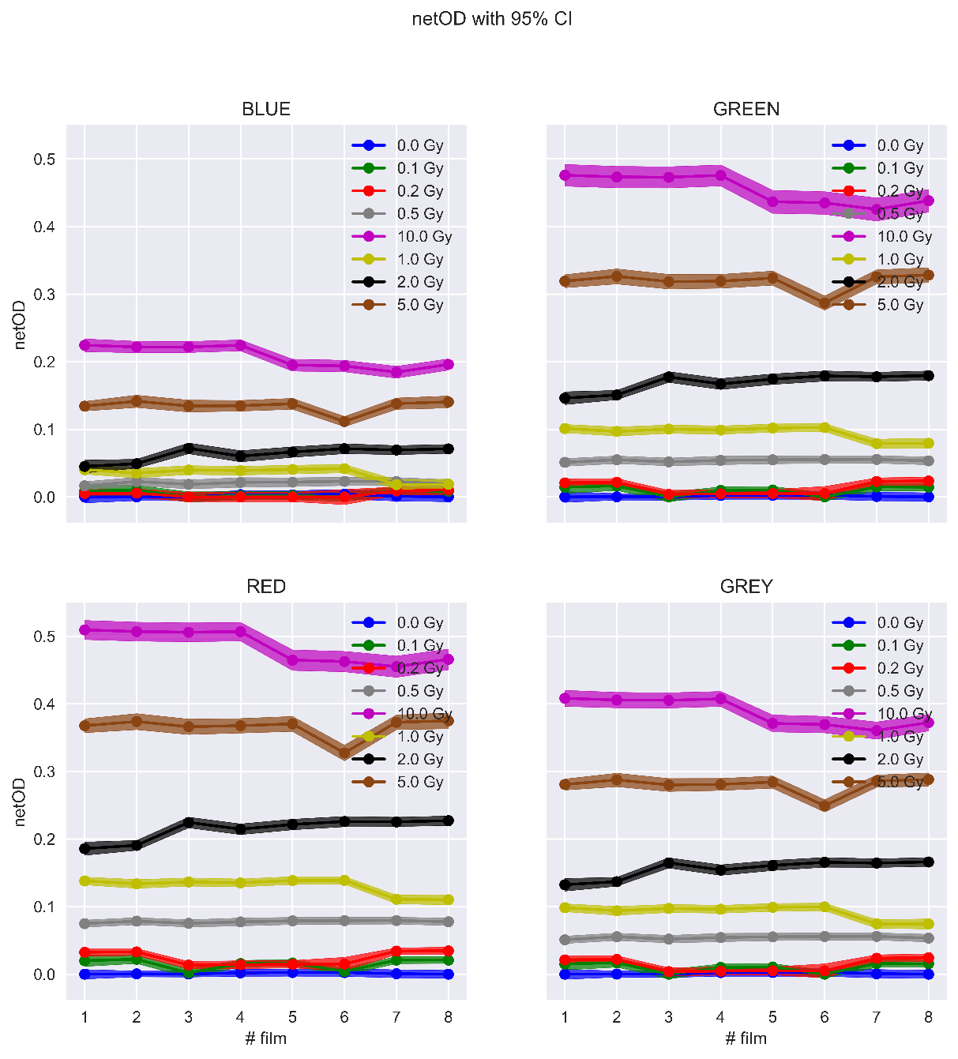

LM fit

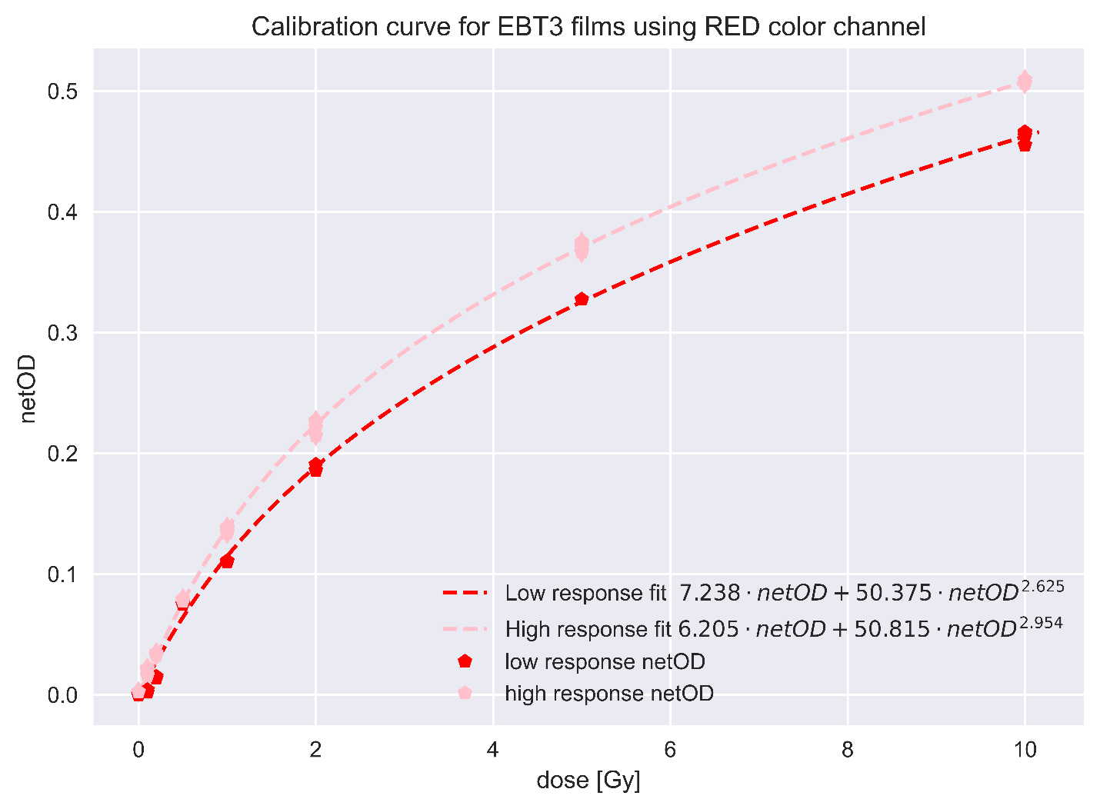

Random initialization of LM guess.

In Appendix A you can find the initial guesses made for the LM algorithm. We see that in all but one of the tests runs we ended up with the same set of parameters.

Dose profile

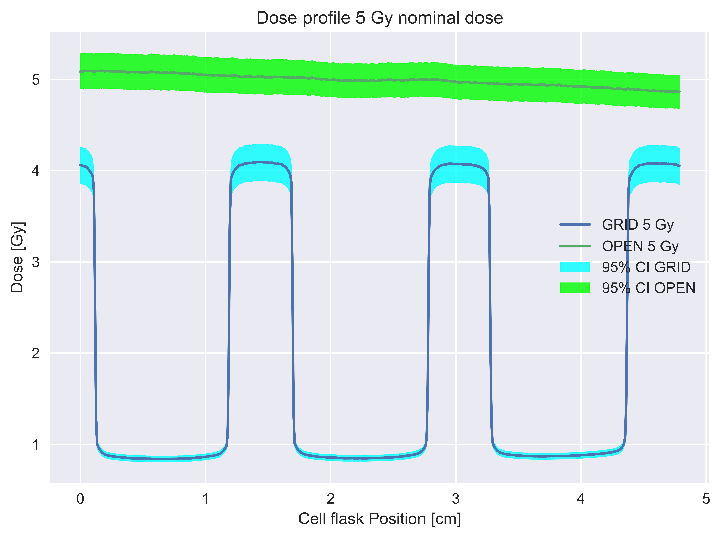

Dose profile dotted grid

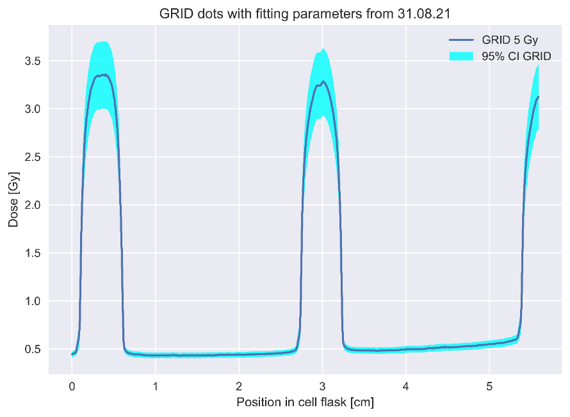

131021

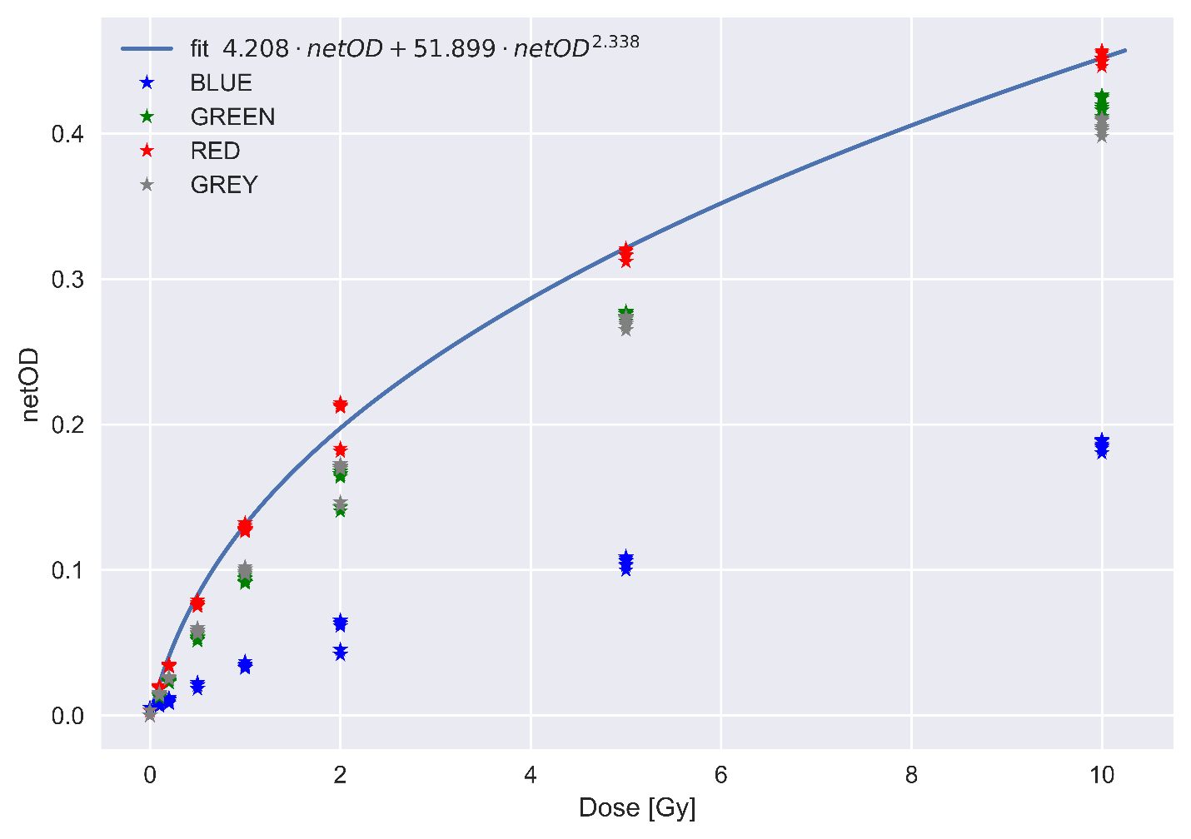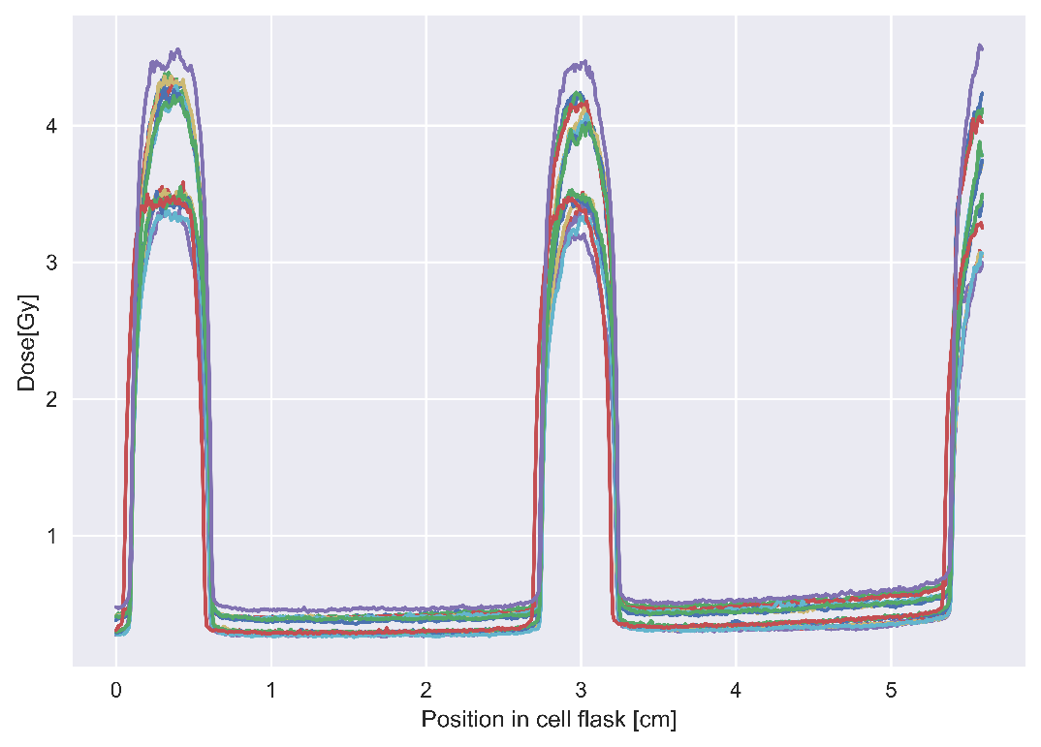

## Cell survival

Data acquisition

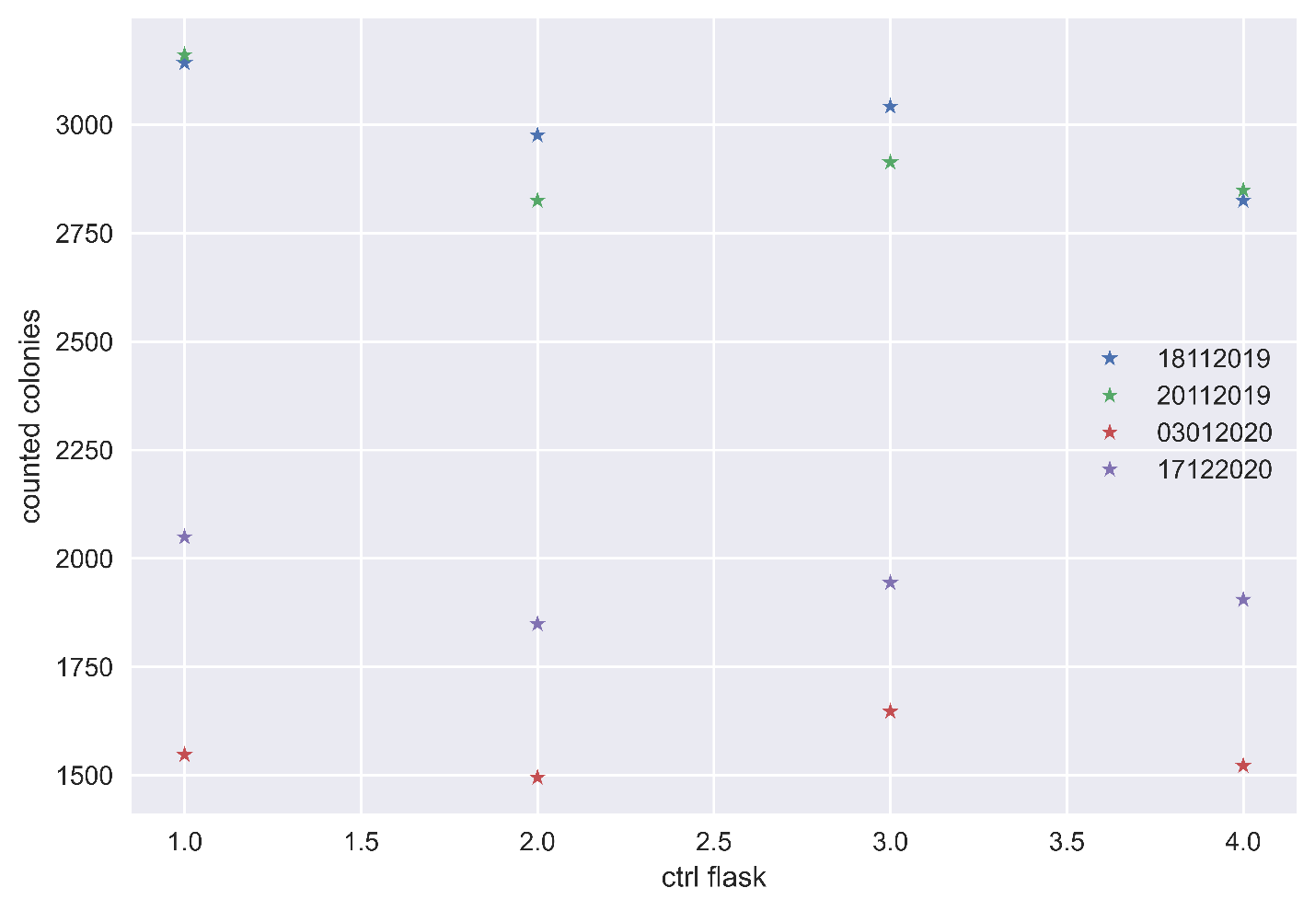

ANOVA results we see from the plot that the data with the most means are 17122020 and 03012020, 18112019 and 20112019. We therefore performed ANOVA on these individual combinations of data.

Table 6. Based on which means were closest, we performed an ANOVA test on the associated data. The P-values from this test is seen in the third row.

|  |  |  |  |  |
| --- | --- | --- | --- | --- |
|  | 18.11.2019 | 20.11.2019 | 03.01.2019 | 17.12.2020 |
| Ctrl flask counted colonies | 3142 | 2976 | 3042 | 2825 |
| Anova p-value | 0.581 | | 0.0004 | |

## 1D survival

Regression fit

$$\hat{S}= -0.06±0.04 D-0.011±0.008 D^{2}$$

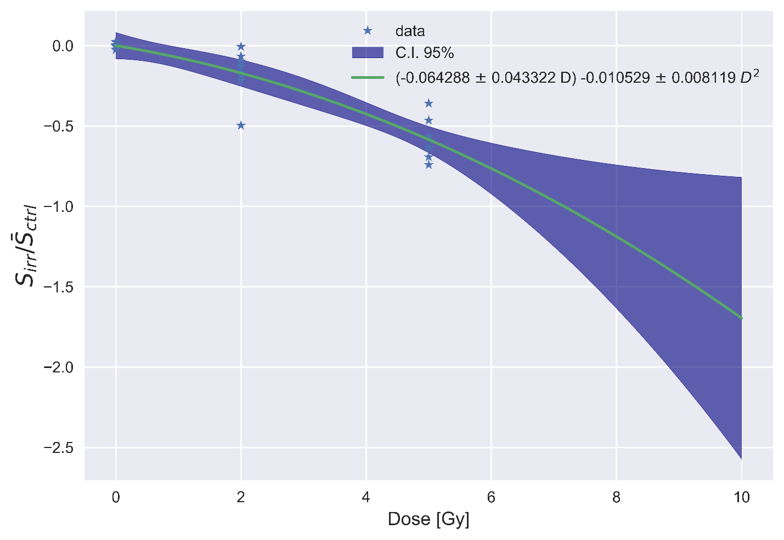

GRID

Row weights

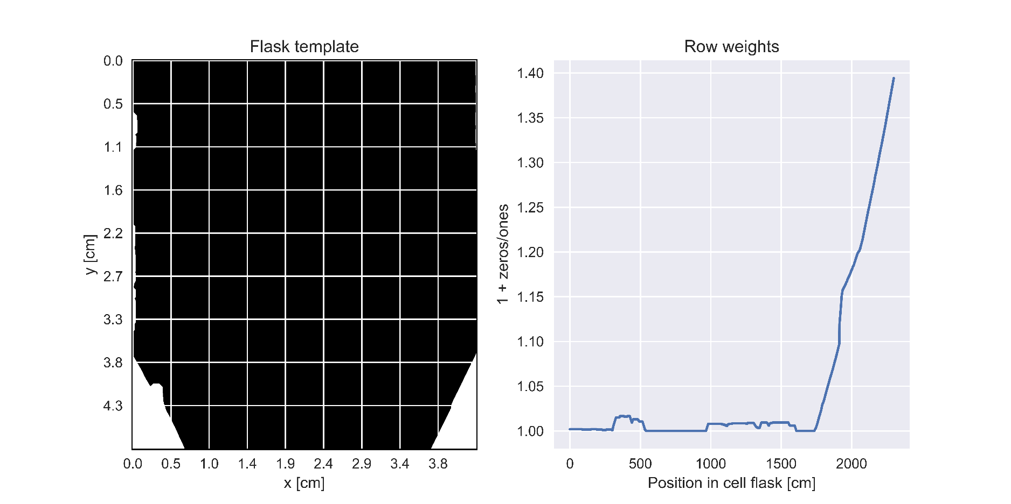

# Discussion

## X-ray Dosimetry

## Gafchromic film dosimetry

Discuss the two responses seen in 31.08.21 and not in 13.10.21, and how we suspect film to film variations.

It has been shown that the size of the ROI affects the dosimetry, and for field sizes (area of radiation field at a specified SDD) larger than 10 x 10 mm2 an ROI of 4 x 4 mm2 is recommended (Gholizadeh Sendani et al., 2018).

Red channel dosimetry (Micke et al., 2011)

## 1D survival analysis

## 2D Survival analysis

Klassen et al. proposed cleaning the films, because of their tendency to gather dust. This was not discovered until after the experiments were performed.

Maybe we got two responses because we didn’t manage to only scan in one direction, because of the long side not being long enough. But then why did it also appear 13.10 when we ensured correct orientation by making the longer side longer to enhance the difference.   
  
In (ref here) we see the intra-batch response variation. The source of variation is unclear, but one reason might be that the films might have flipped during handling as explained in (ref here). However, the method was improved for the second calibration, and we still had a split response.

The dosimetry for both OPEN field and GRID was validated with Monte Carlo simulations performed by Delmon Arous, PhD-student. He used FLUKA, a particle physics Monte Carlo simulation package to simulate how the photons would interact in our experimental setup. Thereby, accurately measuring how the different GRID collimators affected dose in peak and valley areas.

# References

*A549 Cell Subculture Protocol – A549 Cell Line: Cell Culture and Transfection Protocol*. (n.d.). Retrieved April 5, 2022, from https://www.a549.com/cell-subculture-protocol/

*Adenosine triphosphate | Definition, Structure, Function, & Facts | Britannica*. (2020, March 12). https://www.britannica.com/science/adenosine-triphosphate

Aksnes, I. (2020, November 8). History of X-rays—125 years in the making (pt 2). *Excillum*. https://www.excillum.com/history-of-x-rays-x-ray-tubes/

Alberts, B., Johnson, A., Lewis, J., Raff, M., Roberts, K., & Walter, P. (2014). *Molecular Biology of the Cell* (6th ed.). Garland Science.

Aldelaijan, S., & Devic, S. (2018). Comparison of dose response functions for EBT3 model GafChromicTM film dosimetry system. *Physica Medica*, *49*, 112–118. https://doi.org/10.1016/j.ejmp.2018.05.014

Alm Carlsson, G. (2001). *Bragg-Gray Dosimetry: Theory of Burch*. Linköping University Electronic Press. http://urn.kb.se/resolve?urn=urn:nbn:se:liu:diva-57834

Alm Carlsson, G. (2002). *Spencer-Attix Cavity Theory*. Linköping University Electronic Press. http://urn.kb.se/resolve?urn=urn:nbn:se:liu:diva-57893

Amiri, S., Ali, P. J. M., Mohammed, S., Hanus, R., Abdulkareem, L., Alanezi, A. A., Eftekhari-Zadeh, E., Roshani, G. H., Nazemi, E., & Kalmoun, E. M. (2021). Proposing a Nondestructive and Intelligent System for Simultaneous Determining Flow Regime and Void Fraction Percentage of Gas–Liquid Two Phase Flows Using Polychromatic X-Ray Transmission Spectra. *Journal of Nondestructive Evaluation*, *40*(2), 47. https://doi.org/10.1007/s10921-021-00782-w

Andreo, P. (2015). Dose to ‘water-like’ media or dose to tissue in MV photons radiotherapy treatment planning: Still a matter of debate. *Physics in Medicine and Biology*, *60*(1), 309–337. https://doi.org/10.1088/0031-9155/60/1/309

Andreo, P., Burns, D. T., Nahum, A. E., Seuntjens, J., & Attix, F. H. (2017). Chemical Dosimeters. In *Fundamentals of Ionizing Radiation Dosimetry* (1st ed., pp. 562–562). John Wiley &amp; Sons, Incorporated.

*Apoptosis | cytology | Britannica*. (2013, September 27). https://www.britannica.com/science/apoptosis

Arous, D., Schrunner, S., Hanson, I., Frederike Jeppesen Edin, N., & Malinen, E. (2022). Principal component-based image segmentation: A new approach to outline in vitro cell colonies. *Computer Methods in Biomechanics and Biomedical Engineering: Imaging & Visualization*, *0*(0), 1–13. https://doi.org/10.1080/21681163.2022.2035822

Ashburner, J., & Friston, K. (2007). CHAPTER 4—Rigid Body Registration. In K. Friston, J. Ashburner, S. Kiebel, T. Nichols, & W. Penny (Eds.), *Statistical Parametric Mapping* (pp. 49–62). Academic Press. https://doi.org/10.1016/B978-012372560-8/50004-8

Asur, R., Butterworth, K. T., Penagaricano, J. A., Prise, K. M., & Griffin, R. J. (2015). High dose bystander effects in spatially fractionated radiation therapy. *Cancer Letters*, *356*(1), 52–57. https://doi.org/10.1016/j.canlet.2013.10.032

Attix, F. H. (1986). *Introduction to Radiological Physics and Radiation Dosimetry*. John Wiley & Sons.

Attix, F. H. (2008). *Introduction to Radiological Physics and Radiation Dosimetry*. John Wiley & Sons.

*AvgPool2d—PyTorch 1.11.0 documentation*. (n.d.). Retrieved April 28, 2022, from https://pytorch.org/docs/stable/generated/torch.nn.AvgPool2d.html

Billena, C., & Khan, A. J. (2019). A Current Review of Spatial Fractionation: Back to the Future? *International Journal of Radiation Oncology*Biology*Physics*, *104*(1), 177–187. https://doi.org/10.1016/j.ijrobp.2019.01.073

Bingham, N. H., & Fry, J. M. (2010). *Regression*. Springer London. https://doi.org/10.1007/978-1-84882-969-5

*Biomolecule | Definition, Structure, Functions, Examples, & Facts | Britannica*. (2020, March 18). https://www.britannica.com/science/biomolecule

Bjørg Vårli Håland. (2020). *2D dosimetry and radiobiological modelling in GRID therapy*. University of Oslo.

Blyth, B. J., & Sykes, P. J. (2011). Radiation-induced bystander effects: What are they, and how relevant are they to human radiation exposures? *Radiation Research*, *176*(2), 139–157. https://doi.org/10.1667/rr2548.1

Borca, V. C., Pasquino, M., Russo, G., Grosso, P., Cante, D., Sciacero, P., Girelli, G., Porta, M. R. L., & Tofani, S. (2013). Dosimetric characterization and use of GAFCHROMIC EBT3 film for IMRT dose verification. *Journal of Applied Clinical Medical Physics*, *14*(2), 158–171. https://doi.org/10.1120/jacmp.v14i2.4111

Burnham, K. P., & Anderson, D. R. (1998). Information Theory and Log-Likelihood Models: A Basis for Model Selection and Inference. In K. P. Burnham & D. R. Anderson (Eds.), *Model Selection and Inference: A Practical Information-Theoretic Approach* (pp. 32–74). Springer. https://doi.org/10.1007/978-1-4757-2917-7_2

Cameron, A. C., & Trivedi, P. K. (Eds.). (2013a). Introduction. In *Regression Analysis of Count Data* (2nd ed., pp. 1–20). Cambridge University Press. https://doi.org/10.1017/CBO9781139013567.004

Cameron, A. C., & Trivedi, P. K. (Eds.). (2013b). Model Specification and Estimation. In *Regression Analysis of Count Data* (2nd ed., pp. 21–68). Cambridge University Press. https://doi.org/10.1017/CBO9781139013567.005

Cavazzuti, M. (2013). *Optimization Methods*. Springer Berlin Heidelberg. https://doi.org/10.1007/978-3-642-31187-1

*Centromere | biology | Britannica*. (2012, May 24). https://www.britannica.com/science/centromere

Chadwick, K. H., & Leenhouts, H. P. (1973). A molecular theory of cell survival. *Physics in Medicine and Biology*, *18*(1), 78–87. https://doi.org/10.1088/0031-9155/18/1/007

Chen, P. (2011). Hessian Matrix vs. Gauss–Newton Hessian Matrix. *SIAM Journal on Numerical Analysis*, *49*(4), 1417–1435. https://doi.org/10.1137/100799988

Cooper, G. M. (2000a). DNA Repair. *The Cell: A Molecular Approach. 2nd Edition*. https://www.ncbi.nlm.nih.gov/books/NBK9900/

Cooper, G. M. (2000b). DNA Replication. *The Cell: A Molecular Approach. 2nd Edition*. https://www.ncbi.nlm.nih.gov/books/NBK9940/

Devic, S., Seuntjens, J., Hegyi, G., Podgorsak, E. B., Soares, C. G., Kirov, A. S., Ali, I., Williamson, J. F., & Elizondo, A. (2004). Dosimetric properties of improved GafChromic films for seven different digitizers. *Medical Physics*, *31*(9), 2392–2401. https://doi.org/10.1118/1.1776691

Devic, S., Seuntjens, J., Sham, E., Podgorsak, E. B., Schmidtlein, C. R., Kirov, A. S., & Soares, C. G. (2005). Precise radiochromic film dosimetry using a flat-bed document scanner. *Medical Physics*, *32*(7Part1), 2245–2253. https://doi.org/10.1118/1.1929253

Devic, S., Tomic, N., & Lewis, D. (2016). Reference radiochromic film dosimetry: Review of technical aspects. *Physica Medica*, *32*(4), 541–556. https://doi.org/10.1016/j.ejmp.2016.02.008

Einstein, A., & Infeld, L. (1938). *Evolution of Physics*. Simon and Schuster.

*Epithelium | anatomy | Britannica*. (2009, April 1). https://www.britannica.com/science/epithelium

Franken, N. A. P., Rodermond, H. M., Stap, J., Haveman, J., & van Bree, C. (2006). Clonogenic assay of cells in vitro. *Nature Protocols*, *1*(5), 2315–2319. https://doi.org/10.1038/nprot.2006.339

GafChromic. (n.d.). *1GafChromic®EBT2 and EBT3 Films for Ball Cube II Phantom*. Retrieved March 31, 2022, from https://hobbydocbox.com/Photography/67018394-Gafchromic-ebt2-and-ebt3-films-for-ball-cube-ii-phantom.html

Galvin, J. M., Smith, A. R., & Lally, B. (1993). Characterization of a multileaf collimator system. *International Journal of Radiation Oncology*Biology*Physics*, *25*(2), 181–192. https://doi.org/10.1016/0360-3016(93)90339-W

Gavin, H. P. (2020). *The Levenberg-Marquardt algorithm for nonlinear least squares curve-ﬁtting problems*. 19.

George Casella & Roger L. Berger. (2002). Chapter 11 Analysis of Variance and Regression. In *Statistical Inference* (2nd ed.). Duxbury-Thomson Learning.

Gholizadeh Sendani, N., Karimian, A., Ferreira, C., & Alaei, P. (2018). Technical Note: Impact of region of interest size and location in Gafchromic film dosimetry. *Medical Physics*, *45*(5), 2329–2336. https://doi.org/10.1002/mp.12885

Ghosh, S., Ghosh, A., & Krishna, M. (2015). Role of ATM in bystander signaling between human monocytes and lung adenocarcinoma cells. *Mutation Research/Genetic Toxicology and Environmental Mutagenesis*, *794*, 39–45. https://doi.org/10.1016/j.mrgentox.2015.10.003

Gianfaldoni, S., Gianfaldoni, R., Wollina, U., Lotti, J., Tchernev, G., & Lotti, T. (2017). An Overview on Radiotherapy: From Its History to Its Current Applications in Dermatology. *Open Access Macedonian Journal of Medical Sciences*, *5*(4), 521–525. https://doi.org/10.3889/oamjms.2017.122

Giard, D. J., Aaronson, S. A., Todaro, G. J., Arnstein, P., Kersey, J. H., Dosik, H., & Parks, W. P. (1973). In vitro cultivation of human tumors: Establishment of cell lines derived from a series of solid tumors. *Journal of the National Cancer Institute*, *51*(5), 1417–1423. https://doi.org/10.1093/jnci/51.5.1417

Girard, F., Bouchard, H., & Lacroix, F. (2012). Reference dosimetry using radiochromic film. *Journal of Applied Clinical Medical Physics*, *13*(6), 339–353. https://doi.org/10.1120/jacmp.v13i6.3994

Giridhar, P., & Rath, G. K. (2020). Clinical Significance of Cell Survival Curves. In S. Mallick, G. K. Rath, & R. Benson (Eds.), *Practical Radiation Oncology* (pp. 171–175). Springer. https://doi.org/10.1007/978-981-15-0073-2_27

Goel, A. (2021a, September 19). *Filament circuit | Radiology Reference Article | Radiopaedia.org*. Radiopaedia. https://doi.org/10.53347/rID-29738

Goel, A. (2021b, September 20). *Filters | Radiology Reference Article | Radiopaedia.org*. Radiopaedia. https://doi.org/10.53347/rID-29737

Grieken, R. van, & Markowicz, A. (1993). *Handbook of X-ray spectrometry: Methods and techniques*. Marcel Dekker.

Griliches, Z., & Ringstad, V. (1970). Error-in-the-Variables Bias in Nonlinear Contexts. *Econometrica*, *38*(2), 368–370. https://doi.org/10.2307/1913020

Grote, S. J., & Revell, S. H. (1972). CORRELATION OF CHROMOSOME DAMAGE AND COLONY-FORMING ABILITY IN SYRIAN HAMSTER CELLS IN CULTURE IRRADIATED IN G. *Curr. Top. Radiat. Res. Quart. 7: No. 3, 303-9(Jun 1972).* https://www.osti.gov/biblio/4599614

Guido van Rossum & and the Python development team. (2020). *Python Tutorial Release 3.8.1 Guido van Rossum and the Python development team*.

Hall, E. J., & Giaccia, A. J. (2012). *Radiobiology for the radiologist* (7th ed). Wolters Kluwer Lippincott Williams & Wilkins.

Han, D. (2013). *Comparison of Commonly Used Image Interpolation Methods*. 1556–1559. https://doi.org/10.2991/iccsee.2013.391

Haralick, R. M., Shanmugam, K., & Dinstein, I. (1973). Textural Features for Image Classification. *IEEE Transactions on Systems, Man, and Cybernetics*, *SMC-3*(6), 610–621. https://doi.org/10.1109/TSMC.1973.4309314

Harding, S. M., Benci, J. L., Irianto, J., Discher, D. E., Minn, A. J., & Greenberg, R. A. (2017). Mitotic progression following DNA damage enables pattern recognition within micronuclei. *Nature*, *548*(7668), 466–470. https://doi.org/10.1038/nature23470

Harris, C. R., Millman, K. J., Walt, S. J. van der, Gommers, R., Virtanen, P., Cournapeau, D., Wieser, E., Taylor, J., Berg, S., Smith, N. J., Kern, R., Picus, M., Hoyer, S., Kerkwijk, M. H. van, Brett, M., Haldane, A., Río, J. F. del, Wiebe, M., Peterson, P., … Oliphant, T. E. (2020). Array programming with NumPy. *Nature*, *585*(7825), 357–362. https://doi.org/10.1038/s41586-020-2649-2

*High Accuracy Electrometers for Low Current/High Resistance Applications | Tektronix*. (n.d.). Retrieved March 28, 2022, from https://www.tek.com/en/documents/brochure/high-accuracy-electrometers-low-current-high-resistance-applications

Hu, W., Xu, S., Yao, B., Hong, M., Wu, X., Pei, H., Chang, L., Ding, N., Gao, X., Ye, C., Wang, J., Hei, T. K., & Zhou, G. (2014). MiR-663 inhibits radiation-induced bystander effects by targeting TGFB1 in a feedback mode. *RNA Biology*, *11*(9), 1189–1198. https://doi.org/10.4161/rna.34345

Iyer, R., & Lehnert, B. E. (2002). Low dose, low-LET ionizing radiation-induced radioadaptation and associated early responses in unirradiated cells. *Mutation Research/Fundamental and Molecular Mechanisms of Mutagenesis*, *503*(1), 1–9. https://doi.org/10.1016/S0027-5107(02)00068-4

James, G., Witten, D., Hastie, T., & Tibshirani, R. (Eds.). (2013). *An introduction to statistical learning: With applications in R*. Springer.

Jeffers, J. R., Parganas, E., Lee, Y., Yang, C., Wang, J., Brennan, J., MacLean, K. H., Han, J., Chittenden, T., Ihle, J. N., McKinnon, P. J., Cleveland, J. L., & Zambetti, G. P. (2003). Puma is an essential mediator of p53-dependent and -independent apoptotic pathways. *Cancer Cell*, *4*(4), 321–328. https://doi.org/10.1016/S1535-6108(03)00244-7

Jolliffe, I. T. (2002). *Principal component analysis* (2nd ed). Springer.

Kanagavelu, S., Gupta, S., Wu, X., Philip, S., Wattenberg, M. M., Hodge, J. W., Couto, M. D., Chung, K. D., & Ahmed, M. M. (2014). In Vivo Effects of Lattice Radiation Therapy on Local and Distant Lung Cancer: Potential Role of Immunomodulation. *Radiation Research*, *182*(2), 149–162. https://doi.org/10.1667/RR3819.1

Khan, A. ul M., Mikut, R., & Reischl, M. (2016). A New Feedback-Based Method for Parameter Adaptation in Image Processing Routines. *PLOS ONE*, *11*(10), e0165180. https://doi.org/10.1371/journal.pone.0165180

Kirkup, L. (2012). *Data Analysis for Physical Scientists: Featuring Excel®* (2nd ed.). Cambridge University Press. https://doi.org/10.1017/CBO9781139005258

Klassen, N. V., van der Zwan, L., & Cygler, J. (1997). GafChromic MD-55: Investigated as a precision dosimeter. *Medical Physics*, *24*(12), 1924–1934. https://doi.org/10.1118/1.598106

Koturbash, I., Loree, J., Kutanzi, K., Koganow, C., Pogribny, I., & Kovalchuk, O. (2008). In Vivo Bystander Effect: Cranial X-Irradiation Leads to Elevated DNA Damage, Altered Cellular Proliferation and Apoptosis, and Increased p53 Levels in Shielded Spleen. *International Journal of Radiation Oncology*Biology*Physics*, *70*(2), 554–562. https://doi.org/10.1016/j.ijrobp.2007.09.039

Lewis, D., & Chan, M. F. (2015). Correcting lateral response artifacts from flatbed scanners for radiochromic film dosimetry. *Medical Physics*, *42*(1), 416–429. https://doi.org/10.1118/1.4903758

Lloyd, S. (1982). Least squares quantization in PCM. *IEEE Transactions on Information Theory*, *28*(2), 129–137. https://doi.org/10.1109/TIT.1982.1056489

*LPPool2d—PyTorch 1.11.0 documentation*. (n.d.). Retrieved April 28, 2022, from https://pytorch.org/docs/stable/generated/torch.nn.LPPool2d.html

Luce, A., Courtin, A., Levalois, C., Altmeyer-Morel, S., Romeo, P.-H., Chevillard, S., & Lebeau, J. (2009). Death receptor pathways mediate targeted and non-targeted effects of ionizing radiations in breast cancer cells. *Carcinogenesis*, *30*(3), 432–439. https://doi.org/10.1093/carcin/bgp008

Magnus Børsting. (2020). *GRID irradiation and bystander effects in lung cancer cells* [MasterThesis, University of Oslo]. https://www.duo.uio.no/bitstream/handle/10852/81244/1/Magnus-B-rsting---masteroppgave.pdf

Mandal Ananya. (2019, February 26). *What are Cytokines?* https://www.news-medical.net/health/What-are-Cytokines.aspx

Mao, X., Boyd, L. K., Yáñez-Muñoz, R. J., Chaplin, T., Xue, L., Lin, D., Shan, L., Berney, D. M., Young, B. D., & Lu, Y.-J. (2011). Chromosome rearrangement associated inactivation of tumour suppressor genes in prostate cancer. *American Journal of Cancer Research*, *1*(5), 604–617.

Mao, Z., Bozzella, M., Seluanov, A., & Gorbunova, V. (2008). Comparison of nonhomologous end joining and homologous recombination in human cells. *DNA Repair*, *7*(10), 1765–1771. https://doi.org/10.1016/j.dnarep.2008.06.018

Mason, K. A., Losos, J. B., & Duncan, T. (2020). *Biology* (Twelfth edition). McGraw-Hill Education.

Matson, S. W., Bean, D. W., & George, J. W. (1994). DNA helicases: Enzymes with essential roles in all aspects of DNA metabolism. *BioEssays: News and Reviews in Molecular, Cellular and Developmental Biology*, *16*(1), 13–22. https://doi.org/10.1002/bies.950160103

McLaughlin, W. L., & Chalkley, L. (1965). Measurement of Radiation Dose Distributions with Photochromic Materials. *Radiology*, *84*(1), 124–125. https://doi.org/10.1148/84.1.124

McLaughlin, W. L., Puhl, J. M., Al-Sheikhly, M., Christou, C. A., Miller, A., Kovács, A., Wojnarovits, L., & Lewis, D. F. (1996). Novel Radiochromic Films for Clinical Dosimetry. *Radiation Protection Dosimetry*, *66*(1–4), 263–268. https://doi.org/10.1093/oxfordjournals.rpd.a031731

McMahon, S. J. (2018). The linear quadratic model: Usage, interpretation and challenges. *Physics in Medicine & Biology*, *64*(1), 01TR01. https://doi.org/10.1088/1361-6560/aaf26a

*Mean free path | physics | Britannica*. (2007, February 12). https://www.britannica.com/science/mean-free-path

Mesnil, M., Piccoli, C., Tiraby, G., Willecke, K., & Yamasaki, H. (1996). Bystander killing of cancer cells by herpes simplex virus thymidine kinase gene is mediated by connexins. *Proceedings of the National Academy of Sciences of the United States of America*, *93*(5), 1831–1835.

Micke, A., Lewis, D. F., & Yu, X. (2011). Multichannel film dosimetry with nonuniformity correction. *Medical Physics*, *38*(5), 2523–2534. https://doi.org/10.1118/1.3576105

Mitchel, R. E. J. (2004). The Bystander Effect: Recent Developments and Implications for Understanding the Dose Response. *Nonlinearity in Biology, Toxicology, Medicine*, *2*(3), 173–183. https://doi.org/10.1080/15401420490507512

Mizuno, H., Takahashi, Y., Tanaka, A., Hirayama, T., Yamaguchi, T., Katou, H., Takahara, K., Okamoto, Y., & Teshima, T. (2012). Homogeneity of GAFCHROMIC EBT2 film among different lot numbers. *Journal of Applied Clinical Medical Physics*, *13*(4), 198–205. https://doi.org/10.1120/jacmp.v13i4.3763

*Monomer | Definition & Facts | Britannica*. (2022, March 5). https://www.britannica.com/science/monomer

Morgenroth, K., & Ebsen, M. (2008). CHAPTER 8—Anatomy. In P. J. Papadakos, B. Lachmann, & L. Visser-Isles (Eds.), *Mechanical Ventilation* (pp. 69–85). W.B. Saunders. https://doi.org/10.1016/B978-0-7216-0186-1.50012-0

Mothersill, C., & Seymour, C. (1997). Medium from irradiated human epithelial cells but not human fibroblasts reduces the clonogenic survival of unirradiated cells. *International Journal of Radiation Biology*, *71*(4), 421–427. https://doi.org/10.1080/095530097144030

Nadrljanski, M. M. (2021a, June 7). *Anode (x-ray tube) | Radiology Reference Article | Radiopaedia.org*. Radiopaedia. https://doi.org/10.53347/rID-8178

Nadrljanski, M. M. (2021b, September 18). *Cathode (x-ray tube) | Radiology Reference Article | Radiopaedia.org*. Radiopaedia. https://doi.org/10.53347/rID-8180

Nagasawa, H., & Little, J. B. (1992). Induction of sister chromatid exchanges by extremely low doses of alpha-particles. *Cancer Research*, *52*(22), 6394–6396.

Najafi, M., Fardid, R., Hadadi, G., & Fardid, M. (2014). The Mechanisms of Radiation-Induced Bystander Effect. *Journal of Biomedical Physics & Engineering*, *4*(4), 163–172.

Nambiar, M., Kari, V., & Raghavan, S. C. (2008). Chromosomal translocations in cancer. *Biochimica et Biophysica Acta (BBA) - Reviews on Cancer*, *1786*(2), 139–152. https://doi.org/10.1016/j.bbcan.2008.07.005

Narayanan, P. K., Goodwin, E. H., & Lehnert, B. E. (1997). Alpha particles initiate biological production of superoxide anions and hydrogen peroxide in human cells. *Cancer Research*, *57*(18), 3963–3971.

Niclas Börlin. (2007, November 22). *Nonlinear Optimization Least Squares Problems—The Gauss-Newton method*.

Niroomand-Rad, A., Blackwell, C. R., Coursey, B. M., Gall, K. P., Galvin, J. M., McLaughlin, W. L., Meigooni, A. S., Nath, R., Rodgers, J. E., & Soares, C. G. (1998). Radiochromic film dosimetry: Recommendations of AAPM Radiation Therapy Committee Task Group 55. *Medical Physics*, *25*(11), 2093–2115. https://doi.org/10.1118/1.598407

*Nucleotide | biochemistry | Britannica*. (2008, July 17). https://www.britannica.com/science/nucleotide

O’Connor-Cox, E., Mochaba, F. M., Lodolo, E., Majara, M., & Axcell, B. (1997). Methylene blue staining: Use at your own risk. *Master Brew Assoc Am Tech Q*, *34*, 306–312.

Paelinck, L., Neve, W. D., & Wagter, C. D. (2006). Precautions and strategies in using a commercial flatbed scanner for radiochromic film dosimetry. *Physics in Medicine and Biology*, *52*(1), 231–242. https://doi.org/10.1088/0031-9155/52/1/015

P.Andreo, A.E. Nahum, K.Hohlfeld, & H.Svensson. (1996). *Review of Data and Methods Recommended in the International Code of Practice, IAEA Technical Reports Series No. 277, Absorbed Dose Determination in Photon and Electron Beams*. INTERNATIONAL ATOMIC ENERGY AGENCY. https://www.iaea.org/publications/5546/review-of-data-and-methods-recommended-in-the-international-code-of-practice-iaea-technical-reports-series-no-277-absorbed-dose-determination-in-photon-and-electron-beams

Panzacchi, S., Gnudi, F., Mandrioli, D., Montella, R., Strollo, V., Merrick, B. A., Belpoggi, F., & Tibaldi, E. (2019). Effects of short and long-term alcohol-based fixation on Sprague-Dawley rat tissue morphology, protein and nucleic acid preservation. *Acta Histochemica*, *121*(6), 750–760. https://doi.org/10.1016/j.acthis.2019.05.011

Pardee, A. B. (1974). A Restriction Point for Control of Normal Animal Cell Proliferation. *Proceedings of the National Academy of Sciences of the United States of America*, *71*(4), 1286–1290.

Park, S., Kang, S.-K., Cheong, K.-H., Hwang, T., Kim, H., Han, T., Lee, M.-Y., Kim, K., Bae, H., Su Kim, H., Han Kim, J., Jae Oh, S., & Suh, J.-S. (2012). Variations in dose distribution and optical properties of GafchromicTM EBT2 film according to scanning mode. *Medical Physics*, *39*(5), 2524–2535. https://doi.org/10.1118/1.3700731

Pedregosa, F., Varoquaux, G., Gramfort, A., Michel, V., Thirion, B., Grisel, O., Blondel, M., Prettenhofer, P., Weiss, R., Dubourg, V., Vanderplas, J., Passos, A., Cournapeau, D., Brucher, M., Perrot, M., & Duchesnay, E. (2011). Scikit-learn: Machine Learning in Python. *Journal of Machine Learning Research*, *12*, 2825–2830.

Philip Mayes, Alan Nahum, & Jean-Claude Rosenwald. (2007). *Handbook of Radiotherapy Physics*. Taylor & Francis group.

*Photon Dose Distributions | Oncology Medical Physics*. (n.d.). Retrieved March 23, 2022, from https://oncologymedicalphysics.com/photon-dose-distributions/

Podgorsak, E. B. (2016). *Radiation Physics for Medical Physicists*. Springer International Publishing. https://doi.org/10.1007/978-3-319-25382-4

Potts, P. J. (2005). X-RAY FLUORESCENCE AND EMISSION | Wavelength Dispersive X-Ray Fluorescence. In P. Worsfold, A. Townshend, & C. Poole (Eds.), *Encyclopedia of Analytical Science (Second Edition)* (pp. 419–429). Elsevier. https://doi.org/10.1016/B0-12-369397-7/00674-9

Preim, B., & Botha, C. (2014). Chapter 4—Image Analysis for Medical Visualization. In B. Preim & C. Botha (Eds.), *Visual Computing for Medicine (Second Edition)* (pp. 111–175). Morgan Kaufmann. https://doi.org/10.1016/B978-0-12-415873-3.00004-3

*RADIATION BIOLOGY: A HANDBOOK FOR TEACHERS AND STUDENTS*. (2010). IAEA.

Rahman, Md. A., Sultana, N., Ayman, U., Bhakta, S., Afrose, M., Afrin, M., & Haque, Z. (2022). Alcoholic fixation over formalin fixation: A new, safer option for morphologic and molecular analysis of tissues. *Saudi Journal of Biological Sciences*, *29*(1), 175–182. https://doi.org/10.1016/j.sjbs.2021.08.075

*Recommendation ITU-R BT.601-7*. (2011). International telecommunication Union. https://www.itu.int/dms_pubrec/itu-r/rec/bt/R-REC-BT.601-7-201103-I!!PDF-E.pdf

Ross, A., & Willson, V. L. (2017). One-Way Anova. In A. Ross & V. L. Willson (Eds.), *Basic and Advanced Statistical Tests: Writing Results Sections and Creating Tables and Figures* (pp. 21–24). SensePublishers. https://doi.org/10.1007/978-94-6351-086-8_5

Samuel, T., Weber, H. O., & Funk, J. O. (2002). Linking DNA Damage to Cell Cycle Checkpoints. *Cell Cycle*, *1*(3), 161–167. https://doi.org/10.4161/cc.1.3.118

Seabold, S., & Perktold, J. (2010). statsmodels: Econometric and statistical modeling with python. *9th Python in Science Conference*.

Seuntjens, J. P., Strydom, W., & Shortt, K. R. (2005). Chapter 2 DOSIMETRIC PRINCIPLES, QUANTITIES AND UNITS. In *Radiation oncology physics: A handbook for teachers and students*. International Atomic Energy Agency.

Shareef, M. M., Cui, N., Burikhanov, R., Gupta, S., Satishkumar, S., Shajahan, S., Mohiuddin, M., Rangnekar, V. M., & Ahmed, M. M. (2007). Role of Tumor Necrosis Factor-α and TRAIL in High-Dose Radiation–Induced Bystander Signaling in Lung Adenocarcinoma. *Cancer Research*, *67*(24), 11811–11820. https://doi.org/10.1158/0008-5472.CAN-07-0722

Shortt, K. R., Bielajew, A. F., Ross, C. K., Stewart, K. J., Burke, J. T., & Corsten, M. J. (2002). The effect of wall thickness on the response of a spherical ionization chamber. *Physics in Medicine and Biology*, *47*(10), 1721–1731. https://doi.org/10.1088/0031-9155/47/10/308

Silverman, B. W. (1998). *Density estimation for statistics and data analysis*. Chapman & Hall/CRC.

Soleymanifard, S., & Bahreyni, M. T. T. (2012). Comparing the level of bystander effect in a couple of tumor and normal cell lines. *Journal of Medical Physics / Association of Medical Physicists of India*, *37*(2), 102–106. https://doi.org/10.4103/0971-6203.94745

Sterzing, F., Kalz, J., Sroka-Perez, G., Schubert, K., Bischof, M., Röder, F., Debus, J., & Herfarth, K. (2009). Megavoltage CT in Helical Tomotherapy—Clinical Advantages and Limitations of Special Physical Characteristics. *Technology in Cancer Research & Treatment*, *8*(5), 343–352. https://doi.org/10.1177/153303460900800504

Stevens, M. A., Turner, J. R., Hugtenburg, R. P., & Butler, P. H. (1996). High-resolution dosimetry using radiochromic film and a document scanner. *Physics in Medicine and Biology*, *41*(11), 2357–2365. https://doi.org/10.1088/0031-9155/41/11/008

Strang, G. (2006). *Linear algebra and its applications* (4th ed). Thomson, Brooks/Cole.

Studzinski, G. P., & Danilenko, M. (2005). CHAPTER 92—Differentiation and the Cell Cycle. In D. Feldman (Ed.), *Vitamin D (Second Edition)* (pp. 1635–1661). Academic Press. https://doi.org/10.1016/B978-012252687-9/50096-6

*Thermionic emission | physics | Britannica*. (2021, March 23). https://www.britannica.com/science/thermionic-emission

Thevenaz, P., Ruttimann, U. E., & Unser, M. (1998). A pyramid approach to subpixel registration based on intensity. *IEEE Transactions on Image Processing*, *7*(1), 27–41. https://doi.org/10.1109/83.650848

Thomas S. Robinson. (2020). Chapter 7 Delta Method. In *10 Fundamental Theorems for Econometrics*. https://bookdown.org/ts_robinson1994/10_fundamental_theorems_for_econometrics/dm.html

*Transcription | Definition, Steps, & Biology | Britannica*. (2019, September 26). https://www.britannica.com/science/transcription-genetics

van Leeuwen, C. M., Oei, A. L., Crezee, J., Bel, A., Franken, N. A. P., Stalpers, L. J. A., & Kok, H. P. (2018). The alfa and beta of tumours: A review of parameters of the linear-quadratic model, derived from clinical radiotherapy studies. *Radiation Oncology*, *13*(1), 96. https://doi.org/10.1186/s13014-018-1040-z

Villarraga-Gómez, H. (2016, July 26). *X-ray Computed Tomography for Dimensional Measurements*.

Virtanen, P., Gommers, R., Oliphant, T. E., Haberland, M., Reddy, T., Cournapeau, D., Burovski, E., Peterson, P., Weckesser, W., Bright, J., van der Walt, S. J., Brett, M., Wilson, J., Millman, K. J., Mayorov, N., Nelson, A. R. J., Jones, E., Kern, R., Larson, E., … SciPy 1.0 Contributors. (2020). SciPy 1.0: Fundamental Algorithms for Scientific Computing in Python. *Nature Methods*, *17*, 261–272. https://doi.org/10.1038/s41592-019-0686-2

Waldeland, E., Hole, E. O., Sagstuen, E., & Malinen, E. (2010). The energy dependence of lithium formate and alanine EPR dosimeters for medium energy x rays. *Medical Physics*, *37*(7Part1), 3569–3575. https://doi.org/10.1118/1.3432567

Weinstein, I. B. (2002). Addiction to Oncogenes—The Achilles Heal of Cancer. *Science*, *297*(5578), 63–64. https://doi.org/10.1126/science.1073096

Wu, X., Ahmed, M. M., Wright, J., Gupta, S., & Pollack, A. (2010). On Modern Technical Approaches of Three-Dimensional High-Dose Lattice Radiotherapy (LRT). *Cureus*, *2*(3). https://doi.org/10.7759/cureus.9

Yan, W., Khan, M. K., Wu, X., Simone, C. B., Fan, J., Gressen, E., Zhang, X., Limoli, C. L., Bahig, H., Tubin, S., & Mourad, W. F. (2019). Spatially fractionated radiation therapy: History, present and the future. *Clinical and Translational Radiation Oncology*, *20*, 30–38. https://doi.org/10.1016/j.ctro.2019.10.004

Yung, Y., Walker, J. L., Roberts, J. M., & Assoian, R. K. (2007). A Skp2 autoinduction loop and restriction point control. *The Journal of Cell Biology*, *178*(5), 741–747. https://doi.org/10.1083/jcb.200703034

Zhang, D., Zhou, T., He, F., Rong, Y., Lee, S. H., Wu, S., & Zuo, L. (2016). Reactive oxygen species formation and bystander effects in gradient irradiation on human breast cancer cells. *Oncotarget*, *7*(27), 41622–41636. https://doi.org/10.18632/oncotarget.9517

Zhang, X., Penagaricano, J., Yan, Y., Sharma, S., Griffin, R. J., Hardee, M., Han, E. Y., & Ratanatharathom, V. (2016). Application of Spatially Fractionated Radiation (GRID) to Helical Tomotherapy using a Novel TOMOGRID Template. *Technology in Cancer Research & Treatment*, *15*(1), 91–100. https://doi.org/10.7785/tcrtexpress.2013.600261

# Appendix

## Appendix A

### Compton Scattering

Here we derive the photon energy scattered after interaction with a free electron at rest. We will use the four-momentum vector $\vec{P}=\left[p^{0}, p^{1}, p^{2}, p^{3}\right]$  , which consist of a time component $p^{0}$ and three space components $[p^{0}, p^{1},p^{2}, p^{3}]=$ $\vec{p}=\left[p_{x}, { p}_{y},{ p}_{z}\right]$.   
  
First, we use conservation of energy.

$$E= E^{'}$$

$$E_{γ}+E_{e}={E^{'}}_{γ}+E_{e}^{'}$$

The energy of the incident photon is $hν$. Because of the assumption of an electron at rest, we only have rest energy $m_{e}c^{2}$. The energy of the photon after the interaction is simply $hν^{'}$, and the energy of the electron after the interaction is unknown. We end up with this equation

|  |  |
| --- | --- |
| $$hν+m_{e}c^{2}=hν^{'}+E_{e}^{'}$$ | 5‑1 |

Finding $E_{e}^{'}$ requires that we introduce conservation of momentum. We need to find the components of the four-momentum vector for the photon and the electron. We’ll use Figure 1‑3 as a basis for our calculations.

For the incident photon, the time component become $p_{γ}^{0}=\frac{E_{γ}}{c}=\frac{hν}{c}$. We only have momentum in the x-direction. Using the relation

|  |  |
| --- | --- |
| $$E^{2}={\left(pc\right)}^{2}+{\left(m_{0}c^{2}\right)}^{2},$$ | 5‑2 |

and the fact that the photon is massless, we get $p_{γ}^{1}=\frac{E}{c}=\frac{hν}{c}$.

The electron at rest does not have momentum, but it does have rest energy. The time component become $p_{e}^{0}=\frac{E_{e}}{c}=\frac{m_{e}c^{2}}{c}=m_{e}c$. Where $m_{e}$ is the rest mass of the electron.

We use trigonometry to find the spatial components of the momentum for the electron and photon after the interaction. Combining all the results, we get four four-momentum vectors

|  |  |
| --- | --- |
| $$\vec{P_{γ}}= \left[\begin{matrix}\frac{hν}{c} \\ \frac{hν}{c} \\ 0\end{matrix}\right], \vec{P_{γ}^{'}}= \left[\begin{matrix}\frac{hν^{'}}{c} \\ \frac{hν^{'}}{c}⋅cosϕ \\ \frac{hν^{'}}{c}⋅sinϕ\end{matrix}\right], \vec{P_{e}}= \left[\begin{matrix}m_{e}c \\ 0 \\ 0\end{matrix}\right], \vec{P_{e}^{'}}= \left[\begin{matrix}\frac{E_{e}^{'}}{c} \\ p_{e}^{'}⋅cosθ \\ p_{e }^{'}⋅sinθ\end{matrix}\right]$$ | 5‑3 |

With all the components in place, we use conservation of momentum.

$$P=P^{'}$$

$$P_{γ}+P_{e}=P_{γ}^{'}+P_{e}^{'}$$

First, we separate the $γ$ and $e$, then we square both sides of the equation. For simplicity, we remove the vector sign above our four-vectors. We get this equation

|  |  |
| --- | --- |
| $$P_{γ}^{2}-2P_{γ}P_{γ}^{'}+{P_{γ}^{'}}^{2}=P_{e}^{2}-2P_{e}P_{e}^{'}+{P^{'}}_{e}^{2} .$$ | 5‑4 |

The product of two four-vectors is $X⋅Y=x_{0}y^{0}-\left(\vec{x}⋅ \vec{y}\right)$, we see that $P_{γ}^{2}$ becomes $0$. And $P_{e}^{2}$ becomes $m_{e}^{2}c^{2}$.   
We use the dot product to find $P_{γ}P_{γ}^{'}$, $P_{e}P_{e}^{'}$, ${P_{γ}^{'}}^{2}$, and ${P^{'}}_{e}^{2}$.

$$P_{γ}P_{γ}^{'}=p_{γ}^{0}{⋅p}_{γ}^{'0}-\left(p_{γ}^{1}{⋅p}_{γ}^{'1}+ p_{γ}^{2}{⋅p}_{γ}^{'2} \right) \\ =\frac{hν}{c}⋅\frac{hν^{'}}{c}-\frac{hν}{c}⋅\frac{hν^{'}}{c} cosϕ+0 \\ =\frac{hν}{c}\frac{hν^{'}}{c}\left(1-\cos{ϕ}\right) \\ P_{e}P_{e}^{'} = p_{e}^{0}{⋅p}_{e}^{'0}-\left(p_{e}^{1}{⋅p}_{e}^{'1}+ p_{e}^{2}{⋅p}_{e}^{'2}\right) \\ =m_{e}c⋅\frac{E_{e}^{'}}{c}-\left(p_{e}^{'}\cos{θ}⋅0+p_{e}\sin{θ}⋅0\right) \\ =m_{e}c⋅\frac{E_{e}^{'}}{c}$$

$${P_{γ}^{'}}^{2}=p_{γ}^{' 0}⋅p_{γ}^{' 0}-\left(p_{γ}^{' 1 }⋅p_{γ}^{' 1} + p_{γ}^{' 2}⋅p_{γ}^{' 2}\right) \\ ={\left(\frac{hν^{'}}{c}\right)}^{2}-{\left(\frac{hν^{'}}{c}\right)}^{2}\left(\cos^{2}{ϕ+\sin^{2}{ϕ}}\right) \\ =0 \\ {P_{e}^{'}}^{2}={\left(\begin{matrix}\frac{E_{e}^{'}}{c}\end{matrix}\right)}^{2}-\left({p_{e}^{'}}^{2}\cos^{2}{θ}+{p_{e}^{'}}^{2} \sin^{2}{θ}\right)= = {\left(\begin{matrix}\frac{E_{e}^{'}}{c}\end{matrix}\right)}^{2}-{p_{e}^{'}}^{2}$$

If we use equation 5‑2, we can exchange ${\left(\begin{matrix}\frac{E_{e}^{'}}{c}\end{matrix}\right)}^{2}$ with ${p_{e}^{'}}^{2}+m_{e}^{2} c^{2}$. We get

$${P_{e}^{'}}^{2}=m_{e}c^{2} .$$

Finally, we put all our calculations together and rewrite equation 5‑4 to get

$$-2\frac{hν}{c}⋅\frac{hν}{c}\left(1-cosϕ\right)= -2m_{e}E_{e}^{'}+{2m}_{e}^{2}c^{2} ,$$

solving for $E_{e}^{'}$ we get

$$E_{e}^{'}=\frac{hνhν^{'}}{m_{e}c^{2}}\left(1-cosϕ\right)+m_{e}c^{2}$$

Inserting this expression into equation 5‑1 and solving for photon energy after the interaction we get

|  |  |
| --- | --- |
| $$hν+m_{e}c^{2}=hν^{'}+ \frac{hνhν^{'}}{m_{e}c^{2}}\left(1-cosϕ\right)+m_{e}c^{2} \\ hν^{'}=\frac{hν}{1+\frac{hν}{\left(m_{e}c^{2}\right)\left(1-cosϕ\right)}}$$ | 5‑5 |

Which is the expression for the energy of the photon after the interaction, with scattering angle $ϕ$.

### Mean free path

Here we derive the mean free path of a photon.

Assume that you have incoming photons hitting a slab of material with infinitesimal area dA and width dx (see Figure 6‑1). The total probability of N photons hitting the slab, with an interaction probability of $σ$ is

|  |  |
| --- | --- |
| $$P=\frac{Nσ}{dA} =nσdx$$ | 5‑6 |

Where n is atoms per unit volume

$$n=\frac{N}{dV}=\frac{N}{dAdx} .$$

The probability of **not** interacting ­is of course $1-P$, then number of photons after the slab $N\left(x+dx\right)$ becomes

$$N(x+dx)=N(x)(1-P)=N(x)-N(x)P .$$

Rearranging and inserting our expression for P we get

$$N(x+dx)-N(x)= -N(x) nσdx .$$

If we divide by $dx$ and let $dx$ approach $0$, we get

$$\lim_{dx → 0}{\frac{N\left(x+dx\right)-N\left(x\right)}{dx}}=\frac{dN}{dx}= -N\left(x\right) nσdx .$$

Solving the differential equation, we get

$$N(x)=N_{0}e^{-nσx} →\frac{N\left(x\right)}{N_{0}} = e^{-nσx} = 1-P=Q,$$

where $N_{0}$ is the number of photons entering the slab. Now we have the fraction of photons that doesn’t interact in the slab. If we multiply Q with P, we get a binomial looking probability density function, which describes the probability of an interaction happening somewhere between $x$ and $dx$

$$PQ=nμ e^{-nσx}dx.$$

Integrating over possible pathlength from $0$ to $∞$ we get an expected pathlength of

$$<x> = \int_{0}^{∞}{x⋅nμe^{-nσx}dx} .$$

Solving the integral using partial integration we get

$$<x> =nσ \left[-\frac{x}{nσ}e^{-nσx}-\frac{1}{{\left(nσ\right)}^{2}}e^{-nσx}\text{|}\begin{matrix}∞ \\ 0\end{matrix}\right]$$

Using L’Hôpital’s rule we see that

$$\lim_{x→∞}{xe^{-nσx}}=0 .$$

For the second term we get $1/{\left(nσ\right)}^{2}$. This results in a mean free path of

$$<x> =\frac{1}{nσ}$$

We know that $n$ is atoms per unit volume, and from 1.1.1 that $σ$ has the unit $cm^{2}$. Multiplying them, we get the attenuation coefficient $μ$, resulting in the expression

|  |  |
| --- | --- |
| $$<x> =\frac{1}{μ}$$ | 5‑7 |

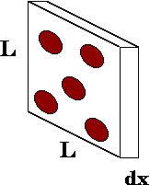

Figure 7‑1. A thin slab of material with atoms that might interact with an incoming photon (“Mean Free Path,” 2021)

### Nearest Peak Code



### Reference conditions of FC65-G ionization chamber

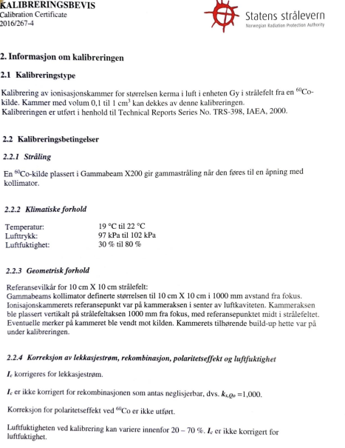

### Initial guess LM

Initial guess for unknown parameters of the model

$D=a⋅netOD+b⋅netOD^{n}$

|  |  |  |  |  |
| --- | --- | --- | --- | --- |
|  |  |  | Convergence [a,b,n] |  |
| a | b | n | Low response | High response |
| -2.505 | -0.994 | 0.207 | [7.238, 50.375, 2.625] | [6.205, 50.815, 2.954] |
| 1.333 | -1.283 | 0.711 | [77223.095, -77194.254, 1.0] | [100403.926, -100379.48, 1.0] |
| -0.39 | -1.349 | 1.001 | [7.238, 50.375, 2.625] | [6.205, 50.815, 2.954] |
| 0.176 | 0.17 | 0.715 | [7.238, 50.375, 2.625] | [6.205, 50.815, 2.954] |
| -0.3 | -0.358 | 0.114 | [7.238, 50.374, 2.625] | [6.205, 50.815, 2.954] |
| -0.551 | -0.035 | 0.535 | [7.238, 50.375, 2.625] | [6.205, 50.815, 2.954] |
| 1.387 | -1.142 | 0.445 | [7.238, 50.375, 2.625] | [6.205, 50.815, 2.954] |
| -0.328 | -0.096 | 0.88 | [7.238, 50.374, 2.625] | [6.205, 50.815, 2.954] |
| -0.428 | 0.308 | 0.468 | [7.238, 50.375, 2.625] | [6.205, 50.815, 2.954] |
| -1.604 | -1.323 | 0.271 | [7.238, 50.374, 2.625] | [6.205, 50.815, 2.954] |